ЎҚУВ МАТЕРИАЛИ
LECTURE 1. Introduction to the subject “Country Study”

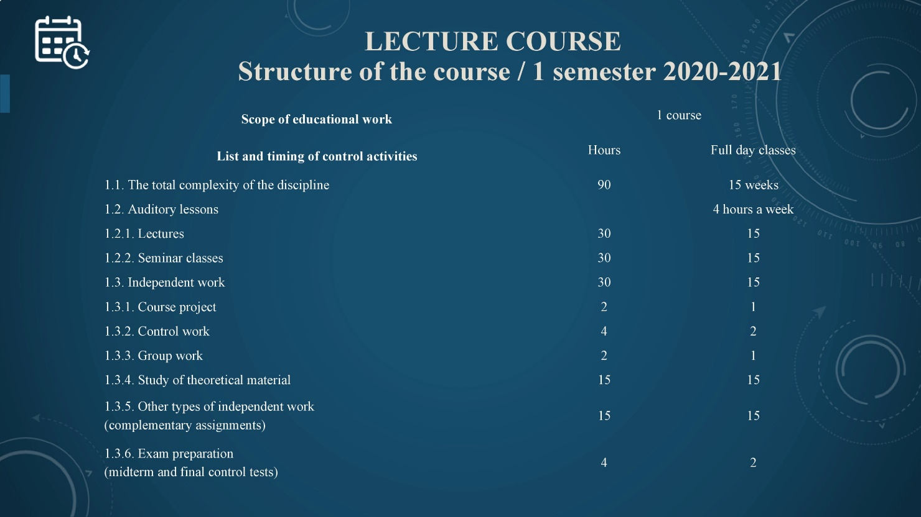

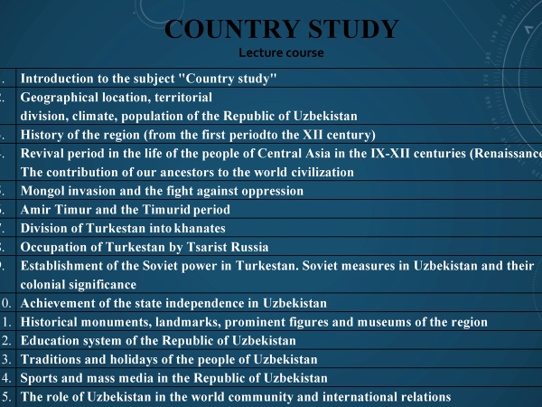

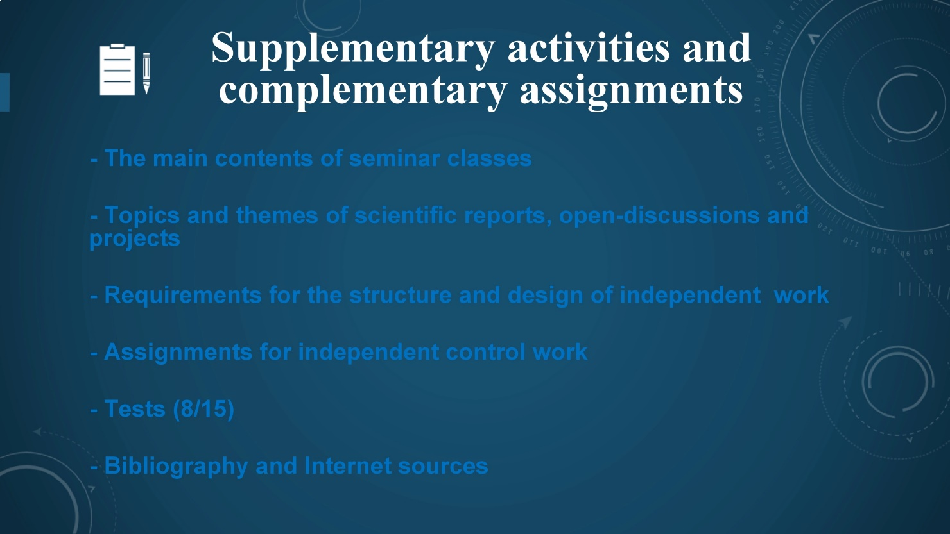

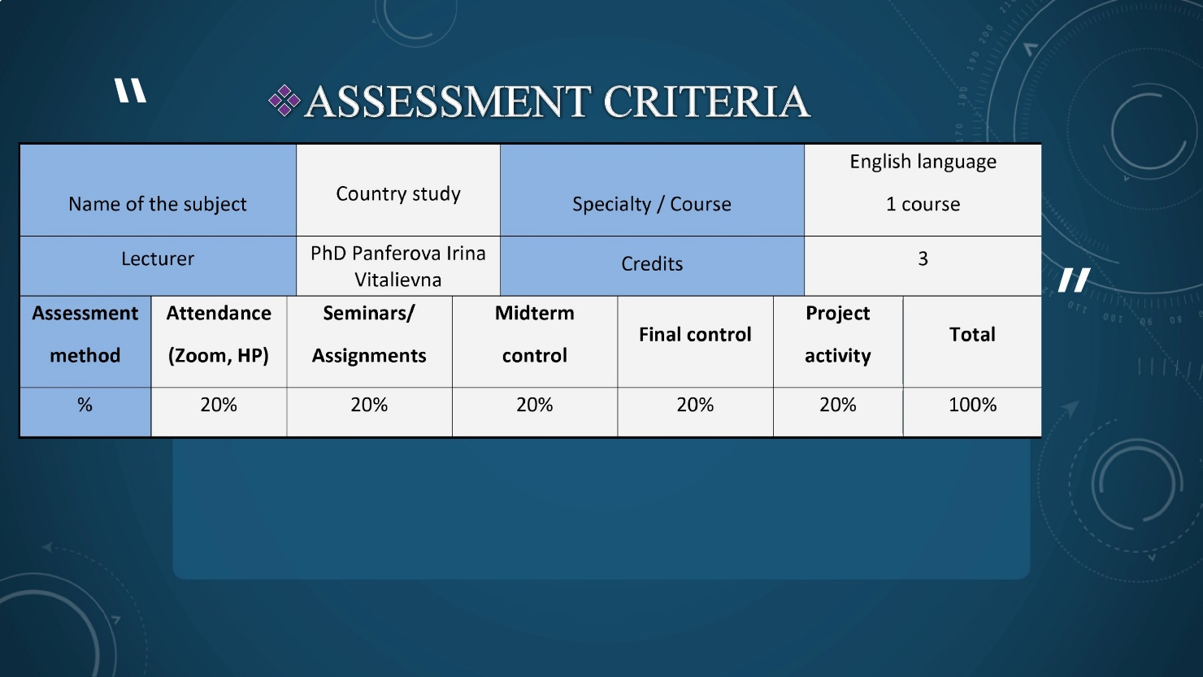

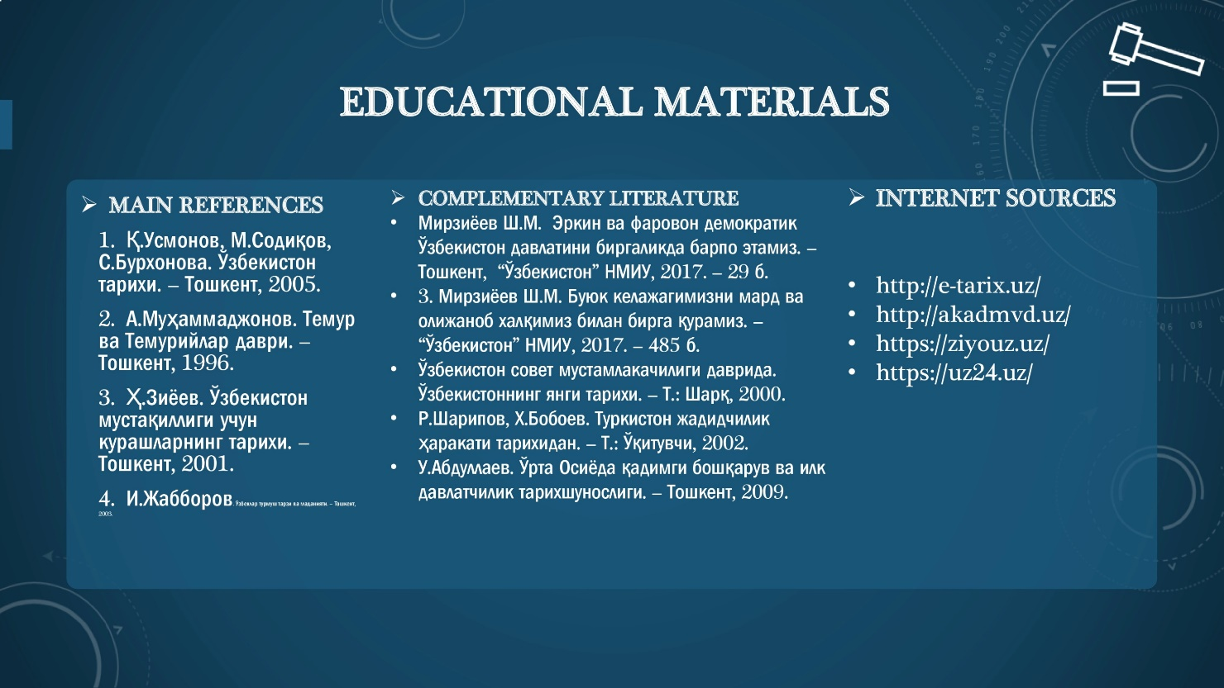





LECTURE 2. GEOGRAPHICAL LOCATION, TERRITORIAL DIVISION, CLIMATE, POPULATION OF THE REPUBLIC OF UZBEKISTAN
GEOGRAPHICAL LOCATION
Uzbekistan, officially the Republic of Uzbekistan, being a country in Central Asia, lies mainly between two major rivers, the Syr Darya (ancient Jaxartes River) to
the northeast and the Amu Darya (ancient Oxus River) to the southwest, though they only partly form its boundaries. Uzbekistan is bordered by Kazakhstan to the northwest and north, Kyrgyzstan and Tajikistan to the east and southeast, Afghanistan to the south, and Turkmenistan to the southwest. The autonomous Republic of Qoraqalpoghiston (Karakalpakstan) is located in the western third of the country. The Soviet government established the Uzbek Soviet Socialist Republic as a constituent (union) Republic of the U.S.S.R. in 1924. Uzbekistan declared its independence from the Soviet Union on August 31, 1991. The capital is Tashkent (Toshkent).

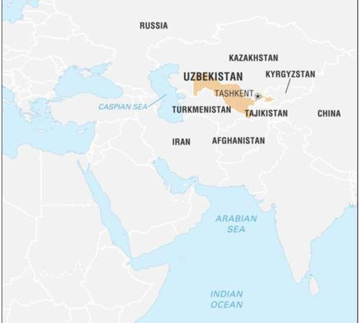
LAND AND TERRITORIAL DIVISION
Nearly four-fifths of Uzbekistan’s territory, the sun-dried western area, has the
appearance of a wasteland. In the northwest the Turan Plain rises 200 to 300 feet (60
to 90 metres) above sea level around the Aral Sea in Karakalpakstan
(Qoraqalpog’iston). This terrain merges on the south with the Kyzylkum (Uzbek:
Qizilqum) Desert and farther west becomes the Ustyurt Plateau, a region of low
ridges, salt marshes, sinkholes, and caverns.

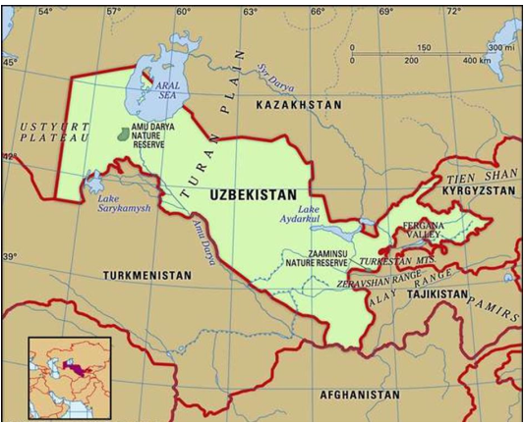
Southeast of the Aral Sea, small hills break the flatness of the lowlying Kyzylkum Desert, and, much farther east, a series of mountain ridges partition Uzbekistan’s territory. The western Tien Shanincludes the Karzhantau, Ugam, and Pskem ranges, the latter featuring the 14,104-foot (4,299-metre) Beshtor Peak, the country’s highest point. Also part of the western Tien Shan are the Chatkal and Kurama ranges. The Gissar (Hissar) and Alay ranges stand across theFergana (Farghona) Valley, which lies south of the western Tien Shan. The Mirzachol desert, southwest of Tashkent, lies between the Tien Shan spurs to the north and the Turkestan, Malguzar, and Nuratau ranges to the south. In south-central Uzbekistan the Zeravshan valley opens westward; the cities of Samarkand(Samarqand) and Bukhara (Bukhoro) grace this ancient cultural centre.

Drainage
Disastrous depletion of the flow of the two historic rivers—the Syr Darya and Amu Darya—has brought rapid change in the Aral Sea and greatly altered the delta of the Amu Darya. Most streams of the delta have dried up, and the Aral Sea, once the fourth largest inland body of water in the world, has lost as much as nine-tenths of both its water (volume) and its surface area since 1961. On the north as well as on the east, huge shallow and dead ponds have become separated from the
main remnant Aral Sea, cut off by sandbars that emerged as the water level dropped
some 45 feet between 1961 and 1992. After 2010 the eastern lobe began alternating
between wet periods and dry periods during which it would dry up completely.
Overuse of water from the Syr Darya and Amu Darya in both agriculture and industry
brought about this dangerous decline. The Syr Darya ceased to deliver any
appreciable amount of water to the Aral Sea by about 1978, and flows from the Amu
Darya became negligible in the first decade of the 21st century. The southern rivers
tributary to the Amu Darya—theSurkhan and Sherabad, followed by
the Zeravshan and Kashka—contribute little flow, for the last two trickle into nothing
in the desert. The Syr Darya, the second largest river in Uzbekistan, forms there by
the confluence of the Naryn and Qoradaryo rivers.

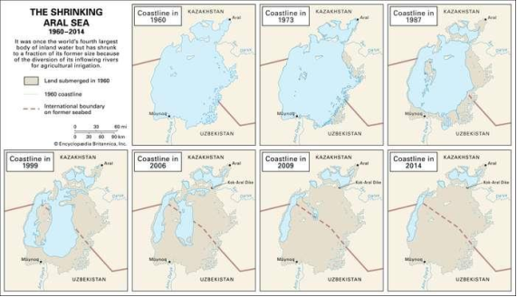
AralSea
Shrinkage of the Aral Sea, 1960–2009. The diversion of the Amu Darya and the Syr Darya has resulted in intense salinization of the sea, which also has suffered tremendouspollution from insecticides and chemical fertilizers during the past several decades. This chemical pollution and the decline in water level have killed the once-flourishing fishing industry, grounded most ships that formerly worked within the Aral’s shores, and contaminated wide areas around the sea with salty lethal dust. This in turn has poisoned vegetables and drinking water, most harmfully affecting the health and livelihood of the human population around the Aral Sea littoral.
CLIMATE
Marked aridity and much sunshine characterize the region, with rainfall averaging only 8 inches (200 mm) annually. Most rain falls in winter and spring, with higher levels in the mountains and minimal amounts over deserts. The average July temperature is 90 °F (32 °C), but daytime air temperatures in Tashkent and elsewhere frequently surpass 104 °F (40 °C). Bukhara’s high summer heat contrasts with the cooler temperatures in the mountains. In order to accommodate to these patterns, Uzbeks favour houses with windows facing away from the sun but open to porches and tree-filled courtyards shut off from the streets. Although more than 600 streams crisscross Uzbekistan, the climate strongly affects drainage, because river water rapidly escapes through evaporation and filtration or runs off into irrigation systems.
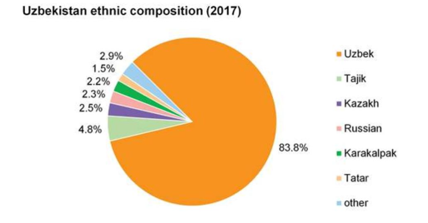
Plant and animal life
Vegetation patterns in Uzbekistan vary largely according to altitude. The
lowlands in the west have a thin natural cover of desert sedge and grass. The high
foothills in the east support grass, and forests and brushwood appear on the hills.
Forests cover less than 8 percent of Uzbekistan’s area. Animal life in the deserts and
plains includes rodents, foxes, wolves, and occasional gazelles and antelopes. Boars,roe deer, bears, wolves, Siberian goats, and some lynx live in the high
mountains.
POPULATION
Ethnic groups
Uzbeks make up more than four-fifths of the population, followed byTajiks, Kazakhs, Tatars, Russians, and Karakalpaks. Uzbeks are the least Russified of the Turkic peoples formerly under Soviet rule, and virtually all of them still claim Uzbek as their primary language.
Languages
The Uzbeks speak a language belonging to the southeastern, or Chagatai (Turki), branch of the Turkic language group. Karakalpak, a distantly related Turkic language, enjoys official status alongside Uzbek in Karakalpakstan, where it is spoken by about half a million people. About one-seventh of the population of Uzbekistan speaks Russian.

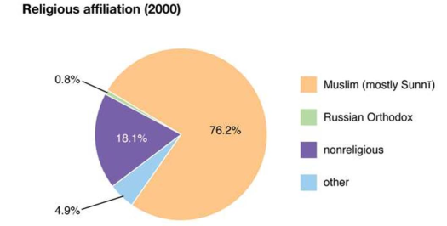
Religion
The Uzbeks are Sunni Muslims, and they are considered to be among the most devout Muslims in all of Central Asia. Thus, about three-fourths of the population is
Muslim. Slightly less than one-tenth of the population is Eastern Orthodox Christian,
and the remainder of the people consider themselves nonreligious or follow other
religions.
SETTLEMENT PATTERNS
Most of the population lives in the eastern half of the country. Heavily populated oases and foothill basins are covered with an extensive network of canals intersecting fields, orchards, and vineyards. The fertile Fergana Valley in the extreme east, the most populous area in Central Asia, supports both old and new cities and towns and traditional rural settlements. Much of Karkalpakstan, in the west, is under threat of depopulation caused by the environmental poisoning of the Aral Sea area. Roughly half of the population of Uzbekistan lives in urban areas; the urban population has a disproportionately high number of non-Uzbeks. Slavic peoples— Russians, Ukrainians, and Belarusians—held a large proportion of administrative positions. In the late 1980s and early ’90s, many Russians and smaller numbers of Jews emigrated from Uzbekistan and other Central Asian states, changing the ethnic balance and employment patterns in the region.

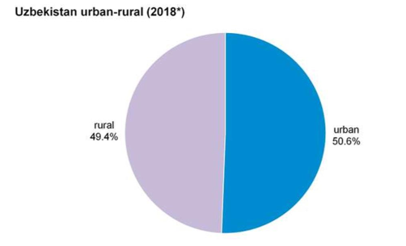
The cities of Samarkand, Bukhara, and Tashkent have histories that extend
back to ancient times. Andijon (Andizhan), Khiva, and Qŭqon (Kokand) also have
served the region as cultural, political, and trade centres for centuries. Soviet-era architects purposely laid out some newer towns, including Chirchiq, Angren, Bekobod, and Nawoiy (Navoi), close to rich mineral and energy resources. Soviet planners also sited Yangiyul, Guliston, and Yangiyer in area that produce and process cotton and fruit.

Demographic trends
Uzbekistan’s population remains youthful in comparison with those of the western parts of the former Soviet Union, though the population aged slightly and steadily over the decades following its independence. Nearly half the population is in
the age range of 25–54. This age structure results from the high birth rate after independence: of all the former Soviet republics, Uzbekistan had the greatest number
of mothers with 10 or more living children under the age of 20. The birth rate has since decreased.
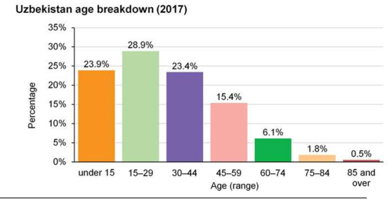
ECONOMY
Uzbekistan is among the world’s leading cotton producers. It is known for its
orchards and vineyards and is also important for raising Karakul sheep and silkworms. Uzbekistan’s mineral and oil and gas reserves are substantial. The country produces and exports a large volume of natural gas. The central bank issues the national currency, the sum.
RESOURCES
The country’s resources include metallic ores; in the Olmaliq(Almalyk) mining
belt in the Kurama Range, copper, zinc, lead, tungsten, and molybdenum are
extracted. Uzbekistan possesses substantial reserves of natural gas, oil, and coal. The
country consumes large amounts of its natural gas, and gas pipelines link its cities
and stretch from Bukhara to the Ural region in Russia as well. Surveys show
petroleum resources in the Fergana Valley (including major reserves in
the Namangan area), in the vicinity of Bukhara, and in Qoraqalpoghiston. The
modern extraction of coal began to gain importance, especially in the Angren fields,
only during World War II. Hydroelectric dams on the Syr Darya, the Naryn, and
the Chirchiqrivers help augment the country’s nuclear-, coal-, and petroleumpowered
generation of electricity.
Centuries-old rumours of extensive gold deposits in Uzbekistan evidently arose
from a basis in fact. Rich polymetallic ores have been found in the Ohangaron
(Akhangaran) field southeast of Tashkent. Miners there extract copper, some gold,
lead, molybdenum, tungsten, and zinc. A plant for heat-leaching gold from low-grade
ore was built in the mid-1990s by a subsidiary of the Newmont Mining Corporation
in the Muruntau field in the Kyzylkum Desert of north-central Uzbekistan. It was
intended to be a joint venture with the government, but Newmont Mining Corporation’s
share was forfeited in a legal battle in 2007.
Uzbekistan requires greater water resources. By the early 1980s the
government considered the shortage of water desperate. Officials in Moscow and
Tashkent developed a plan to divert substantial amounts of water out of the Irtysh
River far to the north into a pumped system that would aid in watering parts of lower
Russia, Kazakhstan, and Uzbekistan. The project was killed, however, before it
began, leaving Uzbekistan with chronic water shortages.
AGRICULTURE
Ample sunlight, mild winters of short duration, fertile irrigated soil, and good
pastures make Uzbekistan suitable for cattle raising and the cultivation of cotton.
Irrigation has fallen into disfavour owing to the depletion of the great rivers, and the construction of new irrigation systems has been prohibited or curtailed. Already
existing grand canals include the Great Fergana, Northern Fergana, Southern
Fergana, and Tashkent. Several large artificial lakes and reservoirs have been created
on the Zeravshan and other rivers.
In addition to the high and stable cotton yield in this most northerly of the great
cotton regions of the world, growers have raisedsilkworms systematically since the
4th century. The silkworms are fed mulberry leaves from the many trees planted
along streets and ditches. The Fergana Valley is especially noted for silk production.
Varieties of melons, apricots, pomegranates, berries, apples, pears, cherries,
and figs grow abundantly, as do vegetables such as carrots, cucumbers, onions,
tomatoes, and greens. Uzbekistan’s grapes are made into wine or raisins or are eaten
fresh. Fruits and vegetables are sold both in the bazaars of Tashkent, Samarkand,
Fergana, and other localities and in trade with neighbouring states. Korean
agriculturalists cultivate rice along the middle Syr Darya. Sheep are the principal
livestock.
INDUSTRY
Uzbekistan is the main producer of machinery and heavy equipment in Central
Asia. The republic manufactures machines and equipment for cotton cultivation,
harvesting, and processing and for use in the textile industry, irrigation, and road
construction. This emphasis on making machinery also makes ferrous and nonferrous
metallurgy important. The first metallurgical plant began operation at Bekobodin
1946. Light industry includes tea-packing plants and factories for garment making.
TRADE
The leading exports from Uzbekistan consist largely of extracted natural
resources or raw materials—cotton, natural gas, oil, coal, silk, fruit, and Karakul
pelts. Some fresh produce reaches Moscow and other northern markets.
Manufactured goods such as machines, cement, textiles, and fertilizer are also
exported. Uzbekistan’s largest sources of imports are China, Russia, South Korea,
and Kazakhstan. Its main export destinations are Switzerland, China, Turkey, and
Kazakhstan.

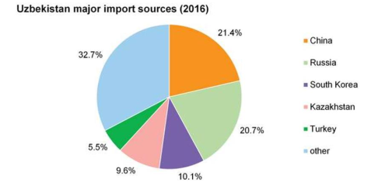

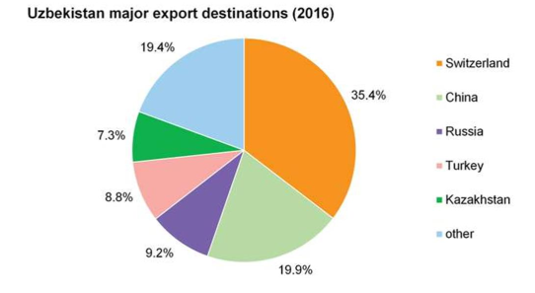
TRANSPORTATION
The great obstacle to further development of markets for
Uzbekistan’s copious truck gardening and fruit growing remains the antiquated
means of distribution. Neither the surface nor air transport now available can
efficiently or with adequate refrigeration handle the volume produced in Uzbekistan
and needed by the Baltic states, Russia, Belarus, and Ukraine.
Old railways connect the republic’s major urban centres with other Central
Asian republics and extend to Moscow and Siberia. Uzbekistan never had a domestic
airline of its own until after independence in 1991, when former Soviet Aeroflot
airplanes and their pilots were chartered to fly rather infrequently from such cities as
Samarkand and Tashkent to nearby cities. Air service now connects Tashkent with
London, New York, and other international cities.
Trucks transport most of the freight carried, and the roadways, like other
facilities, require much repair—virtual reconstruction—and widening before they can
support the modernizing economies that their builders once hoped to link with each
other. The Great UzbekTashkent-Termiz Highway runs south almost to the border
withAfghanistan. Termiz remains virtually a dead end in terms of trade, however,
especially since the Soviet intervention (1979–89) in theAfghan War. A second road,
the Zeravshan Highway, connects Samarkand with Chärjew, Turkmenistan, in the
west. The Fergana Ring links the main settlements within the populous Fergana
Valley.

LECTURE 3. HISTORY OF THE REGION (FROM THE FIRST
PERIOD TO THE XII CENTURY)
FIRST ANCIENT STATES

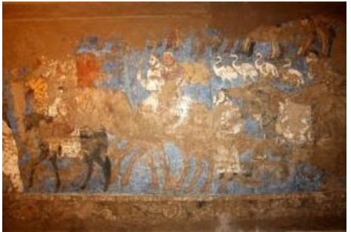
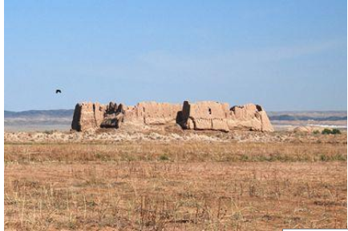
Achaemenid (Persian) dynasty
In the 6th century BC Central Asia was conquered by the king Cyrus, the
founder of the Achaemenid Persian state. Over two hundred years the entire southern
part of Central Asia was a part of the Achaemenid Empire, in which all its territory
was divided into satraps. Three of the Central Asian satrapies: Bactria, Sogdiana,
Khorezm were first ancient states, which wholly or partialy were located within the
territory of modern Uzbekistan. Freedom-loving people of Central Asia could not live
under the oppression of the Persians. They often struggled against invaders. In the
second half of the 4th century BC after long struggle, Khorezm gained its
independence. Then Saks became an independent state. Numerous rebellions
weakened the Persians and the arrival of the army of Alexander the Great brought an
end to the Achaemenid Empire.
Age of Hellenism
The collapse of the Persian empire occurred in the 4th century BC, when the
great Greek military leader Alexander the Great defeated the Persians at the Battle of
Gavgamellah. In 329 BC Alexander strengthened his power in Sogdiana.
In 323 BC, after Alexander's death, Sogd became the part of the Seleucid State,
founded by the Greek commander Seleucus. In 250 BC a Seleucid satrap Diodot
detached from this state a separate Greco-Bactrian kingdom with the capital in
Baktry. This ancient state included Margiana and Sogdiana. After Diodot Evtidem
came to the power and then Demetriy became the ruler of the state. During his reign a
part of India was joined to the Greco-Bactrian State. Culture and economy reached a
high level of prosperity, crafts, agriculture, trade and town planning were developed
and money was coined. The ancient state was centralized and, as well as the Seleucid
State, it was divided into satrapies. At that time, due to the construction of the road
from Seleucid State to Baktria an international trade and relations with various
countries around the world were developing. Baktria was situated on the trade road of
China-India (southern branch of the Silk Road).
Kushan Empire

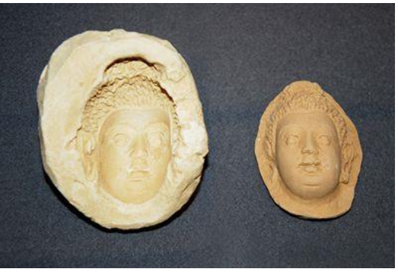
Despite the rapid development, the Greco-Bactrian kingdom was torn by civil
dissensions. It caused to the collapse of the state in the middle of the 2nd century BC.
Sogd waited another stage of development in the new state, Kushan. It was founded
by a nomadic tribe of Kushan (Yuezhi), which managed to conquer a previously
separated Khorezm. The Kushan Empire became one of the greatest states of the
period. It included Central Asia, a part of present-day Afghanistan and northern India.
Kushan ruler, Kanishka I, adopted Buddhism. Throughout the state Buddhist temples
were constructed. Cities of Central Asia became the centers of crafts and trade. It was
the period of prosperity of the region, its economy, culture and art development. But
the most important achievement of that period was a new land trade route, later
named the Great Silk Road. The route stretched from China to western countries
through a vast territory. Central Asia, namely central part of Uzbekistan and the
Fergana Valley, became an important part of this highway. Kushan Empire existed in
the 1st-4th centuries AD. It was destroyed by the nomad tribes of Hephthalites.
Parthia

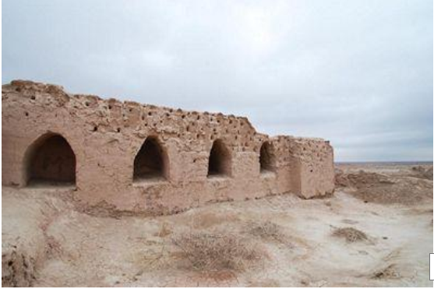
One of the most powerful states in Central Asia, Parthia separated from the
Seleucid State in 250 BC. Parthia was located south-east from the Caspian Sea, on
the territory of today Turkmenistan and a part of northern Iran. During the prosperity
of the state, Parthia conquered territory, stretching from Asia Minor to India. The first
ruler of Parthia, Androgen was soon replaced by Arkshak I, a founder of Arkshakid
Dynasty. The Parthian State reached the highest prosperity during the reign of
Mitridad in 170-138 BC, who took eastern satrapies: Persia, major part of Mesopotamia and Armeny, away from Seleucid state and conquered a part of the
Greco-Bactrian state. He was first who took the title “king of kings” and declared
himself the successor of Achaemenids. The capital of the Parthian State was located
in Nisa. Ruins of this city are located close to Ashgabat. Nisa was divided into two
parts: Old Nisa, king’s reserve, and new Nisa, ruins of the ancient Parthian city. Torn
by internecine conflicts and pressure from Rome, the Parthian State collapsed in 226
AD.
Kangju

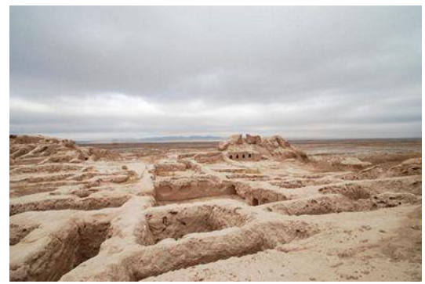
First notes about the ancient state Kangju were found in Avesta, where it was
called Kangha. Since the 3rd century Kangju existed as an independent state, and it
reached the highest prosperity in the 1st-2nd centuries AD. Kangju included the Syr
Darya steppes and regions along the lower and middle reaches of Syr Darya. In the
south Kangju bordered with Kushan Kingdom and in the north-east with China
Empire. The Silk Road laid through Kangju State that caused to the development of
the economy. Strategically important location of the state provided the influence of
Kangju on the political situation in the region.
Major facts about Kangju we have from Chiness sources, namely from historical records Shih Tzu by Sim Tzyan. He wrote that Kangju was the confederate state with developed economy and system of administration. Main population of Kangju consisted of nomadic tribes, but the population of southern part of the state was agricultural. The decline of the ancient state was in the 4th century AD, during the new movement of tribes and invasion of nomadic tribes to agricultural districts of
Central Asia.
EARLY MIDDLE AGES: 5TH-11TH CENTURIES
Hephthalite State

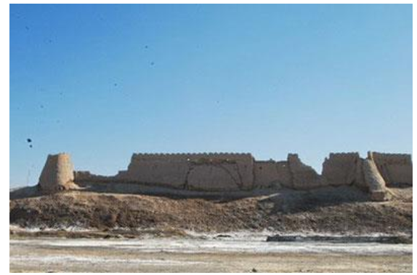

In the 5th century Hephthalites conquered all the cities of Central Asia and
created a vast empire that stretched from the Caspian Sea to Kashgar, and from the Aral Sea to India. They preferred not to interfere in politics of Sogdiana, which
meanwhile had been divided into many kingdoms, the largest of which was Samarkand. Hephthalites promoted Buddhist traditions, they built many Buddhist
temples. Hephthalites carried on active foreign trade through the Great Silk Road.
They had good relations with China, India and Byzantine. They traded silk, jewelry
and spices.
Turkic Khanate

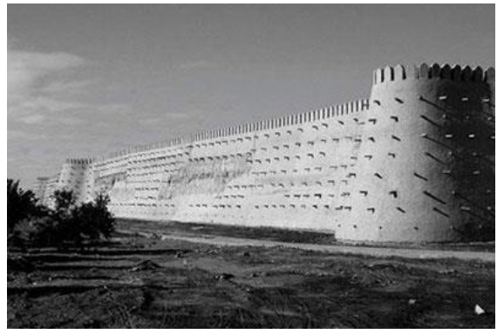
In the 6th century the Hephthalite State was destroyed by the Turks, who in
550-750 through the union of various nomadic tribes and Altai nations established a
powerful state, Turkic Khanate, stretching from China to the Volga. Central Asia
became its part. Turkic Khanate lived by endless wars, by which it became richer.
Captives were settled in special villages and paid to Khagans by products or
handicrafts. Sogdiana and Fergana cities under the reign of Turks preserved a relative
autonomy and paid only a tribute to kaghans.
The Turkic Khanate took part in political and economic relations of the largest
states of that period: Byzantine, Sassanid Empire, Iran and China and struggled for
the control on the Silk Road. Cotton and silk production were actively developed. In
the early Middle Ages cotton and silk were the main resources of the region; local
gold and silver were highly estimated too.
The Arab conquest and early Muslim expansion

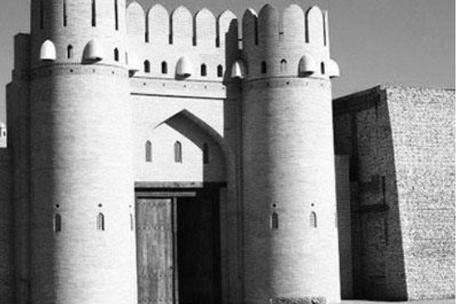
In the 7th century AD a Sogdian fertile land became a subject of keen interest
of the Arabs who from 673 started to invade these lands. The Arabs called it
Mawarannahr ("that which is beyond the river"). In 709-712 the Arab leader Ibn
Muslim Kuteiba conquered the main centers of Mawarannhr: Samarkand, Bukhara
and Khorezm. As a result, Uzbekistan and practically the whole Central Asia became
a part of the Arab Caliphate under the control of the Baghdad caliphs (Omeiad
Dynasty till the middle of 8th century and since 750 the Abassid dynasty). The Arab
influence in the Mawarannahr became dominant. The Arabs brought Islam and
forcibly converted residents of the conquered lands to this new religion. By the 10th
century the entire population of Mawarannahr (the region between the Amu Darya
and Syr Darya) adopted Islam. All attempts of local people to resist the invaders were
not successful. But such major rebellions as the rebellion of Mukanna and Rafi ibn
Leis forever remained in the chronicles of the liberation movements of Central Asian
nations.
Tahirid State
Baghdad caliphs appointed governors in the conquered regions from the Persian officials. In 821 Abdullah ibn Takhir was appointed the Governor of Khorasan. He founded the Takhirid Dynasty, influence of which spread to Chorasan and Mawarannahr. During the Arab conquest economy and culture of the region were
almost destroyed. Hundreds of the most precious monuments were ruined. Arabic
became a state official language. Takhirids 0took decisive measures to organize
strong power and to order agriculture. They improved water supply and constructed
new channels. By an order of Abdallah ibn Takhir, outstanding lawyers of the
country worked out standards to use water for irrigations. For two centuries these
works had served as the guidance to solve disputes in water consumption matters .
Samanid State

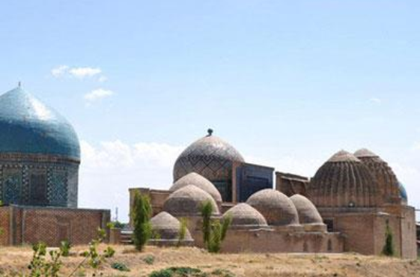
Lest the possession of Chorasan and Mawarannahr did not increase too much
power of the Takhirid Empire, the caliphate began to strongly promote the Persian
race of Samanids. The descendants of the founder of the Saman-Khudat kin were
appointed the governors of Mawarannahr cities: Nuh in Samarkand, Ahmad in
Fergana, Yahya in Tashkent and Ilyas in Herat. In 900, the Samanids attached
Chorasan to their possessions. Samanids became the founders of the first centralized
feudal state in Mawarannahr with the capital in Bukhara. Their reign lasted till 999.
Samanids created new economy based on the reasonable tax collection, organized
efficient work of the state apparatus. Samanids contributed to the unprecedented rise
in cultural life. Bukhara, Merv, Samarkand, Urgench were worldwide famous centers
of science and culture in the early Middle Ages. Trade flourished as never before.
Particularly Samarkand paper and glass as well as leather, cloth, silk and wool were
in demand.

Karakhanid State
In the end of the 10th century the Turkic tribes (the remnants of once powerful
Turkic Khanate) founded a new state headed by a dynasty of Karakhanids, which in
992-999 won Mawarannahr. In 999 the Karakhanid Dynasty took the place of
Samanids in Samarkand and Bukhara. Karakhanids had been ruling for 200 years,
almost till the Mongol invasion in the 13th century, with short break in the 11th
century, when Seljuks came to the power. State borders were constantly changing at
that time.
Ghaznavid State
In the period of Samanid dynasty, Makhmud of Ghazni (city of Ghazni in
eastern Afghanistan) was appointed the governor of Chorasan. Taking advantage of
revolts in the Samanid State, he began to interfere in the affairs of Mawarannahr and
infringe on the heritage of the Samanids. But he could not break the influence of
Karakhanids who had already consolidated their position in the conquered Mawarannakhr and moved to Khorezm, which was a separate state at that time. In
1017 he defeated and destroyed Khorezm. Then he decided to conquer India.
Makhmud of Ghazni made 15 campaigns to India from 1002 to 1026. In the 12th
century Ghaznavid Dynasty was replaced by Ghurids Dynasty.
Seljuk Empire
In 1040 the state, created by Makhmud of Ghazni, was weakened by the
nomads, the Seljuk-Turks tribes. Ghaznavids were unable to hold power for long and
by 1059 Seljuks had taken over Chorasan and Mawaranahr. As the result of countless
conquests these tribes succeeded to create a great empire at the turn of the 11th-12th
centuries. This empire included Asia Minor, Middle East and major part of the
Armenian-Kurdish highlands. Following the approval of Western domination Seljuks
transferred their attention to the east, namely to Mawarannahr. They conquered it in
1097. During the Seljuk reign, territory of modern Uzbekistan was decorated with
many wonderful palaces and buildings. Architecture, crafts, arts and culture were
flourishing. In the 12th century Mawarannahr was invaded by new nomadic tribes,
Kara-Khitan. They conquered the entire Mawarannahr, large areas from Khorezm to
Kashgar. Defeating the Seljuk Empire, Kara-Khitan created all the prerequisites for
the strengthening of a powerful state of Khorezmshahs in the early Middle Ages.

LECTURE 4. REVIVAL PERIOD IN THE LIFE OF THE PEOPLE OF
CENTRAL ASIA IN THE IX-XII CENTURIES (RENAISSANCE).
THE CONTRIBUTION OF OUR ANCESTORS
TO THE WORLD CIVILIZATION
The great contribution of Uzbek ancestors to the development of world civilization is known to the whole world today. They are great scientists, philosophers, thinkers, religious leaders, commanders and rulers too. They influenced the world by their genuinely inbuilt qualities of knowledge, wisdom, observation, administration and message. A few ones are supposed to be mentioned in this framework.
Abu Abdalloh Muhamad ibn Musa al Khorezmi
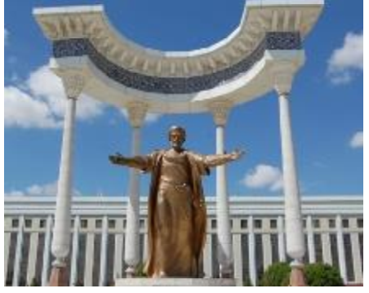
Born: about 780 in Khorezm province in Uzbekistan. Died: about 850. Mathematician, astronomer, geographer and historian, creator of algebra Muhammad аl Khorezmi a scholar who made an invaluable contribution to the development for world science and made great discoveries. The bibliographical data had not been found. But, there are the facts that at the beginning of 800’s he was invited to Ma’mun ibn Haruna ar-Rashid court, the Baghdad Caliph’s viceroy in Khorasan, and by twenty years old he was well-known scientist, got his education in native Khorazm. In 813 Ma’mun took the throne and together with his scholars that he had gathered around him in Marv moved to Bagdad. Ma’mun was a fan of science. Here, he had founded Bayt al Hikma (The House of Wisdom), at the history of science it was named as “Baghdad academy” or “Ma’mun Academy”. Muhammad al Khorazmi was the leader of scientific center to the end of his life. A lot of scholars and scientists from different parts of Central Asia and Arabian East worked there. The richest library of old manuscripts was at their disposal. The observatory had been constructed for works and discoveries.
Main Scientific Works
Muhammad al Khorazmi was the author about 20 scientific works that were
written in Arabian. Today, only seven of them are available, they are:
Fi hisab al-hind (The book on Indian count) - an essay, where the decimal
positional system with nine digits and zero had been justified and set out;
Al Kitab al Muhtasarfi hisab al-jabrva al mukabala (Brief book on algebra and
al mukabala)- the work, where algebra was founded as a science by the author and
gave its name; Zij al Khuarazmi (Astronomical tables) – an essay, consists of a small
theoretical part and tables, where table of trigonometric function of sinus are shown;
Kitab surat al – ard (The Book of World Picture) – a geographical tractate, where the
description of eastern hemisphere had been shown for the first time in the medieval,
the Pacific ocean (Bahr al Muzallam) was described, inhabited world map was
shown.
Contribution to the World Science
Muhammad al Khorazmiy made his contribution to the development of mathematics, astronomy, geography and through them – to the development of civilization. He founded and he substantiated and coined the decimal positional number system with nine figures and zero sign. Created algebra as a science and gave its name.
He developed and implemented a new method of presenting scientific and
educational works – through clear and exact rules. In European literature it is given as “algorithm”, which dates back to the name of al-Khorazmi in Latin transcription. This concept is the basis of all modern digital information and computer technology. Due to this method of exposition, the works of Muhammad al-Khorazmi are widespread. Furthermore, it is known that he is the first who had used polar coordinates.
In the astronomical book of Muhammad al Khorazmi “Zij” the movement of the sun, the moon, the five planets, mathematical geographic issues, trigonometry, the
eclipses of the Sun and Moon were examined. In 1126 it was translated into Latin, in
1914 into German and in 1962 into English languages.
The World Recognition
Muhammad al-Khorazmi’s merits in the development of mathematics and
world civilization are widely recognized, and his name is the only name of the
Eastern scientists, is enshrined in the title of “algorithm”, as well as the term “algebra”. Paying tribute to the genius of Al-Khorazmi, the most accurate assessment
of his significance in the history of science has given American historian J.Sarton “…
is the greatest mathematician of his time, and if we take into account all the
circumstances, and one of the greatest scientists of all time.”
Abul-Abbas Ahmad ibn Muhammad ibn Kasir al Farghani
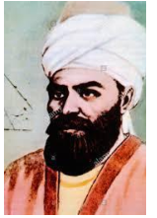
Life: about 798-865
Astronomer, mathematician, and engineer The exact date of birth and death of Ahmad al Farghani is not known. It is obvious from his name that he is from Ferghana. In Western Europe he was recognized of Latin name - Alfraganus.
Ahmad al Farghani worked together with Muhammad al Khorazmi in Bayt al Hikma (The House of Wisdom) in Bagdad. He participated in measuring the length of a meridian degree in Sanjar desert in Iraq.
The only reliable date in the biography of Ahmad al-Fargani is 861, when he built a new Nilometer (scale that measures water level of the Nile) on the island of Rauda near Cairo, which functioned until 1971, i.e. until the Aswan Dam construction.
The Main Scientific Works
The list of preserved to date, 11 works by Ahmad al Farghoni written in the Arabic language includes – Kitab fi usul ilm an-nujum («The elements of
astronomy»), Bab fi ma’rifa al-vaqt al-lati yakuni al-kamar fiha fa-vqa al-ard av tahtakha («the Treatise on time, when the Moon goes under and above the Earth»),
Hisab al-akalim as-sab’a («The calculus of seven climates»), al-Kamil fi san’a alasturlab ash-shimali wa-l-janubi bi-l handasa wa-l-hisab («A comprehensive book on the structure of the north and south astrolabe supplied with geometrical justification»), Kitab amal ar-ruhamat («A book of construction of sundials»), Kitab amal bi-l asturlab («A book of operations with astrolabe») and many others. The “Elements of Astronomy” used as a textbook for astronomy classes, was translated in the XII century into the Latin language and was very popular in Europe.
The book contains evidence for spherical form of the Earth and the data on the
planet’s size, which induced Ch. Columbus, F. Magellan and other travelers to make
geographical discoveries.
Both «A comprehensive book on structure of the north and south astrolabe supplied with geometrical justification», and «A book of construction of sundials»,
contain guidelines for designing, making and applying astronomic tools – astrolabes
(a planar astronomic instrument made of copper, bronze or other similar alloys,
which is used for defining the coordinates of celestial bodies) and sundials. In his “Book of operations with astrolabe” Ahmad al-Farghoni, proved the theorem of Ptolemy on the stereographic projection (stereographic projection – projecting of points on the surface of the imaginary heavenly sphere from one pole on to the plane crossing through its other pole, or on to the plane containing the equator), which is recognized as the main theory of astrolabe – the most popular medieval astronomic instrument.
Contribution to the World Science
The book “Elements of Astronomy” used in most European universities up till
the XVII century as the main textbook on astronomy brought him big fame. The book
was the source of knowledge both for scientists and ordinary people interested in the
matters of the world structure. So, the great Italian poet of the XIII century Dante Aligueri made use of the cosmography by Ahmad al-Farghoni, in his poetry work “The Feast”.
World Recognition
One of the craters on the Moon is called «Alfraghanus » (from XVII century). It was in 1998 when on the initiative of the President Islam Karimov and at the support from UNESCO, we widely celebrated the 1200th birthday of Ahmad alFarghoni. The Ferghana State University was named after A. Farghoni. In 2007, when the President of Uzbekistan was in Egypt on the official visit, a monument to Ahmad al-Farghony was mounted on the island of Raud.
Imam Al-Bukhari
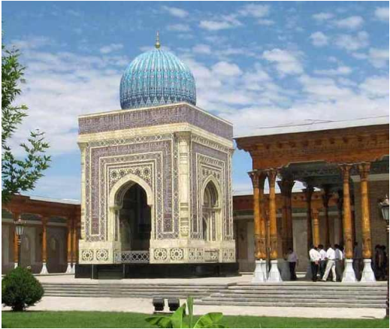
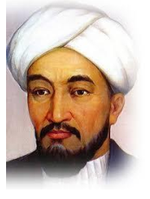
Imam Al-Bukhari (810-870) the well known scientist in the Islamic religion, theologian. His famous work is “Al-Jome as–Sakhikh” is reckoned the second holy book after the Koran in the Muslim world. Imam Abu Mansur Al-Moturidi was also (870-944) the great thinker of the Muslim world, the founder of Islamic theology and the Maturidiya school of Sunni doctrine.

Abu Nasr Muhammad Al-Farabi
Abu Nasr Muhammad Al-Farabi (872-950) the philosopher, mathematician and
explorer of music. In XII-XIII centuries many of his works were translated into Latin,
Ancient Hebrew, and Persian languages. Later it was translated into the languages of
other peoples of the world. In addition to the fact that he was the teacher of Avicenna
and well-known commentator on Aristotle’s works, he was also the author of many
books on philosophy and politics. He wrote comments on Plato’s “Laws”, and, in the
sphere of philosophy, he was reckoned as the second scientist after Aristotle. As a
token of recognition of his merits he was titled as “The Second Teacher”.
Abu Arrayhan Muhammad ibn Ahmad al – Biruni
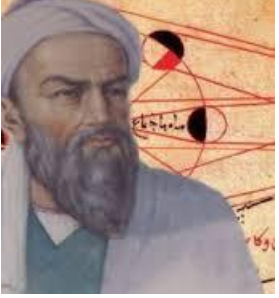
Born: 15 Sept 973 in Kath, Khwarazm (now Khorezm province, Uzbekistan). Died: 13 Dec 1048 in Ghazna (now Ghazni, Afganistan.) Al - Biruni is one of the major figures of Islamic mathematics. He contributed
to astronomy, mathematics, physics, medicine and history. Abu Rayhan al - Biruni was born in Khwarazm, a region adjoining the Aral Sea now known as Karakalpakstan. The two major cities in this region were Kath and Jurjaniyya. Al - Biruni was born near Kath and the town were he was born is today called Biruni after the great scholar. He lived both in Kath and in Jurjaniyya as he grew up and we know that he began studies at a very early age under the famous astronomer and mathematician Abu Nasr Mansur.
The total number of works produced by al - Biruni during his lifetime is impressive. It is estimated, that he wrote around 146 works with a total of about 13,000 folios (a folio contains about the same amount as a printed page from a
modern book). The range of al - Biruni’s works covers essentially the whole of
science at his time.
We know certain dates in al - Biruni's life with certainty for he describes
astronomical events in his works which allow accurate dates and places to be
determined. By the age of seventeen al - Biruni was engaged in serious scientific
work for it was in 990 that he computed the latitude of Kath by observing the
maximum altitude of the sun.
His description of an eclipse of the moon on 24 May 997 which he observed at
Kath means that he had returned to his native country by this time. The eclipse was
an event that was also visible in Baghdadand al - Biruni had arranged with Abu'l -
Wafa to observe it there. Comparing their timings enabled them to calculate the
difference in longitude between the cities. We know that al - Biruni moved around
frequently during this period for by 1000 he was at Gurgan being supported by
Qabus, the ruler of the Ziyarid state. He dedicated his work Chronology to Qabus
around 1000 and he was still in Gurgan on 19 February 1003 and 14 August 1003
when he observed eclipses of the moon there. We should record that in the Chronology al - Biruni refers to seven earlier works which he had written: one on the
decimal system, one on the astrolabe, one on astronomical observations, three on
astrology, and two on history.
His most famous work India was written as a direct result of the studies he
made while in that country. The India is a massive work covering many different
aspects of the country. Al - Biruni describes the religion and philosophy of India, its
caste system and marriage customs. He then studies the Indian systems of writing and
numbers before going on to examine the geography of the country. The book also
examines Indian astronomy, astrology and the calendar. The book might have been
written, when al - Biruni was in India with Mahmud Ghaznavid during Mahmud's
military excursions into India. It is likely that al - Biruni was essentially a prisoner of
Mahmud and was not free to leave and it meant that al - Biruni was taken to that
country by Mahmud. From around 1022 Mahmud's armies began to have success in
taking control of the northern parts of India and in 1026 his armies marched to the
Indian Ocean. Al - Biruni seems only to have been in the northern parts of India, and
we are uncertain how many visits he made, but observations he made there enabled
him to determine the latitudes of eleven towns around the Punjab and the borders of
Kashmir.
Al - Biruni studied Indian literature in the original, translating several Sanskrit
texts into Arabic. He also wrote several treatises devoted to certain aspects of Indian
astronomy and mathematics which were of particular interest to him. Al - Biruni was
amazingly well read, having knowledge of Sanskrit literature on topics such as astrology, astronomy, chronology, geography, grammar, mathematics, medicine, philosophy, religion, and weights and measures.
One of the most important of al - Biruni's many texts is Shadows which he is
thought to have written around 1021.The contents of the work include the Arabic
nomenclature of shade and shadows, strange phenomena involving shadows, gnomonic, the history of the tangent and secant functions, applications of the shadow
functions to the astrolabe and to other instruments, shadow observations for the
solution of various astronomical problems, and the shadow - determined times of
Muslim prayers. Shadows is an extremely important source for our knowledge of the
history of mathematics, astronomy, and physics. It also contains important ideas such
as the idea that acceleration is connected with non - uniform motion, using three
rectangular coordinates to define a point in 3-space, and ideas that some see as
anticipating the introduction of polar coordinates.
The book details the mathematical contributions of al-Biruni. These include:
theoretical and practical arithmetic, summation of series, combinatorial analysis, the
rule of three, irrational numbers, ratio theory, algebraic definitions, method of solving
algebraic equations, geometry, Archimedes' theorems, trisection of the angle and
other problems which cannot be solved with ruler and compass alone, conic sections,
stereometry, stereographic projection, trigonometry, the sine theorem in the plane,
and solving spherical triangles.
Important contributions to geodesy and geography were also made by alBiruni. He introduced techniques to measure the earth and distances on it using triangulation. He found the radius of the earth to be 6339.6 km, a value not obtained in the West until the 16th century. His Masudic canon contains a table giving the coordinates of six hundred places, almost all of which he had direct knowledge. Not all, however, were measured by al-Biruni himself, some being taken from a similar table given by al - Khwarizmi. The author of remarks that al- Biruni seemed to realize that for places given by both al - Khwarizmi and Ptolemy, the value obtained by al - Khwarizmi is the more accurate. Al-Biruni also wrote a treatise on time - keeping, wrote several treatises on the astrolabe and describes a mechanical calendar. He makes interesting observations on the velocity of light, stating that its velocity is immense compared with that of sound.

Abu Ali ibn Sina
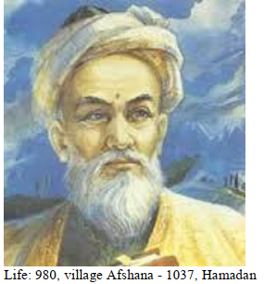
Abu Ali al-Huseyn ibn Abdallah ibn Sina was born in Afshana near Bukhara.
He got primary education by his father, then he learned sciences at Abu Abdallah anNatili in Bukhara. For special achievements in 996 the young Huseyn was invited to emir Nuha ibn Mansura as-Samani’s palace (976-997). But soon the ruling of
Samanids ended and after 1002 year Ibn Sino moved to Gurganj – to the Khorezmshah Abu-l-Hasana Ali ibn Mamun (997-1009). There he became one of the
most active members of Mamun academy. In 1011 Ibn Sino left Gurganj avoiding the
chase of sultan Mahmud Gaznevi. He went to Abivard at the north of Horasan, then –
to the Nishapur and then – to the Gurgan and then – from 1014 to 1037 he live in Re,
Isfahan. Ibn Sino died in 1037 year in Hamadanl. His grave has been saved here till our days.
Main science works
Ibn Sino was the real encyclopedia-scientist successfully worked almost all kinds of subjects of knowledge of his times. There are more than 450 his works, and about 240 of them saved till our days, they are written mainly in Arabic. Scientific opinion of Ibn Sino is well considered in his following works: alkanun fi-t-tibb (Canons of Medicine) – medical encyclopedia, in which organized all the questions of theoretical and practical medicine of that period of time; it consists of 5 books. Kitab ash-shifa (the book of healing) – philosophical encyclopedia, which contain of 4 parts: logic, exact sciences, mathematic sciences, metaphysics (theology). Kitab an-najat (the book of saving) – the short version of book on healing. Danish-name (the book of knowledge) – philosophic work in Persian, in which he considered many question of theoretic philosophy, and logic as well. Risala al-iksir (tract of elixir) – honored to chemistry, to practical ways of transmutation of steels, al-Aydviyat al-kalbiya (medicine for heart) – philosophic-medicine work, honored of healing heart diseases, in which giving the authors opinion about a soul. Salaman va Ibsal (Salaman and Ibsal), (Alive son of Awake) – literature-philosophic stories. Correspondence with Ibn Sino and Beruni on physics and philosophy. The range of interests of the scientist is very wide: medicine, philosophy, logic, psychology, physics, astronomy, math, music, chemistry, ethics, literature, linguistics and etc. But Ibn Sino became famous mainly because of his works for medicine and philosophy. The “Canons of Medicine” and philosophic encyclopedia “the book of healing”, which includes not only philosophic questions, but also of natural knowledge.
Contribution to the World Science
Ibn Sino has taken an active part in many kinds of science, offering very modern scientific ideas of his period of time. In astronomy, in one of his works, quoting by Beruni, Ibn Sino give his specific way of calculating of length of a city, using the watching of shadowing of the moon; he firstly made a tool, which from XVI cent. Was known as “nonius” (radial astronomic tool for calculating of some spherical coordinates of suns), By the name of Portugal scientist Nonius who was the second to explored it. He made some theories in natural knowledge about the origin of earthquakes, volcanoes, appearance of mountains, which was set in modern geology, made classification of a things, classification of a sciences, in which he set the natural
sciences for the first place In medicine he made new and effective methods of diagnosis, therapeutical and surgeon healing, most of which was secondly discovered in Europe. Also Ibn Sino brought much new in anatomy. For example, he fixed prescription of the eye and its functions, gave a new explanation of viewing process, close to the modern imagination. Famous historian, academic V.N. Ternovsky, prescription of structure and function of vessels, nerves and muscles give the link between anatomy and practice, which let to consider the basis of Russian practical anatomy N. Pirogov as a follower of Avicenna. Avicenna was a good diagnosis. Some of his methods of diagnosis doesn’t lose its meaning to the nowadays. For example, precussion – understanding of diseases by knocking to the gland. This method was secondly discovered by Venice doctor Leopold Auenbrugger (1722-1809) after 600 years after Avicenna. This method began practiced only after 50 years. Firstly, in the history of medicine Avicenna differed cholera from plague; exactly prescript the symptoms and continuation of meningitis, stomach ulcer, hepatitis, plevritis, leprosy, chicken pox and another illnesses. He understood the rabies, its transmissibility, symptoms and state of patient at this illness. Avicenna made a lot in developing of surgery. In his medical works, for example, in famous “Canons of Medicine” Avicenna prescript the methods, which nowadays are using in modern surgery. For example, knitting of h(a)emorrhoidal node, stopping the bleeding with tampon, caustic or sewing up, tracheotomy (cut and putting a pipe in the throat for breathing), and also Fixing of dislocation of shoulder with simple pressing on is known as “Avicenna’s method” till nowadays. Besides, Avicenna got a big attention to anesthesia while operations. For this goal he used the plants with narcotic action.
Avicenna took a big part in developing of pharmacy. He ended the formation of new pharmacy, which appeared in the Muslim East based on formation of ancient scientists. His methods of taking, keeping, processing of medical plants are very close to the modern one.
Today many medicines, used by Avicenna, are using in modern pharmacopeia.
In his works Ibn Sino developed the classic Greek philosophy, added it with new ideas. His philosophic correspondence with Beruni the researchers named as «correspondence of the century». In it Ibn Sino had a discuss with Beruni about the teachings of Aristotle (384-322 year BC) for some question of physics (natural place of bodies and substances, the centrifugal force of bodies, divisibility of tiny particles of a variety of worlds, self-fix in substances questions optics, vacuum availability,
etc. The content of correspondence indicates advanced for their time views of these
scientists in many of current issues of science.
World Recognition
Ibn Sino is one of those great persons, whose service to humanity is difficult to
convey. His name is associated with one of the most demand at all times a branch of
science medicine: his works since the 12th century were translated into Latin and
from the 15th century were published about 40 times. He is known in the West by the
name Avicenna. The translation of his grandiose work “Canon of Medicine” into
Latin language was the best book in Medicine at that time. For six centuries it served
as the best manual and guide book for doctors of all European countries. Scientific, philosophical outlook of such prominent European thinkers and cultural figures like Roger Bacon (1214-1291), Dante (!265-1221), Leonardo Da Vinci (1452-1519) Michelangelo (1475-1564), Vesalius (1514-1564),Volterra (1694- 1778), Goethe (1749-1832) were influenced by the works of Avicenna.
His writings on various sciences have been translated into many western and eastern languages and published repeatedly. His name has been immortalized in the
names of tropical plants as Avicenna, mineral avisennit as well as great number of
street names, educational and medical institutions, and monuments all around the
world.
Burkhoniddin Al-Marghinoni (1187-1197) the great philologist and one of the founders of the Islamic Law, Jurisprudence, Sheykh ul-Islam (the head of the Islamic clergy) and poet. He created the great work, “Khidoya” (“The True Way”), which consists of 57 books. For eight century the book was considered as the most respected and perfect resource of Jurisprudence. His classic work was not only translated into many European languages, but also there appeared many comments and explanations on it, which bear witness to the universal legacy of Marghiloni.
Sultan Jaloliddin Manguberdi (1197-1231) the defender of the Fatherland,
the brave commander, statesman, national hero of Uzbek people. For eleven years
(out of his thirty two) he headed the fight against Mongol invaders. The 800-th
anniversary of his birth was celebrated in November, 1999.

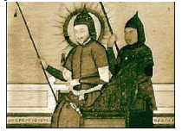
Amir Timur (1336-1405) the world-wide statesman and commander. He was
the founder of a great empire with Samarkand as the capital. It included Maverannahr, Khorazm, the regions located round the Caspian Sea, the territory of present-day Afghanistan, some parts of India, Iraq, Iran, Syria, Caucasus and West Asia. He revived the world’s transcontinental trade route – the Great Silk Road across Maverannahr. Historians note two big services involuntarily rendered to the European
people by the talented commander Amir Timur. First of al, he rendered indirect
assistance to Russia, so that they could put an end to the Tatar-Mongolian invasion.
In 1395, he defeated the troops of the Golden Horde in Terek and devastated its
capital city of Bayazid, the Sultan of the Ottoman empire, and having taken Bayazid
prisoner, he delayed the invasion of Constantinople by the Turks for about 50 years.
He wrote a book entited “Timur Tuzuklari” (“Timur’s codes”), the code of laws n
state governing. Its historical importance lies in fact , that for hundred years’ rule of
his generation, the Timurids almost complete peace and stability were preserved in
the country. It served as an important factor for the development of science, culture,
art and economics.
Mirza Muhammad Taraghay ibn Shahrukh ibn Timur

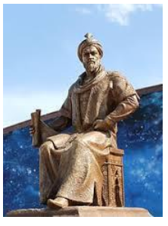
Life: 22 March 1394, Sultaniyeh - 27 October 1449, Samarkand
Astronomer, mathematician, geographer, historian
Mirza Ulugh Beg was born in 1394 in the city of Sultaniyeh (currently Iran) during his grandfather’s (Amir Temur’s) five-year campaign. His father was Amir
Temur’s younger son Shohruh Mirza (1377-1447). The real name of Mirza Ulugh Beg named after Amir Temur’s father was Muhammad Taraghay. As a child he demonstrated a logical mind and sharp brain, for which his grandfather called him
Ulugh Beg (Great Bey – translation from Turkic). It was under this name that he became known in history and fully justified the expectations of his grandfather.
Like most of the Timurids, he was brought up at the court of Amir Temur. His teachers were reknown scientists and writers of the time. It is not accidental that he became not only an outstanding scientist, but also a connoisseur of poetry like his
brothers Ibrahim Sultan and Boysunkur Mirzo.
In 1405 Amir Temur died and following the failure of his grandson Khalil
Sultan in 1409, the throne passed to Shahrukh. The same year, Ulugh Beg was declared governor of Transoxiana (part of Central Asia to the east of the Amudarya
River) with the capital in Samarkand. Shahrukh ruled from Herat and proved himself an outstanding statesman. In this complex political environment, he was not only capable of keeping together the empire created by Amir Temur for almost 40 years, but together with his son Ulugh Beg he secured peace and prosperity in the country.
Along with public affairs, Mirzo Ulugh Beg actively engaged in development of Transoxiana, built higher educational institutions (madrasahs) in Samarkand, Bukhara, Gijduvan and Karman. Keeping the tradition of his grandfather, he invited to Samarkand famous scientists, astronomers and mathematicians of the Islamic world. During his reign, Samarkand became one of the world centers of science.
Main scientific works
Ulugh Beg’s main area of interest in science was astronomy. In 1428 the construction of the Ulugh Beg observatory was completed. Its main mechanism was
the quadrant with a radius of 40 meters, the only one of its kind in the world at the
time. Ulugh Beg’s associates included prominent astronomers such as Qadi Zada alRumi, Ghiyath al-Din al-Kashi, and Ali Qushji. Ulugh Beg’s main work in astronomy, Ziji Jadidi Guragani (New astronomical tables of Guragana) was in Persian and consisted mainly of the tables of coordinates
of stars. The compilation of 1018 stars with high precision of spheric coordinates made hime famous initially in the Muslim world, and later (starting from the mid-
17th century) in Europe and the whole world.
Contribution to world scientific heritage
First of all, his contribution to the world scientific heritage includes the catalogue of 1018 stars. The first star catalogue was compiled in the 2nd century B.C. by the ancient Greek astronomer, Hipparchus. Later astronomers introduced amendments to Hipparchus’ catalogue without performing original observations. By the beginning of the 15th century discrepancies between the actual position of the stars in the sky and their coordinates became significant, and Ulugh Beg decided to conduct his own measurements of the coordinates of stars. Thus, his table became the first catalogue after Hipparchus (i.e. 16 centuries later!) that was obtained on the basis of original astronomical measurements. This is the enduring scientific value Ulugh Beg’s Zij.
Contribution to mathematics
The core text of Ulugh Beg’s main work “New astronomical tables of Guragana” begins with trigonometric tables of very high accuracy. The table of sines is compiled with an increment of one minute, the table of tangents – in the range of 1- 45 degrees with an increment of one minute, in the range of 45-90 degrees – with an increment of 5 minutes. The values are given to Quint 60-ary number system, which gives 7 to 12 correct digits in terms of the decimal system, i.e. the tables are compiled with the precision to 10–7–10–12. In order to find the value of sin1° with great precision, Ulugh Beg, together with his colleagues developed a method of successive approximations , as set forth in
his treatise “On the computation of the sine of one degree.”
In order to formulate the astronomical tables, which required the calculation of
trigonometric functions and the coordinates of the stars with the abovementioned
accuracy in a very large quantity, Ulugh Beg set up a research center, which became a prototype for the modern data centers.
International recognition
Ulugh Beg’s name is a symbol of selfless service in the name of science. In the
mid-17th century a reknown Polish astronomer Hevelius included Ulugh Beg’s catalogue in his Astronomy: Beginning. He supplied his work with two illustrations,
in which Ulugh Beg is pictured along with prominent astronomers of the world of
different times. These illustrations are included in textbooks on astronomy and
treatises on the history of science. They have become the invaluable relics commemorating the astronomical school of Ulugh Beg. His name is commemorated
in the name of a crater on the Moon (17th century). One of the minor planets of the
solar system, discovered in 1977 and registered by the Harvard Center under the registry number of 2439, was named after him.
According to the decrees of the President of Uzbekistan Islam Karimov National University of Uzbekistan and the Astronomical Institute of the Academy of Sciences of the Republic of Uzbekistan are named after Ulugh Beg. In 2004, during the official visit of the President of Uzbekistan to Latvia a monument of Mirza Ulugh Beg was officially opened in Riga.

Alisher Navoi

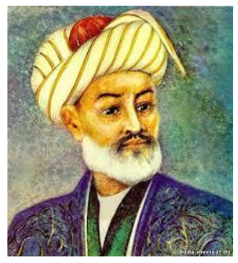
Alisher Navoi (1441-1501), one of the greatest poets of the Medieval East, the author of many lyrical poems, gazelles, prose work, scientific treatises, the founder of Uzbek literature and the statesman, humanist, the patron of scientists, painters and
craftsmen. For more than five centuries the people of the world have enjoyed reading his book, singing his songs and studying his work. Alisher Navoi was born on 9 February 1441 and spent most part of his life in the town of Herat, located in Horasan. From 10-12 years old he began to write verses.
During the life A.Navoi has visited many countries of the East, and got acquainted with many outstanding oriental people. Develop his poetic mastership. In 1464-65 his admirers made his first collected verses (divan).
In 1472 A.Navoi was appointed a vizier (minister) in the court of Sultan Husain Mirzo Boiqaro, the governor of Horasan. A.Navoi actively participated in political life of his country. By his order, hospitals, madrasassah and bridges were created. Since 1488 begun a new epoch in the life of Navoi, he spent more time writing. In 1490-1501 Navoi wrote his main Lyric, public, philosophic and scientific works. In 1483-85 he wrote "Hamsa", the work consisted of 5 separate poems: "Hairat alabrar" -"confusion of righteous", "Farhad va Shirin" -"Farhad and Shirin", "Laili va
Majnun", "Sabai saiyar" - " Seven planets", "Saddi Iskandari" - "the wall of Iskandar". "Hamsa" - is the first work in that genre ever written in Turkic language. Navoi tried to prove that it is possible to create such work in Chagatai (old uzbek) language, which can stand on the same level with works written in Persian language. And in fact he did it. Navoi tried himself in all popular genres of literature of the time and shows that he has his own voice and style.
Alisher Navoi died on 3 January, 1501, when he was 60 years old. Alisher Navoi exerted an enormous influence on the development of Uzbek and other Turkish-speaking literatures. The poems of Alisher Navoi have been translated to many languages of the world. His manuscripts are being preserved in the largest libraries of the world (France, Great Britain, USA, Russia, Turkey, Iran and etc).
The national park named after Alisher Navoi with his monument was created in
the center of Tashkent – capital of Uzbekistan. The city and one of the 12 provinces in Uzbekistan were named after Alisher Navoi, as well as National Library, Theater of Opera and Ballet, Metro station in Tashkent, schools and colleges. There are a lot of monuments of Alisher Navoi that were constructed in foreign countries: in Moscow, Russia in 2002 and at Soka University, Japan in 2004.
Kamoliddin Bekhzod (1455-1535) is world renowned miniature-painter. In Europe he was named as “Rafaello of the East”. His creative activity prospered under
the patronage of Timur’s great-grandson Sultan Husain Bayqaro and the poet Alisher
Navoi, who held a high state post. The Art Academy of Uzbekistan is named in honor
of Bekhzod.

Zahiriddin Muhammad Bobur
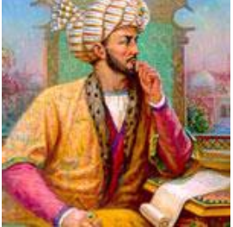
Zahiriddin Muhammad Bobur was born on February 14, 1483, in the city of Andijan in present-day Uzbekistan. He was the eldest son of Omar Sheikh, ruler of
the Ferghana Valley, and the fifth generation of Amir Temur. In 1494 when Bobur
was only 12 years old, he became a ruler. In 1503 – 1504 he conquered Afghanistan. During 1519 – 1525s he tried to conquer India five times. He became the founder of
Bobur`s Empire which lasted more than three centuries (1526 - 1858). He died in 1530, December 26, in Agra. His grave was in Agra but then it was brought to Kabul.
He gathered his lyric testament in 1519 in Kabul into “Kabul Devonu”, and in 528 –1529 in “Hind Devoni”.
There is the information that he created the completed devon. The general amount of his poems is more than 400. 119 of them are written in such as style that is
called “gazal” and 231 of them are “ruboi”. “Boburnoma” was translated into Farsiy/Persian in 1586, into Dunish in 1705 by Vitsen, into English in 1826 by J. Layden and V.Erskin, into French in 1871 by P. de Kurtail, into Turkish in the XX th century by Rashit Rahmat and into Russian by Michail Salye. During 1826 – 1985 “Boburname” was translated four times into English (1826, 1905, 1921, 1922) three times into French (1878, 1980, 1985) and only once into German. Among them there are such novels “Boburhan”, which was written by Flora Ann Stealning (Paris, 1940), “Bobur” by Fernand Grenardning (Paris, 1930), “Bobur-Tiger” by Garold Lamb (New York, 1961), “Bobur and his ancestors or Great Moguls” (New York, 1980) by Vamber Gaskoin. The Indian Munil`al wrote 6 novels about Boburids. In Uzbek Literature such writers as Qodirov P., Bayqobilov B., Sultonov H., devoted their novels, and short stories and “doston” to Bobur.
Russian and West European scientists such as Veselovskiy, Ilminskiy, Erskin,
Eduard Holden, and Elfiniston appreciated “Boburnoma”. Javaharlal Neru wrote in
his book “The discovering of India” about Bobur and Bobur`s generation influence
on development of India and the world`s civilization. Zohidov V., Azimjonova S., Shamsiyev P., Hasanov S. wrote their books about the creative work of Bobur. During the last years the scientists of National University of Uzbekistan did their investigations on the style of Bobur`s lyric poetry according to his work “Mubayyin” Bobur`s “Mubayyin-l-zakot” gives us information on the tax work of 1521. And his work “Muxtasar”, which was written in 1523 – 1525, is about “aruz”. These two works have been kept till today. Bobur was also engaged in translation. He translated Hoja Ahror`s work “Volidiya” from Persian/Farsi into Uzbek. There is also the information that Bobur wrote such books as “Harb ishi” (Military Work) and “Musiqa ilmi” (The knowledge of Music), but they were not found.

LECTURE 5. MONGOL INVASION AND THE FIGHT AGAINST
OPPRESSION

INTRODUCTION
The Mongol invasions of Central Asia were the greatest catastrophe in the history of Islamic civilization, laying waste to the global centre of intellectual achievement during the 11th to 13th centuries. The classical Islamic civilization of
the dawlatayn (Umayyad and Abbasid dynasties) had continued in one form or
another into the early 12th century, supporting the famous blossoming of culture and
science which gave birth to the modern world during the European Renaissance.
The region of Central Asia is located in the meeting place of Europe and Asia,
extending from the countries of the Eastern Mediterranean to China, between Russia
to the north and Iran, Afghanistan and India in the south. The region consists of the
modern republics of Uzbekistan, Kazakhstan, Tajikistan, Turkmenistan and Kyrgyzstan. Historically it has always been populated by sedentary cultivators and
Turkic nomads. Following its annexation by Cyrus the Great (580-529 BCE) during
the Achaemenid Empire (648-330 BCE), the region was successively controlled by
the Saka nomads and Hunnic invaders before becoming part of the Indo-Buddhist
Kushan Empire. Ardashir I, the founder of the Sassanid Empire (226-650 CE),
captured the region c. 227. The Sassanids’ frontiers were persistently threatened by
the Huns until Khusrau Anushirvan (531-579 CE) definitively crushed them in 559 in
alliance with western Turks.
The Muslims initially encountered Transoxiana in pursuit of the fleeing
Sassanid authorities, including Yezdigird (632-651), as the latter attempted to muster
a counter offensive in collaboration with regional and Chinese forces. Central Asia
subsequently became an economically important zone of the Umayyad Empire (661-
750). Large-scale conversion made it central in Arab-Islamic intellectual and political
life, but the rapacious taxation policies of the Umayyads led to the region promoting
the Abbasid revolution in 750. Under the Abbasid dynasty (750-1258) the region was
increasingly independent following the policy of provincial autonomy accelerated by
Harun al-Rashid, paving the way for semi-independent Muslim dynasties including
the Takhirids (821-873), the Saffarids (861-1003) and the Samanids (874-999).
Classical Islamic culture, including the core Islamic science of hadith (traditions of
the Prophet Muhammad, upon which Sunni jurisprudence is based) as well as mathematical and medicinal learning, is virtually synonymous with Central Asia. It is
unclear how exactly the region came to witness large-scale conversion; fragmentary
accounts of the ceremonial burning of the native idols in Samarqand by the Umayyad
general Qutaybah bin Muslim hardly suffice to explain the remarkable intellectual
contribution of the inhabitants to Islamic civilization, but it can be inferred that astute
cultural adaptations, such as allowing the Qur'an to be recited in Persian translation in
Bukhara and Samarqand, enabled the common people (and more importantly the
Persian-speaking intelligentsia) to understand and engage with the Islamic message.
This process was fundamentally facilitated by the Abbasid concession of semiautonomy and the cultural patronage of the Samanid governors.
The region was also military important, both in internal affairs (e.g. AlMa’mun seized the Caliphate with armies from Khorasan in 813) and as a buffer zone between the nomadic tribes of Inner Asia and the sedentary Islamic civilization to the south. In the latter regard it functioned as a conduit for the absorption of restive Turkic tribes, incorporating them into the framework of Islamic governance in the local periphery (e.g. the Ghaznavids and Khwarezmids) and in the Iraqi centre (e.g. Al-Mu’tasim [r. 833-842] recruited Turks to his central army, consolidating Abbasid rule in Iraq and leading to an urban boom, such as the development of Samarra as a garrison town for the Turkish soldiers). As a result, Islam gained strong support among the Turkish tribes, who became more integrated into sedentary civilization for the first time.
Origin of the Mongols
Before discussing the Mongol mayhem to the Islamic civilization of Central
Asia we should aware about the early history of Mongols and the rise of Chengis
Khan to power. According to Chu Hsi, Tung-kian-kang-mu, the name „Mongol” was
unfamiliar in the world history until the late Tang (619-907) period. Rashiduddin
Fadlullah in Jamiut Tawarikh asserts that Siberia was populated by „Turks” including
the Mongol, Chalair, Tatar, Kirghiz, Kunghurat and Aroulad clans. The Mongol
nation (Shubah-i-Mughul) was considered one among many „Turkish peoples”
(Aqwam-i-Atrak), but later the prowess and grandeur of the Mongols led to all other
Turkish tribes being identified with them and thus being referred to as „Tatars”.
Birth of Temuchin
According to Muslim historians Temuchin was born on the 20th Zilqadah 540/
22 January 1155; some other traditions assert that he was born on 9th Zilhijjah 540/
22 May 1146 in the cycle year of boar or Hog (Tankuz) at the foot of the DeliunBoldak on the bank of the Onon. He was born to Yesugai Bahadur and his wife Oyelun/Yassuka Khatun, from the Borgin clan of Mongols and the Unggirat tribe, respectively. Temuchin was named after the chieftain Temuchin Uka, vanquished by his father.
At the age of nine Temuchin married Bortei, a ten year-old of the Olkhuna tribe in order to find a wife for him. Following the poisoning of his uncle by the Tatars, Temuchin became the heir of the Borgigan clan in 1166-67 CE, at the age of 11. Due to his youth many tribesmen refused to acknowledge him and the clan diminished in relative importance. Rival clans stole their livestock and the Markit tribe kidnapped Bortei for many years; she was recovered during the subsequent campaigns of Chengis in which he unified the Naimans, Markits, Uighurs, Tartars and Keraits by 1206.
THE MONGOL INVASION OF CENTRAL ASIA
The disintegration of Seljuq governance in the 12th century led to a resurgence of the embittered Abbasids (who had been reduced to ceremonial status) and the rise of the local Khwarezmid dynasty in Central Asia. As the latter refused to capitulate to Abbasid authority there was great hostility between the Abbasid Caliph Al-Nasir (1180-1225) and the Khwarazm-Shah Ala-ad-Din Muhamad II, including the former hiring the Kara-Khitai (Turkic nomads) to attack the Khwarazm-Shah and instigating a campaign of political assassination; thus the Muslim east was in disarray and
disunity at the onset of the Mongol encounter with Central Asia.
The Mongol invasions of the early thirteenth century were among the most significant events in world history. The Mongol conquest of Central Asia opened the
way for the advance of the Mongol hordes into the rest of the Muslim world and
Europe, leading to the sack of Baghdad and fundamentally altering the course of
Islamic history. Early expeditions into Eastern Turkestan by the Mongols started as early as
1207, and a punitive action against the Kara-Khitai was the prelude to the all-out Mongol invasion of Central Asia in 1218-1219. Sultan Jalal Al-Din Muhammad, the
Khwarazm-Shah, was by then aware of the turbulence in the Turkic belt to the north,
and he pre-emptively challenged and defeated the small Mongol punitive force against the Kara-Khitai. Subsequent efforts at diplomacy by the Mongols failed to
prevent war, and in the meantime a caravan of merchants from the Mongol Empire was butchered at Otrar on the orders of the Khwarezmid governor. This political
event accelerated the Mongol attack of Central Asia, which proved to be the greatest
nakba then encountered by the Central Asian Muslims. John Andrew Boyle, the
renowned scholar, divided the Mongol invasion and occupation of Central Asia into
three phases: the first phase (1206-1227) concerning Chengis Khan and the conquest
of the Khwarezmid Sultanate; the second of consolidation and growth under Ogedai
(1229-1241); and the third of the Pax Mongolica under Mongke Khan (1251-1259)
and Qubilai Khan (1260-1294). The Mongol invasions are notorious to all Muslims because of the popular misconception that the Mongols signified an irresistible and indomitable power that
was beyond the Muslims‟ capability to challenge. The Mongols themselves anticipated a ruinous and costly campaign, and were surprised by the ease with which
Central Asia fell to their control. It was the demoralization and lack of effective
leadership among the Muslims that forced them to retreat, and the Islamic civilization
later overcame greater odds in the battle of Ayn Jalut in 1260.
It was thus a number of factors that paved the way for the Mongol invasions,
including the absence of a central, unified leadership in the Muslim world, reflected in the demotion of the Abbasids to traditional figureheads who at best could hire mercenaries and conduct assassinations in pursuit of their aims, and increasingly dynamic population movements and expansion by the Turkic tribes of Central Asia. Juvaini attributed the catastrophe to a number of mistakes of the Muslim rulers and elites, as well as the normal Muslims (particularly traders) for their fraud and wickedness of numerous kinds (he begins the narrative of the causes of the invasion
with the attempt by Muslim merchants to swindle Chengis Khan). A general lack of a
civilizational ethos given by Islam and other ideologies in other times and places is
reflected by the widespread alcoholism among the elites cited by Juvaini. This is one
of many examples of references of wine in Persian culture during the autumn of the
Abbasid era, but it should be borne in mind that many literary cases wine is used as a
cultural metaphor reflecting forgetting the troubles of the world. There were certainly
plenty of troubles among the people of Central Asia prior to the Mongol attack
invasion.
Mongol Strength
The chief characteristics comprising the formidable strength of the Mongols
are well recorded. On a fundamental level, it is obvious that the Mongol forces were
not conventionally superior to those they defeated – mainly the Chinese and the
Muslims of Central Asia. Their siege-craft were primitive – their catapults collapsed
at Otrar, which ultimately fell after an extensive siege. The crucial benefit the
Mongols possessed lay in combating superiority of their soldiers, their strategic
advantage and their logistical organisation. We may simply say that the Mongol
armies were “better led, organized, and disciplined than those of their opponents.”
Organization was certainly fundamental, and Juvaini recorded the effectiveness of the
Mongol nerge in the following observations: now war – with its killing, counting of
the slain and sparing of the survivors is after the same fashion, and indeed analogous
in every detail, because all that is left in the neighbourhood of the battle are a few
broken down wretches. The Mongol troops had a strict code of discipline and harsh penalties for
infringements of regulations. The Mongol hordes were divided in units of 10, 100,
1,000, and 10,000 soldiers (known as an arban, jagun, minghan and tümen
respectively; the latter corresponds to a modern regiment). Under this system fighters
from different tribes were united in unified military formations, whose chief strategy
was to “march divided, attack united,” and the strategies used were based on largescale skirmish manoeuvres that helped the Mongols defeat numerically superior but fragmented forces from the Oxus to the Volga.

The Invasion
In addition to their logistical and conventional strength, the most overlooked
feature of the Mongol invasion is their sophisticated use of intelligence. Having perceived the military weakness of the Khwarezmids in the initial skirmish
marshalled by Jebe, whatever perception the Mongols once had of Muslim
invincibility and greatness was gone. Additionally, Chengis was aware of the societal
divisions and weaknesses in the Muslim camp, and the Mongols disseminated
misinformation and subterfuge from the inception of the campaign. Chengis had
Islamic advisors who told him for example that the Khwarazm-Shah was deeply
unpopular, that he could not convincingly inspire a jihad, and that appeals could be
made to his mother to oppose her son. Thus the initial operations of Chengis were
psychological; he proclaimed support for the citizens suffering from the oppression of
the Khwarazm-Shah, and offered his mother the throne if she collaborated.
Additionally, Muslim heralds were typically sent to implore towns and cities to
surrender, as at Otrar and Herat, and Turcomen collaborators who knew the roads of
the region guided the Mongol armies. These local guides were representative of the
snowballing effect of the Mongol army, which immediately recruited experts and
levied troops from the vanquished. Chinese siege engineers were quickly joined by
Uighur and Kara-Khitai troops en route to the Khwarezmid Empire, and thereafter
were joined by the inhabitants of the region itself; with tragic irony, troops levied
from Bukhara were part of the assault on Samarqand.
It is commonly assumed that the Mongols simply overwhelmed Transoxiana and Khurasan by their sheer numbers; this is not true. The Mongols suffered heavy losses in their lengthy siege of Otrar – essentially the doorstep of the region from the Mongols‟ perspective – and they were outnumbered on several occasions. Given the casus belli, the Mongols naturally advanced on Otrar first in September 1219, but were bogged down by the defensive walls and the city only fell after a length siege of six months. However, Chengis simply left a force there (including Chinese siege
engineers and Uighur Muslim allies) and took the rest of his forces in the direction of
Bukhara. The formation of massive armies that subsequently split at geographical
junctures was to form the pattern of Mongol campaigns on a macro-level. In this
sense, although a well-fortified city like Otrar could withstand a siege for months, it
should be recalled that the cities of Central Asia were not conquered one by one, as
several cities and towns were under attack simultaneously. Classical narratives
therefore typically focused on particularly notable engagements – as at Otrar and Herat – or on key cities, such as Bukhara and Samarqand.

THE FIGHT AGAINST OPPRESSION
It would be unfair to state that the Khwarazm Shah had not prepared for war;
Juvaini referred to the perception that he had “passed a lifetime in Holy War”, and he
had engaged in arduous campaigns against the Kara-Khitai among others whom he
considered to be Turkic barbarians menacing the Islamic lands. However, the long-term neglect of defence in the region, originating in the trade-loving inhabitants’
dislike of taxes (as when they compelled the Samanids to allow mighty defensive
structures to fall into disrepair), meant that the region was not on a footing for a
serious war. Nevertheless, the Shah’s miscalculation was to presume that he could
shelter in mighty citadels while the savage Mongol hordes (whom he viewed with
contempt, as revealed in his missive to Jebe) would swarm over the lands of the
Khwarezmid Empire, ineffectually burning some crops and villages, then depart due
to lack of supplies; in short, it can be inferred from his actions that the Shah presumed that he and his people could weather the storm behind their walls. He failed to take into account two key features of the Mongol military machine: their advanced system of hunting and foraging (explored above) and travelling with livestock, which meant that their nomadic society was continually producing the resources it needed (meaning that the Mongols had the advantage in lengthy sieges); and the incorporation of subjugated peoples, the most important of whom were the Chinese
siege engineers and peripheral Turkic (and often Muslim) collaborators, such as the
Uighurs and Kara-Khitai, drafted into Mongol military service. The former could
reduce the fortresses with gunpowder and mining techniques, while the latter
provided intelligence about the inhabitants of the region and were probably involved
in the administration of the region from the initial invasion itself (i.e. as translators
and commissariat officials). This explains the abject failure of the Khwarazm Shah’s dispersal and
retrenchment strategy in general, as criticized by his son. As for the heart of the
Khwarezmid Empire and its armies, Samarqand, to which Chengis turned after the
desolation of Bukhara, was arriving there in March 1220. Chengis guaranteed 50,000
scholars and nobles protection if they defected, which many did. Samarqand fell after
a siege of only 10 days; at some point the Shah fled and urged others to flee. He
himself went to Nishapur to lead a life of dissipation (as narrated by Juvaini), but his
son Jalal Al-Din went south and continued warring against the Mongols. The fall of
Samarqand marked the de facto end of the Khwarezmid Empire and signalled the
complete victory of the Mongols over the Muslims of Central Asia, thus this particular Mongol victory was very important. As for 50,000 scholars, nobles and
other defectors who joined the Mongols, their grievances against the Khwarazm Shah
are well known (as explored previously), thus it could be argued that it was reasonable for them not to wish to die in a last stand defending the greatest
stronghold of the Islamic lands of Central Asia. The pattern was replicated throughout the conquest. When Chengis marched on Balkh in 1221, the scholars and nobles of that prosperous city came out to present the Khan with gifts in the hope of being spared. There is disagreement as to the fate of
the collaborators of Balkh, as Juvaini maintained that the inhabitants were ruthlessly
slaughtered, while Ibn Al-Athir believed the Mongols spared them; it was described
shortly afterwards as a ghost town. Two elements of the Khwarezmid Empire can be cited as examples of Muslim resistance to the Mongols: the city of Herat, and the person of Jalal Al-Din and his
followers. The initial Mongol emissary to Herat was killed in contempt, and after the
Mongols conquered the city and departed, leaving a malik and political agents; the
inhabitants later killed both, refusing to be subdued. Chengis later sent a punitive
expedition of 80,000 men to slaughter the people of the city, but a rugged band of
survivors still refused to submit to the Mongols and conducted a guerrilla war against
them. At times they were so destitute they were reported to resort to cannibalism, but
otherwise they were reported to wear silk and live on sugar, the booty from raiding
the Chinese caravans. As for Jalal Al-Din, after his father’s death in 1220 (hiding on
an island in the Caspian Sea), he adopted the Turkic title of Sultan rather than the
Persian “Shah,” and rallied remaining Khwarezmid troops (presumably Turks,
perhaps with some Tajiks and Perso-Sogdians) and recruited new ones in the
mountains of the Hindu Kush. With a coalition including Afghans and Pashtun
tribesmen, Jalal Al-Din inflicted the first defeat on Chengis Khan‟s armies at the
Battle of Parwan in 1221. The enraged Great Khan then pursued the exhausted
Khwarezmid forces to the Indus, where they fell upon the Muslim evacuation and
destroyed the army. Jalal Al-Din himself famously leapt into the Indus, astonishing
the Mongols, and spent the rest of his life in warfare against the Mongols; he was
certainly the most persevering, and perhaps the bravest man of the century.
MAIN CONCLUSION
The reasons for the Mongol invasion can be reduced to a single cause: Muslim weakness. Of course this umbrella term covers an array of factors, but it should be
stressed that it does not refer to the material weakness of Muslim civilization and
arms in comparison to the Mongols; rather this is one aspect of the essence of the
phenomenon, the failure of the Muslim community in the centuries preceding the
invasion, and immediately prior to it, to form a unified and constructive state.
Mongol propaganda was so successful that its messages endure to the present day,
and fundamentally the psychological impact of the Mongol invasion was the decisive
component in their victory (rather than material or military superiority, which were
important but not sufficient in themselves to inflict such a wholesale humiliation on
Central Asian civilization).
The disintegration of the Seljuqs left a vacuum and an absence of effective
leadership for the Muslim East as a whole. Disunity between rival dynasties made
this prosperous region ripe for invasion by the Mongols, fortified by Chinese military
technology and psychological operations tailored to the Muslims; the Mongol
„hordes‟ were astonishingly sophisticated in their use of advanced weaponry, siege
tactics, logistical strategy and intelligence. Conversely the haughty Muslim elites
fundamentally miscalculated the advantages of their own material strength and the
abilities of the Mongols. Furthermore they had removed any credible basis upon
which they could appeal to Islamic sentiments for an Islamic jihad against the
Mongol invaders.
It is alleged that the Mongols were dismissed by the Muslim elite in Central
Asia, particularly the Khwarazm Shah and his court, as a barbaric horde that posed no
significant threat to them. It finds that the sophisticated system of Mongol
propaganda was so effective that the myths it propagated are widely believed to this
day, with emotive imagery such as the Tigris running red with the blood of the
Muslims and black with the ink of their scholars, as Chengis Khan and his successors
unleashed an unstoppable force of nature to destroy civilization. Conversely, some
studies conclude that the causes of the Mongol invasions were more related to the
weaknesses and incompetence of the Central Asian civilization than to the inherent
strength of the Mongol invaders, and furthermore that the Islamic civilization was
already waning before their arrival in Otrar.
It can be concluded that the Mongol invasions, although initially catastrophic
for Central Asia, as with most invasions, ultimately led to the integration of the
Mongols into Islamic civilization (like the Ghaznavids and Seljuqs before them) and
gave a new impetus to life and culture in the region later expressed in the Timurids
and Mughals.

LECTURE 6. AMIR TIMUR AND THE TIMURID PERIOD

GREAT AMIR TEMUR

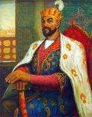
Amir Temur was born (1336-1405) in the village of Khodja-Ilgar, near Shakhrisabz. He was the son of Amir Taragay, who was from Barlos tribes.
Timur, also spelled Timour, byname TimurLenk or Timurlenk (Turkish: “Timur the Lame”), English Tamerlane or Tamburlaine, (born 1336, Kesh, near Samarkand, Transoxania (now in Uzbekistan) - died February 19, 1405, Otrar, near Chimkent (now Shymkent, Kazakhstan), Turkic conqueror, chiefly remembered for the barbarity of his conquests from India and Russia to the Mediterranean Sea and for the cultural achievements of his dynasty.
Timur was a member of the TurkicizedBarlas tribe, a Mongol subgroup that had settled in Transoxania (now roughly corresponding to Uzbekistan) after taking part in Genghis Khan’s son Chagatai’s campaigns in that region. Timur thus grew up in what was known as the Chagatai khanate. After the death in 1357 of Transoxania’s current ruler, Amir Kazgan, Timur declared his fealty to the khan of nearby Kashgar, Tughluq Temür, who had overrun Transoxania’s chief city, Samarkand, in 1361. Tughluq Temür appointed his son Ilyas Khoja as governor of Transoxania, with Timur as his minister. But shortly afterward Timur fled and rejoined his brother-in- law Amir Husayn, the grandson of Amir Kazgan. They defeated Ilyas Khoja (1364) and set out to conquer Transoxania, achieving firm possession of the region around 1366. About 1370 Timur turned against Husayn, besieged him in Balkh, and, after Husayn’s assassination, proclaimed himself at Samarkand sovereign of the Chagatai line of khans and restorer of the Mongol empire.
For the next 10 years Timur fought against the khans of Jatah (eastern Turkistan) and Khwārezm, finally occupying Kashgar in 1380. He gave armed support to Tokhtamysh, who was the Mongol khan of Crimea and a refugee at his court, against the Russians (who had risen against the khan of the Golden Horde, Mamai); and his troops occupied Moscow and defeated the Lithuanians near Poltava.
In 1383 Timur began his conquests in Persia with the capture of Herāt. The Persian political and economic situation was extremely precarious. The signs of recovery visible under the later Mongol rulers known as the Il-Khanid dynasty had been followed by a setback after the death of the last Il-Khanid, Abu Said (1335). The vacuum of power was filled by rival dynasties, torn by internal dissensions and unable to put up joint or effective resistance. Khorāsān and all eastern Persia fell to him in 1383–85; Fars, Iraq, Azerbaijan, Armenia, Mesopotamia, and Georgia all fell between 1386 and 1394. In the intervals, he was engaged with Tokhtamysh, then khan of the Golden Horde, whose forces invaded Azerbaijan in 1385 and Transoxania in 1388, defeating Timur’s generals. In 1391 Timur pursued Tokhtamysh into the Russian steppes and defeated and dethroned him; but Tokhtamysh raised a new army and invaded the Caucasus in 1395. After his final defeat on the Kur River, Tokhtamysh gave up the struggle; Timur occupied Moscow for a year. The revolts that broke out all over Persia while Timur was away on these campaigns were repressed with ruthless vigour; whole cities were destroyed, their populations massacred, and towers built of their skulls.
In 1398 Timur invaded India on the pretext that the Muslim sultans of Delhi were showing excessive tolerance to their Hindu subjects. He crossed the Indus River on September 24 and, leaving a trail of carnage, marched on Delhi. The army of the Delhi sultan Mahmud Tughluq was destroyed at Panipat on December 17, and Delhi was reduced to a mass of ruins, from which it took more than a century to emerge. By April 1399 Timur was back in his own capital. An immense quantity of spoil was conveyed away; according to Ruy González de Clavijo, 90 captured elephants were employed to carry stones from quarries to erect a mosque at Samarkand.
Timur set out before the end of 1399 on his last great expedition, in order to punish the Mamlūk sultan of Egypt and the Ottoman sultan Bayezid I for their seizures of certain of his territories. After restoring his control over Azerbaijan, he marched on Syria; Aleppo was stormed and sacked, the Mamlūk army defeated, and Damascus occupied (1401), the deportation of its artisans to Samarkand being a fatal blow to its prosperity. In 1401 Baghdad was also taken by storm, 20,000 of its citizens were massacred, and all its monuments were destroyed. After wintering in Georgia, Timur invaded Anatolia, destroyed Bayezid’s army near Ankara (July 20, 1402), and captured Smyrna from the Knights of Rhodes. Having received offers of submission from the sultan of Egypt and from John VII (then coemperor of the Byzantine Empire with Manuel II Palaeologus), Timur returned to Samarkand (1404) and prepared for an expedition to China. He set out at the end of December, fell ill at Otrar on the Syr Darya west of Chimkent, and died in February 1405. His body was embalmed, laid in an ebony coffin, and sent to Samarkand, where it was buried in the sumptuous tomb called Gūr-e Amīr. Before his death he had divided his territories among his two surviving sons and his grandsons, and, after years of internecine struggles, the lands were reunited by his youngest son, ShāhRokh.

LEGACY
Timur began his rise as leader of a small nomad band and by guile and force of arms established dominion over the lands between the Oxus and Jaxartes rivers (Transoxania) by the 1360s. He then, for three decades, led his mounted archers to subdue each state from Mongolia to the Mediterranean. He was the last of the mighty conquerors of Central Asia to achieve such military successes as leader of the nomad warrior lords, ruling both agricultural and pastoral peoples on an imperial scale. The poverty, bloodshed, and desolation caused by his campaigns gave rise to many legends, which in turn inspired such works as Christopher Marlowe’sTamburlaine the Great.
The name TimurLenk signified Timur the Lame, a title of contempt used by his Persian enemies, which became Tamburlaine, or Tamerlane, in Europe. Timur was heir to a political, economic, and cultural heritage rooted in the pastoral peoples and nomad traditions of Central Asia. He and his compatriots cultivated the military arts and discipline of Genghis Khan and, as mounted archers and swordsmen, scorned the settled peasants. Timur never took up a permanent abode. He personally led his almost constantly campaigning forces, enduring extremes of desert heat and lacerating cold. When not campaigning he moved with his army according to season and grazing facilities. His court traveled with him, including his household of one or more of his nine wives and concubines. He strove to make his capital, Samarkand, the most splendid city in Asia, but when he visited it he stayed only a few days and then moved back to the pavilions of his encampment in the plains beyond the city.
Timur was, above all, master of the military techniques developed by Genghis Khan, using every weapon in the military and diplomatic armory of the day. He never missed an opportunity to exploit the weakness (political, economic, or military) of the adversary or to use intrigue, treachery, and alliance to serve his purposes. The seeds of victory were sown among the ranks of the enemy by his agents before an engagement. He conducted sophisticated negotiations with both neighbouring and distant powers, which are recorded in diplomatic archives from England to China. In battle, the nomadic tactics of mobility and surprise were his major weapons of attack. Timur’s most lasting memorials are the Timurid architectural monuments of Samarkand, covered in azure, turquoise, gold, and alabaster mosaics; these are dominated by the great cathedral mosque, ruined by an earthquake but still soaring to an immense fragment of dome. His mausoleum, the Gūr-e Amīr, is one of the gems of Islamic art. Within the sepulchre he lies under a huge, broken slab of jade. The tomb was opened in 1941, having remained intact for half a millennium. The Soviet Archaeological Commission found the skeleton of a man who, though lame in both right limbs, must have been of powerful physique and above-average height.

Gur-e Amir (mausoleum of Timur), Samarkand, Uzbekistan
Timur’s sons and grandsons fought over the succession when the Chinese expedition disbanded, but his dynasty (Timurid dynasty) survived in Central Asia for a century in spite of fratricidal strife. Samarkand became a centre of scholarship and science. It was here that Ulūgh Beg, his grandson, set up an observatory and drew up the astronomical tables that were later used by the English royal astronomer in the 17th century. During the Timurid renaissance of the 15th century, Herāt, southeast of Samarkand, became the home of the brilliant school of Persian miniaturists. At the beginning of the 16th century, when the dynasty ended in Central Asia, his descendant Bābur established himself in Kabul and then conquered Delhi, to found the Muslim line of Indian emperors known as the Great Mughals.

CONTRIBUTION

Amir Temur made an outstanding contribution to the national state system, education and culture, and general development of his state. He promoted the construction of monumental historic buildings, especially in Samarkand. Some of them can be seen today. The inscription on the portal of Timur's Palace Ak-Sarai in Shakhrisabz, reads "If you doubt our might, look at our buildings". The impressiveness of the architecture was aimed at the demonstration of the greatness of the empire. All possible means and every effort were exerted to construct these magnificent buildings. A vast range of building materials from neighboring regions, famous architects, suppliers, and a great number of workers were brought to work. Different specialists were taken from occupied lands.
During the entire 14th century there were many experienced architects and artists gathered in Central Asia, most of them particularly in Samarkand. Skilled craftsmen from Iran, Azerbaijan, Khorezm, and India were invited without hesitation. Both foreign and local masters realized the great importance of the projects. They represented different arts and crafts which were mastered by others. They adopted each other’s styles, which combined into a completely original type of design.
Amir Temur's political status required him to have friendly relations with the leaders of many religions.
Such relations were established by constructing mosques, madrassahs, and especially mausoleums. Many of them, for example the Juma Mosque, Gur-Emir Mausoleum and Shahi-Zinda Architectural Ensemble, all in Samarkand, and the Dorus-Siadat Mausoleum in Shakhrisabz, Chashma-Ayub Mausoleum in Bukhara, and Hadji-Ahmad Jassaviy Mausoleum in Turkestan, have stood the test of time and can be seen today.

TIMURID DYNASTY
Timurid dynasty, (fl. 15th–16th century CE), dynasty of Turkic-Mongol origin descended from the conqueror Timur (Tamerlane). The period of Timurid rule was renowned for its brilliant revival of artistic and intellectual life in Iran and Central Asia. After Timur’s death (1405), his conquests were divided between two of his sons: Mīrānshāh (died 1407) received Iraq, Azerbaijan, Moghān, Shīrvān, and Georgia, while ShāhRokh was left with Khorāsān.
Between 1406 and 1417 ShāhRokh extended his holdings to include those of Mīrānshāh as well as Māzandarān, Sīstān, Transoxania, Fars, and Kermān, thus reuniting Timur’sempire, except for Syria and Khuzistan. ShāhRokh also retained a nominal suzerainty over China and India. During ShāhRokh’s reign (1405–47), economic prosperity was restored and much of the damage wrought by Timur’s campaigns was repaired. Trading and artistic communities were brought into the capital city of Herāt, where a library was founded, and the capital became the centre of a renewed and artistically brilliant Persian culture.
In the realm of architecture, the Timurids drew on and developed many Seljuq traditions. Turquoise and blue tiles forming intricate linear and geometric patterns decorated the facades of buildings. Sometimes the interior was decorated similarly, with painting and stucco relief further enriching the effect. The Gūr-e Amīr, Timur’s mausoleum in Samarkand, is the most notable example. The tiled dome, rising above a polygonal chamber, is fluted and slightly bulbous. Of the Ak-Saray, Timur’s palace built between 1390 and 1405 at Kesh, only the monumental gates remain, again with coloured-tile decoration.
The schools of miniature painting at Shiraz, Tabriz, and Herāt flourished under the Timurids. Among the artists gathered at Herāt was Behzād (died c. 1525), whose dramatic, intense style was unequaled in Persian manuscript illustration. The Baysunqur workshops practiced leatherwork, bookbinding, calligraphy, and wood and jade carving. In metalwork, however, Timurid artistry never equaled that of earlier Iraqi schools.
Internal rivalry eroded Timurid solidarity soon after ShāhRokh’s death. The years 1449–69 were marked by a constant struggle between the TimuridAbūSaʿīd and the Uzbek confederations of the Kara Koyunlu (“Black Sheep”) and AkKoyunlu (“White Sheep”). When AbūSaʿīd was killed in 1469, the AkKoyunlu ruled unopposed in the west, while the Timurids receded to Khorāsān. Nevertheless the arts, particularly literature, historiography, and miniature painting, continued to flourish; the court of the last great Timurid, ḤusaynBāyqarā (1478–1506) supported such luminaries as the poet Jāmī, the painters Behzād and ShāhMuẓaffar, and the historians Mīrkhwānd and Khwāndamīr. The vizier himself, MīrʿAlīShīr, established Chagatai Turkish literature and fostered a revival in Persian literature.
Although the last Timurid of Herāt, Badīʿ al-Zamān, finally fell to the armies of the Uzbek MuḥammadShaybānī in 1507, the Timurid ruler of Fergana, Ẓahīr al-
DīnBābur, survived the collapse of the dynasty and established the line of Mughal emperors in India in 1526.

SHĀH ROKH
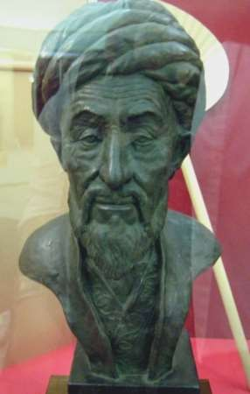
ShāhRokh, also called ShāhRokhMīrzā, Rokh also spelled Rukh, (born Aug. 30, 1377, Samarkand, Timurid empire (now in Uzbekistan) - died March 12, 1447, Fishawand, Timurid Iran), Timurid ruler of much of Central Asia, best known as a patron of the arts. ShāhRokh was the fourth son of Timur (Tamerlane), founder of the Timuriddynasty. At Timur’s death in 1405, a struggle for control of his empire broke out among members of his family. ShāhRokh gained control of most of the empire, including Iran and Turkistan, and held it until his death. The only major areas of Timur’s empire outside of ShāhRokh’s control were Syria and Khūzestān (now in southwestern Iran).
ShāhRokh’s patronage of the arts was centred on his capital at Herāt in Khorāsān (now in western Afghanistan). Particularly important were the library and the school of miniature painting that developed and flourished there. One of his wives, GawharShād, worked with the Persian architect Qavamud-Din in the planning and construction of a series of magnificent public buildings there.
Continuing power struggles among various members of his own family forced ShāhRokh to undertake a number of military campaigns to ensure his power. The settlements he was able to impose were temporary, and intrafamily power struggles eventually destroyed the dynasty.

GHIYĀTHAL-DĪNMUHAMMADKHWĀNDAMĪR

Ghiyāth al-Dīn Muhammad Khwāndamīr, Khwāndamīr also spelled Khondamir, (born c. 1475, Herāt, Khorāsān(now in Afghanistan) - died 1534/37, buried in Delhi, India), Persian historian, considered one of the greatest historians of the Timurid period.
Grandson of the Persian historian Mirkhwānd, Khwāndamīr entered the service of Badīh al-Zamān, the eldest son of the Timurid ruler of Herāt, ḤusaynBāyqarā. Khwāndamīr was an ambassador to the Uzbek ruler Muhammad Shaybānī when the latter captured the city of Herāt in 1507; he also witnessed the Iranian monarch ShāhEsmāīl I take the city and defeat the Uzbek ruler in 1510.
Khwāndamīr then retired temporarily and began writing. Except for a brief period spent with the eldest son of his former patron, Khwāndamīr seems to have settled in Herāt until his departure for India in 1528. Reaching Agra, he entered the service of Bābur, heir to the Timurid tradition and the first of the great Mughal rulers of India, and accompanied him on various missions. After Bābur’s death the historian served his son, Humāyūn. Returning from a march on Gujarat, Khwāndamīr fell ill and died.
A prolific writer, Khwāndamīr’s most outstanding works are Khulāṣat al- akhbār (“The Perfection of the Narratives”), written in 1499–1500 for the Timurid minister and author Mir ʿAlīShīrNavāʾī; Ḥabīb al-siyār (“The Friend of Biographies”), a general history finished in 1524, the most valuable sections of which deal with the reigns of Sultan ḤusaynBāyqarā and ShāhEsmāʿīl I Ṣafavi; the seventh and final volume of the history Rawḍat al-ṣafā (“The Garden of Purity”) of his grandfather, Mirkhwānd; and the Humāyūn-nāmeh (“The Book of Humāyūn”), in which he describes the buildings and institutions of the great Mughal empire.

BATTLE OF DELHI
Battle of Delhi, (17 December 1398). In 1398 the Mongol-Turkish warrior Timur, ruler of Central Asia from his capital at Samarkand, found a pretext to strike south into India. His victory over the sultan of Delhi confirmed the irresistible fighting qualities of his army and the awesome destructiveness that made him a legend of cruelty.
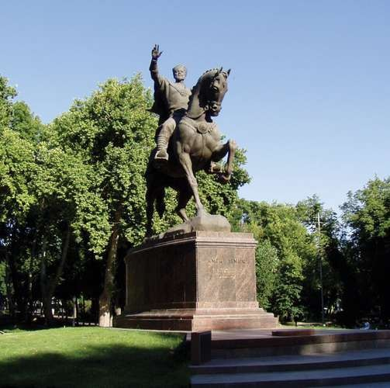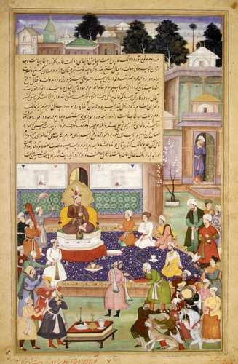

Timur, monument in Tashkent, Uzbekistan
A devout Muslim, Timuralleged that his co-religionist Sultan Nasiruddin Mahmud of Delhi was being too lenient toward his Hindu subjects. On this pretext he marched into the Indian subcontinent in late summer 1398, his tribal steppe horsemen plundering and massacring as they advanced. By the time Timur approached Delhi, his army was so encumbered with loot and captured slaves that military efficiency was imperiled. Timur’s solution was to order his followers to kill all their slaves— possibly around 100,000 people. Thus prepared, the invaders faced Sultan Mahmud’s army outside the walls of Delhi. The sultan had a force of war elephants, creatures with which the steppe warriors were unfamiliar. Timur had his men dig elaborate field fortifications—a system of trenches and ramparts—to block the charge of the pachyderms and give his nervous followers a sense of security.

Timur
An artist's rendering of Timur with his courtiers, 17th century.
The Metropolitan Museum of Art, New York

The course of the battle is hard to piece together from the historical record. Incendiary devices played a part, including catapults that hurled pots of inflammable liquid. By one account, Timur had camels loaded with kindling that was set on fire, releasing them to spread panic among the Indian elephants. The charge of Timur’s horsemen was certainly decisive, reportedly scattering the Indian soldiers "as hungry lions scatter a flock of sheep." Victorious in the field, Timur unleashed his warriors upon Delhi in an orgy of destruction from which the city took a century to recover.
Losses: No reliable figures, although some sources give the Indian death toll as 1,000,000.

ULŪGH BEG
Ulūgh Beg, (born 1394, Solhānīyeh, Timurid Iran—died Oct. 27, 1449, Samarkand, Timuridempire [now in Uzbekistan]), grandson of the Asian conqueror Timur (Tamerlane) and one whose primary interest was in the arts and intellectual matters. Under his brief rule the Timurid dynasty of Iran reached its cultural peak. His father, ShāhRokh, captured the city of Samarkand and gave it to Ulūgh Beg, who made it a centre of Muslim culture. There he wrote poetry and history and studied the Qurhān. His greatest interest was astronomy, and he built an observatory (begun in 1428) at Samarkand. In his observations he discovered a number of errors in the computations of the 2nd-century Alexandrian astronomer Ptolemy, whose figures were still being used.
Ulūgh Beg was a failure in more mundane affairs. On his father’s death in 1447 he was unable to consolidate his power, though he was ShāhRokh’s sole surviving son. Other Timurid princes profited from his lack of action, and he was put to death at the instigation of his son, Abd al-Latīf.

MAIN CONCLUSION
While the Golden Horde was beginning to enter its long decline in the late 14th century, the demise of Chagataid rule in the area between the Amu Darya and Syr Darya was taking place as a result of the rise of Timur. Under Timur’s leadership the Turko-Mongol tribes located in the basins of the two rivers were first united. With the assistance of these tribes he expanded into the neighbouring regions of Khorāsān, Sīstān, Khwārezm, and Mughulistān before embarking upon extensive campaigning in what are now Iran and Iraq, eastern Turkey, and the Caucasus region. In addition, he launched two successful attacks on his erstwhile protégé, Tokhtamysh, ruler of the Golden Horde. In 1398–99 Timur invaded northern India and sacked Delhi, and between 1399 and 1402 he turned westward again to harry the Egyptian Mamlūks in Syria and the Ottoman sultan Bayezid I, whom he captured in battle near Ankara. At the time of his death at Otrar on the Syr Darya in 1405, Timur was leading his forces on an invasion of China.
From his youth he appeared on the political scene as an active politician and military figure. Having become the ruler of Samarkand he built a great army and carried on many annexationist campaigns. Thus he expanded his empire that stretched from the Volga River and the Caucasian ridges in the west to India in the Southwest. But the center of the empire was in Central Asia. Temur wanted to designate his hometown, Shakhrisabz, as his capital, but certain political considerations forced him to leave with Samarkand the loving moniker of "Shining Star of the Orient".
Timur never assumed openly the full attributes of sovereignty, contenting himself with the title of emir while upholding the fictional authority of a series of puppet khans of the line of Chagatai, to whom he claimed kinship by marriage; in consequence he styled himself güregen, meaning “son-in-law” (i.e., of the Chagataid khan). He seems to have lacked the innate administrative capacity or the foresight of Genghis Khan, and after Timur’s death his conquests were disputed among his numerous progeny. In the ensuing struggles his fourth son, ShāhRukh (1407–47), emerged victorious. He abandoned his father’s capital of Samarkand for Herāt in Khorāsān (now in western Afghanistan), where he ruled in great splendour, leaving his son, Ulūgh Beg, as his deputy in the former capital. UlūghBeg’s rule in Samarkand between 1409 and 1447 probably brought a considerable measure of tranquility to the long-troubled region. An enthusiastic astronomer and the builder of a celebrated observatory, Ulūgh Beg ensured that during his lifetime Samarkand would be a major centre of scientific learning, especially in astronomy and mathematics. He was killed on the orders of his son, ʿAbd al-Laṭīf, in 1449.
Throughout the second half of the 15th century, the western part of Central Asia was divided into a number of rival principalities ruled by descendants of Timur, among which Bukhara and Samarkand were the most important. The courts of these rulers witnessed an extraordinary cultural florescence in literature, the arts, and architecture, with Chagatai Turkish, a dialect derived partly from Khakani, the language spoken at the Karakhanid court (and a precursor of modern Uzbek), emerging as a flexible vehicle for sophisticated literary expression. These Timurid epigones, however, were locked in unceasing rivalry with each other and were unable to combine against intruders from beyond their frontiers. By the close of the century, therefore, all the Timurid possessions in Central Asia had passed into the hands of the Uzbeks.

LECTURE 7. DIVISION OF TURKESTAN INTO KHANATES
The Uzbeks
The early history of the Uzbek people (whose rulers were descendants of a
younger brother of Batu, khan of the Golden Horde) is wrapped in obscurity, but by
the mid-15th century they had migrated from their original homeland, east of the Ural
Mountains, southeast toward the lower Syr Darya, whence, under their leader, AbūlKhayr Khan, they began to threaten the Timurids across the river. However, before Abūl-Khayr could undertake a full-scale invasion, he was killed in battle in 1468 by two rebellious kinsmen who, refusing to recognize his assertion of paramountcy, had defected, together with their tribal followers, and placed themselves under the nominal suzerainty of the Chagataid khan of Mughulistān. Their descendants were to become the Kazakh hordes of later centuries.
With the death of Abū Al-Khayr, the fortunes of the Uzbeks temporarily declined, only to be revived under the leadership of his grandson, MuhammadShaybānī, who by 1500 had made himself master of Samarkand as well as of the Syr Darya and Amu Darya basins and was advancing into Khorāsān (Herāt fell to him in 1507) when he was defeated and killed in 1510 by Shah Ismāil Safavi.
He had, however, changed the course of Central Asian history. By the time of his
death, all the lands between the Syr Darya and Amu Darya were in Uzbek hands, and
so they were to remain. Throughout the 16th century, Muhammad Shaybānī’s kinsmen ruled over a powerful and aggressive khanate from Bukhara. They continued
Muhammad Shaybānī’s feud with the Iranian Safavids, articulated along Shīiteversus-Sunni lines, and with the Mughal dynasty in India, whose founder, the Timurid Babur, had been driven out of Central Asia by Shaybānī. In contrast, friendly, if sporadic, ties with the Ottomans were maintained by way of the VolgaDon steppes. Unlike the Ottomans, Safavids, and Mughals, however, the Uzbeks had only limited access to firearms, which placed them at a considerable disadvantage with their rivals.
During Shaybanid rule, and even more under the Ashtarkhanids (also known as
Astrakhanids, Tuquy-Timurids, or Janids) who succeeded them during the 1600s, Central Asia experienced a decline in prosperity compared with the preceding
Timurid period, in part because of a marked reduction in the transcontinental caravan
trade following the opening of new oceanic trade routes. In the 1700s the basins of
the Amu Darya and Syr Darya passed under the control of three Uzbek khanates
claiming legitimacy in their descent from Genghis Khan. These were, from west to
east, the Qungrāts based on Khiva in Khwārezm (1717–1920), the Mangits in Bukhara (1753–1920), and the Mings in Kokand (c. 1710–1876), in the upper valley
of the Syr Darya. During this same period, east of the Pamirs, Kashgaria was torn
apart by the rivalries of Khwājahs and Kyrgyz; in the Semirechye the Kazakhs were
locked in conflict with the Mongol Oirat and Dzungars; while between the Aral and
Caspian seas the Turkmen roamed the northern borders of Iran, enslaving the sedentary peoples there and transporting them to Bukhara to labour in the oases. The
time was ripe for Russian intervention, made easier by the intruders’ possession of
cannon and firearms.

The waning of nomadic military power
From the beginnings of recorded history, pastoral nomadism, practiced on a grandiose scale, was the economic basis of the great Central Asian empires. Once the domestication of the horse was sufficiently advanced to allow for its use in warfare, the superiority of the mounted archer over the foot soldier or the war chariot was never effectively challenged.
When headed by capable leaders, well-trained and disciplined mounted troops
were almost invincible. The sedentary civilizations could not, by their very nature,
put aside for breeding purposes pastures sufficiently large to sustain a cavalry force
that could equal that of the pastoral nomads. Hence the military superiority of the
nomads remained a constant for about 2,000 years of Eurasian history.
At its highest degree of development, Central Asian nomad society constituted
a very sophisticated and highly specialized social and economic structure, advanced
but also highly vulnerable because of its specialization and the lack of diversification
of its economy. Geared almost entirely to the production of war materiel—i.e., the
horse—when not engaged in warfare, it was unable to provide the people with anything but the barest necessities of life. To ensure their very existence, Central
Asian empires had to wage war and obtain through raids or tribute the commodities
they could not produce. When, owing to circumstances such as severe weather
decimating the horse herds or inept leadership, raids against other peoples became
impossible, the typical Central Asian nomad state had to disintegrate to allow its
population to fend for itself and secure the necessities for a subsistence. Hunting and
pastoral nomadism both needed vast expanses to support a thinly scattered population
that did not naturally lend itself to strong, centralized political control. The skill of a
Central Asian leader consisted precisely in the gathering of such dispersed
populations and in providing for them on a level higher than they had been
accustomed to. There was but one way to achieve this: successful raids on other,
preferably richer, peoples. The military machinery was dependent on numbers, which
then precluded self-sufficiency. In case of prolonged military reverses, the nomadic
aggregation of warriors had to disband because it was only in dispersion that they
could be economically autonomous without recourse to war.
In the course of the 15th century, the steppe territory suitable for great horse
herds began to shrink. In the east the Yongle emperor of the Ming led five major
campaigns against the Mongols (1410–24), all successful but none decisive. Yet
when, under the leadership of Esen Taiji (1439–55), the Mongol Oirat pushed as far
as Beijing, they found the city defended by cannon, and they withdrew. In the Middle
East, as noted above, the Ottoman and Safavid gunpowder empires barred the road to
the no-longer-invincible nomad cavalry, and, along the western borders of Central
Asia, the Russians were soon to start on their decisive and irresistible march across
Central Asia to the borders of China, India, and Iran.
The Russian conquests
The most spectacular advance of the Russians into Central Asia carried them
eastward through the forest belt, where the hunting and fishing populations offered little resistance and where the much-coveted furs of Siberia could be found in abundance. Acting on behalf of the Stroganov family of entrepreneurs, in 1578 or
1581 the Cossack Yermak Timofeyevich crossed the Urals and defeated the
Shaybanid prince Kuchum, who alone represented organized political power in
Siberia. The Russian advance from west to east across Siberia, motivated by commercial rather than political considerations, remains unparalleled in history for its rapidity. The native Finno-Ugrians—Samoyed or Tungus hunters accustomed to paying their fur tribute—were little concerned with the nationality of the tax collectors and found it no more unpleasant to deal with the Russians than with Turks or Mongols. Russian penetration was marked by the building of small forts, such as Tobolsk (1587) near the former capital of Kuchum, Tara (1594) on the Irtysh River, and Narym (1596) on the upper Ob River. The Yenisey was reached in 1619, and the
town of Yakutsk on the Lena River was founded in 1632. About 1639 the first small
group of Russians reached the Pacific Ocean in the neighbourhood of present-day
Okhotsk. About 10 years later, Anadyrsk was founded on the shores of the Bering
Sea, and, by the end of the century, the Kamchatka Peninsula was annexed. When
advanced Russian parties reached the Amur River about the mid-17th century, they
entered the Chinese sphere of interest. Although some clashes occurred, restraint on
both sides led to the signing of the treaties of Nerchinsk (1689) and Kyakhta (1727),
which remained in force until 1858. To this day, the border delineated at Kyakhta has
not been altered substantially.
The thorniest question to be dealt with in the early Russo-Chinese negotiations
concerned the Mongols—wedged between the two Great Powers—who, in the course
of the 16th and 17th centuries, reasserted their control over most of the steppe belt. In
the 15th century the western Mongols, or Oirat, had become quite powerful under
Esen Taiji, but, under the strong leadership of Dayan Khan (ruled 1470–1543) and his
grandson Altan Khan (1543–83), the eastern Mongols—more precisely the Khalkha
tribe—gained ascendancy. In 1552 Altan took possession of what was left of
Karakorum, the old Mongol capital. Altan’s reign saw the conversion of a great many
Mongols to the tenets of the Dge-lugs-pa (Yellow Hat) sect of Tibetan Buddhism, a
religion that, until the 1920s, played a major role in Mongol life. The attempts of
Ligdan Khan (1604–34) to unite the various Mongol tribes failed not only because of
internal dissensions but also on account of the rising power of the Manchu, to whom
he was forced to surrender. The active Central Asian policy of China’s Qing dynasty
brought a lasting transformation in the political structure of the region.
More distant from China, the Oirat could pursue a more independent course.
One of their tribes, the Dzungars, under the leadership of Galdan (Dga’-ldan; 1676–
97), created a powerful state that remained a serious menace to China until 1757,
when the Qianlong emperor defeated their last ruler, Amursana, and thus put an end
to the last independent Mongol state prior to the creation, in 1921, of Outer Mongolia
(the Khalkha princes had submitted to the Manchu in 1691).
The treaties of Nerchinsk and Kyakhta established the northern border of the
Chinese zone of influence, which included Mongolia. In the wars against the
Dzungars, the Chinese established their rule over East Turkistan and Dzungaria.
China’s western boundary remained undefined, but it ran farther west than it does in
the present day and included Lake Balkhash and parts of the Kazakh steppe.
Wedged between the Russian and Chinese empires, unable to break through the
stagnant but solid Ottoman and Ṣafavid barriers, the Turkish nomads of the steppe
lying east of the Volga and the Caspian Sea and south of Russian-occupied Siberia
found themselves caught in a trap from which there was no escape. If there is cause
for surprise, it lies in the lateness rather than in the fact of the ultimate Russian
conquest.
West of the Uzbek khanates, between the Aral and Caspian seas, were the nomad Turkmen, who roamed the inhospitable land. The Kazakhs, who during the 17th century divided into three “hordes,” roamed between the Volga and the Irtysh. During the 16th and 17th centuries they fought Oirat and Dzungars but succeeded in holding their own, and in 1771 Ablai, ruler of the “Middle Horde,” located west of Lake Balkhash, was confirmed as ruler by both China and Russia. Yet Russian expansion, motivated by the urge to get closer to the Indian Ocean, forced the Kazakhs to yield. Although some Kazakh leaders, such as the sultan Kinesary, put up spirited resistance (1837–47), the line of the Syr Darya was reached by the Russians toward the middle of the 19th century.
The Uzbek khanate of Kokand was annexed in 1876; those of Khiva and Bukhara became Russian protectorates in 1873 and 1868, respectively. The conquest of the Turkmen in the last quarter of the 19th century defined Russia’s (now Turkmenistan’s) southern frontier with Iran and Afghanistan.
MAIN CONCLUSION
With the beginning of the 16th century a significant political transformation occurred in Central Asia. After governing for more than a century the Timurids were
expelled from Transoxania, Balk, and Khorasan and founded the Mughal state in
northwest India. The Chaghatay khans, the legitimizers of Timurid rule in Central
Asia, were dislodged from eastern Transoxania and established a new state centered
in Kashgar and Yarkand. Khorasan, which had been oriented for over a century
toward Central Asia, was annexed to the new Safavid/Qezelbāš state. In the 16th and
17th centuries Central Asia, including Transoxania, Greater Balk, and Kwārazm,
witnessed a neo-Chingizid (Jochid) political revival, spearheaded by the Arabshahid/Shibanid (Shaibanid) lineage in Kwārazm and the Abulkhairid/Shibanid
and Toqay-Timurid lines in Transoxania and Greater Balk. Though marked by the
restoration of Chingizid khanates, by the competition between the khanates and the
Safavid/Qezelbāš state for control of Khorasan, and by rivalry between the khanates
and the Mughal state in India for influence in Badakšān, in the main political life was
shaped by the neo-Chingizid appanage system of state and its internal dynamic.

LECTURE 8. OCCUPATION OF TURKESTAN BY TSARIST RUSSIA
Under the Russian rule
The Russian conquests in Central Asia had given the tsars control of a vast area
of striking geographic and human diversity, acquired at relatively little effort in terms
of men and money. The motives for the conquest had not been primarily economic;
peasant colonization of the virgin steppes and the systematic cultivation of cotton
were later developments. The factors that determined the Russian advance into the
area were complex and interrelated. They included the historic pull of the frontier, the
thirst for military glory on the part of the officer corps, and the fear of further British
penetration into Central Asia from across the Indus River, as well as the infectious
rhetoric of imperialism common to the age.

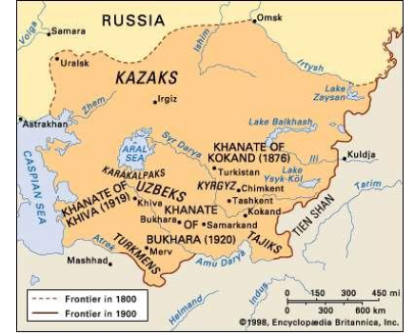
Russian penetration of western Central Asia in the 19th and 20th centuries.
From the outset, Russia’s objectives as a colonial power were strictly limited:
to maintain “law and order” at minimum cost and to disturb as little as possible the
traditional way of life of its new subjects. Such an approach was favored by the
remoteness of the area and its isolation even from the rest of the Muslim world. It
was improbable that an almost wholly illiterate population, its prejudices formed by a
venal and obscurantist ʿulamāʾ (class of Muslim theologians and scholars), could
offer any concerted resistance to the Russian presence; and such, indeed, proved to be
the case. The Russians, like other colonial powers, did experience an occasional
uprising, generally of a very localized character, but the overwhelming military
superiority displayed by the Russians at the time of the initial conquest, the inability
of the inhabitants of the khanates to offer effective resistance, and the heavy-handedness with which subsequent insurrection or insubordination was dealt ensured
minimal opposition. Finally, by preserving the titular sovereignty of the emir of
Bukhara and the khan of Khiva, they left a substantial part of the population,
especially the urban classes, most deeply devoted to the Islamic way of life, under
traditionally minded Muslim rulers.

The Tsarist rule
Yet the Russians, whether intentionally or not, became agents of change throughout the area in much the same way as any other colonial power. The regional
economy was gradually realigned to meet the Russian need for raw materials and new
markets. This required the construction of railroads: by 1888 the Trans-Caspian
Railroad had reached Samarkand; between 1899 and 1905 the Orenburg-Tashkent
Railroad was completed; the Turkistan-Siberian Railroad came later, begun just before World War I and not completed until 1930. In Tashkent and Samarkand new
European suburbs were laid out at a distance from the walled native cities, but, as in
the case of the newly established garrison towns, such islands of European life
required local services and supplies. Nor did the Russians wholly ignore the welfare
of their new subjects. An effort was made, halfheartedly at first, to put down the
indigenous slave trade, irrigation projects were initiated, and bilingual elementary
education was cautiously introduced. As elsewhere in colonial Asia, the work of
Russian scholars studying the literature, history, and antiquities of the Central Asian
peoples aroused on the part of a numerically small but influential Russian-educated
elite, especially among the Kazakhs, nostalgic awareness of a colourful past and a
sense of national, or cultural, identity.
Of the major ethnic groups in Central Asia—Uzbeks, Kazakhs, Turkmen,
Tajiks, and Kyrgyz—the Kazakhs were the first to respond to the impact of Russian
culture. Their early contacts with their new masters had in the main been carried out
through intermediaries—Kazan Tatars, who, paradoxically, had contributed to
strengthening the Kazakhs’ awareness of being part of a greater Muslim world
community and their sense of being a “nation” rather than a welter of tribes and
clans. Moreover, through the Tatars they were exposed to current Pan-Turkish and
Pan-Islamic propaganda. In the 1870s the Russians countered Tatar influence by
establishing bilingual Russian-Kazakh schools, from which emerged a Westernized
elite of considerable distinction.

The Kazakh unrest
This “dialogue” between the Russians and Kazakhs was, however, doomed by
the government’s policy of settling peasants from European Russia and Ukraine on
the Kazakh steppe, where agricultural settlement on an extensive scale could be
undertaken only by curtailing the area available for grazing by the nomads’ livestock
and by restricting their seasonal migrations. As early as 1867–68 the northwestern
fringes of the Kazakh steppe had been the scene of violent protests at the presence of
colonists, but it was not until the last decade of the century that the movement got
fully under way with the arrival of upward of one million peasants, resulting in the
inevitable expropriation of Kazakh grazing grounds and in savage conflict between
the Kazakhs and the intruders. Finally, in 1916, during World War I, the Kazakhs,
driven to desperation by the loss of their lands and by the ruthlessness of the wartime
administration, rose up in protest against a decree conscripting the non-Russian
subjects of the empire for forced labor. The rebellion assumed the character of a
popular uprising, in which many colonists and many more Kazakhs and Kyrgyz were
massacred. The revolt was put down with the utmost savagery, and more than
300,000 Kazakhs are said to have sought refuge across the Chinese frontier.
With the collapse of tsarist rule, the Westernized Kazakh elite formed a party,
the Alash Orda, as a vehicle through which they could express their aspirations for
regional autonomy. Having found during the Russian Civil War that the anticommunist “Whites” were implacably opposed to their aspirations, the Kazakhs
cast in their lot with the “Reds.” After the war the Kazakhs were granted their own
republic, in which, for the first few years, the leaders of the Alash Orda maintained a
fairly dominant position and were active in protecting Kazakh interests. After 1924,
however, direct confrontation with the Communist Party became more intense, and in
1927–28 the Alash Orda leaders were liquidated as “bourgeois nationalists.” The
history of the Kazakhs in the first half of the 20th century was bleak indeed—
expropriation of their grazing lands under the tsars, the bloody uprising and reprisals
of 1916, the losses in the civil war and in the famine in 1921, the purges of the
intelligentsia in 1927–28, collectivization during the 1930s, and further peasant
colonization after World War II.

The Uzbek reforms
In Transoxania—which was divided between the administration of the Russian
governor-general of Turkistan, based on Tashkent, and that of the emir of Bukhara
and the khan of Khiva—opposition to colonial domination was centred in the most
conservative elements of a profoundly Islamic society, the ʿulamāʾ and the inhabitants
of the bazaar. Nonetheless, the Russians favoured, for reasons of expediency, the
preservation of the traditional social framework and endeavoured, with only partial
success, to insulate the inhabitants of the region from contact with the more “advanced” Muslims of the empire—the Volga and Crimean Tatars. In this they were
aided by the fact that the virtual absence of European colonization provided no fuel
for popular resentment comparable to that felt by the Kazakhs; and, in consequence,
the Westernized products of the bilingual Russian-Uzbek educational system,
concerned primarily with reform of the Islamic way of life, regarded the Muslim
“ultras” as their most dangerous opponents.
If the main influence in shaping the outlook of the Kazakh intelligentsia was
the educational system imported from European Russia, the catalyst in the case of the
Uzbeks was knowledge of the educational reforms and the Pan-Turkish ideology of
the Crimean Tatar renaissance of the late 19th century. The Uzbek reformers, known
as Jadids, advocated the introduction of a modern educational system as a prerequisite for social change and cultural revitalization; despite intense opposition from the clerical classes, they opened their first school in Tashkent in 1901 and by 1914 had established more than 100. After 1908, influenced by the Young Turks of the Ottoman Empire, the Young Bukharans and the Young Khivans worked for a program of radical institutional change in the ramshackle governments of the
khanates. It may be doubted, however, whether by 1917 the Uzbek intelligentsia had
made any substantial impact outside a fairly narrow circle of like-minded persons.
MAIN CONCLUSION
As a result of an armed invasion of Russian troops in the 60-ies of the 19th
century the Kokand Khanate was abolished and the Turkestan Governor-Generalship
was established on July 11, 1867. The Emirate of Bukhara and the Khiva Khanate
received the status of a protectorate. Power was concentrated in the hands of the governor-general, who carried out all the military and civil administration. The new government focused on the agricultural sector of Uzbekistan economy: it resulted in the cotton growth for the needs of Russian industry.Gin houses and cottonseed oil mills were built, mining operations began, the Trans Caspian railway was built, which connected Central Asia with European part of Russia.

LECTURE 9. ESTABLISHMENT OF THE SOVIET POWER IN
TURKESTAN. SOVIET MEASURES IN UZBEKISTAN AND THEIR
COLONIAL SIGNIFICANCE

Soviet rule in Central Asia
Neither before nor after the Russian Revolution of 1917 were the nationalist
aspirations of the Muslims of Central Asia compatible with the interests of the
Russian state or those of the European population of the region. This was demonstrated once and for all when the troops of the Tashkent Soviet crushed a
short-lived Muslim government established in Kokand in January 1918. Indeed, the
Soviet authorities in Central Asia regarded the native intelligentsia, even the most
“progressive” of them, with lively and (from their point of view) justifiable apprehension. At the same time, there was the problem of an active resistance on the
part of conservative elements, which was anti-Russian as much as anticommunist.
Having extinguished the khanate of Khiva in 1919 and that of Bukhara in 1920, local
Red Army units found themselves engaged in a protracted struggle with the
Basmachis, guerrillas operating in the mountains in the eastern part of the former
khanate of Bukhara. Not until 1925 did the Red Army gain the upper hand.
Thereafter, Central Asia was increasingly integrated into the Soviet system
through the implementation of planned economy and improved communications,
through the communist institutional and ideological framework of control, and, for
young males, through compulsory service in the Red Army. The economy of the
region became further distorted to meet the needs of the central planners. Traditional
religion, values, and culture were suppressed, but in such areas as education, health
care, and welfare Central Asians benefited to a degree from their forced participation
in the system.
Eventually the Soviets developed an ingenious strategy for neutralizing the two
common denominators most likely to unite Central Asians against continuing control
from Moscow: Islamic culture and Turkish ethnicity. After a protracted period of trial
and error, their ultimate solution was the creation of five Soviet socialist republics in
the region: the Kazakh S.S.R. (now Kazakhstan) in 1936, the Kirgiz S.S.R. (now
Kyrgyzstan) in 1936, the Tadzhik S.S.R. (now Tajikistan) in 1929, the Turkmen
S.S.R. (now Turkmenistan) in 1924, and the Uzbek S.S.R. (now Uzbekistan) in 1924.
The plan was to will into being five new nations whose separate development under
close surveillance and firm tutelage from Moscow would preempt the emergence of a
“Turkistani” national identity and such concomitant ideologies as Pan-Turkism or
Pan-Islamism. To some extent, this ethno-engineering reflected colonial conceptions
of the peoples of Central Asia dating back to tsarist times.
Thus the Kazakhs, whose absorption into the Russian Empire had been a gradual process extending from the early 18th to the early 19th century, were perceived as wholly separate from the Uzbeks south of the Syr Darya, whose territories had been annexed during the mid-19th century. As speakers of an Iranian language, the Tajiks could be clearly distinguished from their Turkish-speaking neighbors, while the Russian perception of the nomadic Turkmen, whom they had conquered during the closing years of the 19th century, set them apart from the sedentary Uzbeks. Similarly, the Kyrgyz of the Issyk-Kul region (whom the Russians of tsarist times had confusingly designated “Kara-Kirgiz,” while applying the name “Kirgiz” to the Kazakhs) were declared to be distinct from their Kazakh neighbors.

Rapid changes
Subdued by tsarist Russian weaponry and colonial administrators, Central
Asians at the turn of the 20th century diverged along two cultural and social orientations. The old intelligentsia and clergy of Bukhara and Khiva generally
persisted on their antiquated course, resisting the modernization of educational,
religious, economic, and governmental institutions. Simultaneously, a small but
vigorous expression of dissent emerged in the form of an active reform movement.
Reformers were centred in Samarkand but were also present in Bukhara, Tashkent,
and Fergana. Jadids, as the reformers called themselves, were inspired and assisted by
Crimean Tatar reformers such as Ismail Gasprinski (Ismail Bey Gaspirali). The
Jadids enjoyed sporadic protection by tsarist governors in Turkistan, and they were
able to prepare numbers of young urban intellectuals for moderate change in their
society and culture. Modernization also came to Turkistan with the advent of the
telegraph, telephone, and press; railroads reached Samarkand and Tashkent by 1905.

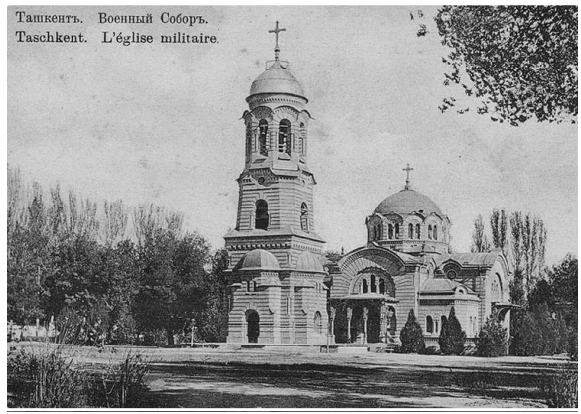
Soviet Uzbekistan
The Russian Revolution of 1917 brought instability and conflict to Turkistan.
In the autumn of 1917 the Soviet power was proclaimed. Turkestan was granted the
status of the Soviet Republic within the RSFSR. Nationalists, disagreed with this
decision, went to the mountains, from where started a fierce guerrilla war for the
sovereignty of their native land. Muslims convoked a National Congress in Kokand
and established an autonomous government under Mustafa Chokayev, which was
liquidated in February 1918 by Red Army forces sent from Tashkent. This action
provoked a prolonged resistance movement known as the Basmachi (Qorbashi)
Revolt. Slavic and European troops and colonists controlling Tashkent successfully
moved to depose the emir of Bukhara and the khan of Khiva in 1920. From 1917 to
1921 in Central Asia there was a struggle between guerillas and troops of the Red
Army, which ended with the victory of the Soviet Union. New leaders initially came
from the ranks of the Jadids, but, by the end of 1921, communist-dominated
politicians held power in both old capitals.
In 1924–25, politicians directed by the Russian Communist Party (Bolsheviks)
redrew the Central Asian map according to a monoethnic principle for each major
entity and its people. Karakalpakstan and Uzbekistan arose overnight as ethnically
designated territories within the Union of Soviet Socialist Republics (U.S.S.R.),
which had been established in December 1922. The authorities soon granted Uzbekistan the formal status of constituent republic of the U.S.S.R. Karakalpakstan
was transferred to the Uzbek S.S.R. in 1936, though it retained autonomous status.
Uzbeks remained a minority in the capital city of Tashkent and were underrepresented in the Soviet bureaucracy and administration. Uzbeks quickly learned that real political authority was held by the Communist Party of Uzbekistan (CPUz), the republic’s branch of the central Communist Party. The
core membership of the CPUz, and for decades its majority, consisted of Slavs and others from outside
Central Asia who made all important local decisions except those reserved to the
Soviet centre.
The new government focused on the agricultural sector of Uzbekistan
economy: it resulted in the cotton growth for the needs of Russian industry. Gin
houses and cottonseed oil mills were built, mining operations began, the Trans Caspian railway was built, which connected Central Asia with European part of
Russia.
The Soviet power and measures in Uzbekistan
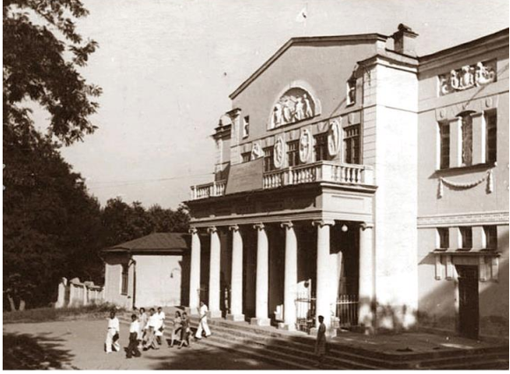
In the first years of the Soviet power in Uzbekistan many measures were directed to the liquidation of illiteracy and construction of schools. At the same time the traditional life style and culture were destroyed. In the 30-ies of the 20th century an active industrialization of Uzbekistan took place: large plants and fabrics of light and heavy industry were constructed, new cities were built near these plants, and old cities were reconstructed. During that period Uzbekistan suffered from Stalin’s political repressions: among the victims there were leading politicians and cultural figures of Uzbekistan. The trauma introduced in Uzbekistan by the communist political purges of the 1930s exacted heavy casualties, especially among Uzbekistan’s relatively small class of intelligentsia and leaders.
During the World War II of 1941-1945 the male population of the republics of the Soviet Union were taken to the front and the most important enterprises and people were evacuated to the republics of Central Asia, including Uzbekistan. World War II (1939–45) brought further emphatic cultural changes as the Soviet authorities moved thousands of Russian, Polish, and Jewish managers, intellectuals, and cultural figures to the towns and villages of Uzbekistan. During this period, Tashkent became a kind of evacuation center, which gave a shelter to refugees from the whole Soviet Union, and was called the City of Bread and the City of Friendship of Nations.
The death of the Soviet leader Joseph Stalin in 1953 helped free Uzbek institutions from some of the negative pressures of his era. In 1954–55 Tashkent was again opened to noncommunist visitors from the West after decades of isolation, and Uzbekistan slowly regained direct contact with the outside world. Uzbeks rose to high levels in Soviet politics; Nuritdin A. Muhitdinov, Sharaf R. Rashidov, and Yadgar S. Nasriddinova made Uzbeks visible in the U.S.S.R., serving actively in Soviet diplomacy and foreign affairs.
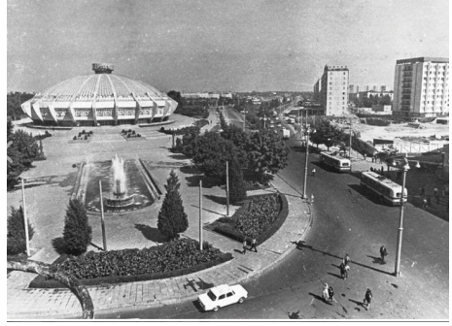
In 1966 a heavy earthquake in Tashkent destroyed the major part of the old
city. In this connection the city was rebuilt in the Soviet style by the architects,
coming from all over the USSR. In 1977 the Tashkent metro was put into operation.
It was the first metro in Central Asia.

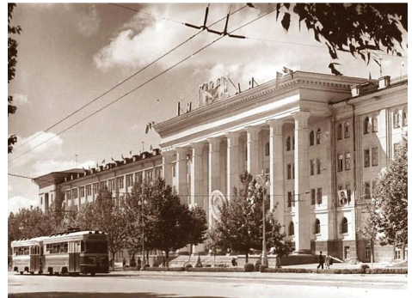
Despite the easing of some controls on the press and on assembly initiated
during the 1980s by the Soviet leader Mikhail Gorbachev, the communist leadership
of Uzbekistan continued its firm control over the republic. In August 1991, CPUz
chiefs led by Islam Karimov supported the Russian coup attempt against Gorbachev.
After the coup failed, Uzbekistan moved quickly to declare independence from the
U.S.S.R. The communists—the only experienced politicians in the republic—retained
mastery over the new country, and Karimov easily won the 1991 presidential election.
MAIN CONCLUSION
The colonial experience and 19th-century Russian ethnological and anthropological fieldwork were, then, when appropriate, enlisted by the Soviets to
serve very different ideological ends. Inevitably, the boundaries of these artificial
creations willed into being by Soviet fiat did not reflect the ethnic and cultural
patterns of Central Asia, and all five republics contained substantial minority
populations (among them, immigrants from European Russia), a situation which, with
the coming of independence in 1991, was fraught with the likelihood of future
conflicts. To ensure the success of this design for stabilizing Central Asia under
Soviet rule, school textbooks, scholarly research and publishing, and cultural policies
in general were devised to stress, on the one hand, the particular and unique
experience of each republic and, on the other, the enduring benefits of the Russian
connection, which paradoxically required that the tsarist conquests and their
consequences be represented as an overwhelming boon to Central Asians. Great
significance was given to language policy, with strenuous efforts being made to
emphasize the linguistic differences among the various Turkish languages spoken in
the republics, clear evidence of intent to divide and rule.
During the last two decades of Soviet history, the remoteness and economic
backwardness of Central Asia meant that this region felt less intensely the winds of
change beginning to blow through metropolitan Russia, Ukraine, or the Baltic republics, although from 1979 Soviet intervention in neighboring Afghanistan
produced ripple effects across the frontier. Historians, however, may conclude that
the most significant aspects of the history of Central Asia under the Soviets were the
extent to which its peoples managed to retain their traditional cultural heritage under
the most debilitating circumstances.
Now that all five are independent sovereign states, their future destinies will be
of more than regional significance. Central Asia will no longer be the backwater that
it became when the age of European maritime discovery brought to an end the centuries-old transcontinental caravan trade.

LECTURE 10. ACHIEVEMENT OF THE STATE INDEPENDENCE IN
UZBEKISTAN
The political independence
In connection with the collapse of the USSR, the political independence of
Uzbekistan was proclaimed at the extraordinary VI session of the Supreme Council
on August 31, 1991.
The 1st of September was announced the Independence Day. The Republic of
Uzbekistan was officially recognized as an independent state by 160 countries around
the world. On March 2, 1992 Uzbekistan became a member of the UN. On December
8, 1992 a new Constitution of the Republic of Uzbekistan was adopted. The core of
the new political system in Uzbekistan became a presidential form of government, in
which the power of the President, as head of the state, and executive power were
concentrated. In the early years of independence, Uzbekistan adopted symbols of
sovereignty such as a new constitution, currency, national anthem, and flag.
Since 1991, the Republic of Uzbekistan has been developing as an independent
state. A number of tasks have been set before this government. First, not only to
declare constitutional independence, but to show it to the people in practice, to be
loyal to basic ideas, principles. Secondly, the promotion of a state based on the
principles of a democratic society and the pursuit of foreign policy on the basis of
equal partnership. The Republic may form alliances, join the unions and other
intergovernmental structures and withdraw from the state to ensure the highest
interests, welfare and security of the people ".

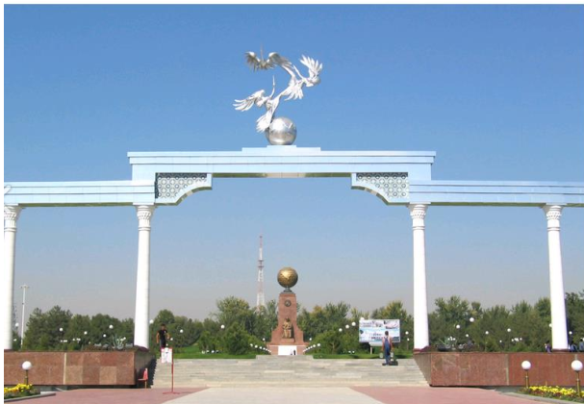
The "Uzbek model" development
Uzbekistan has undergone its development through reforms in all socioeconomic and political developments, called the "Uzbek model". The "Uzbek model" defines the main strategic direction of many aspects ofdevelopment. In this regard, the first President of Uzbekistan on the difficult situation of independence, I.Karimov, said: "I read in a book an exemplary story ... Amir
Temur conquered the half world, went to remote forest tribes, and eventually subjugated them to Caesar and the commander of the tribal leader, a militant, free and
sincere, gave his weapons to Timur, saying, "Oh Temur! You defeated us with the
power of arms. But we have the conditions to tell you. If you are a barber, cut us off,
if you are a merchant, buy it if you are a king".
... There is a great wisdom in this story. That is to say, the people should become
the guardian of the people, the head of the people, and become aware of the hot cold
of the people " (A lecture delivered in Tashkent on February 24, 1990, attended by
representatives of the USSR, the Uzbek SSR and local Soviets of People's Deputies
and the public).
In response to social political processes, a number of state-run changes have
taken place since the first days of independence. In particular, the decree was issued
on 27 August 1991 as confirmation of the independence of the Uzbek SSR President
in the country. In order to protect the interests of the republic, the Ministry of Internal
Affairs and the State Security Committee have been legally subordinated to the
Uzbek SSR. In addition, the internal troops of the USSR Ministry of Internal Affairs
located in the Republic of Uzbekistan were directly subordinate to the President of
the Uzbek SSR.
On the day of the next popular day - on August 31, 1991 at the Sixth Session of
the Supreme Soviet of the Uzbek Soviet Socialist Republic, Islam Karimov solemnly
proclaimed independence of the Republic of Uzbekistan.
Through the history of this political significance, the people began to restore
confidence in their future, began to see their children and their family's peace, and
began to be deeply grateful to the principles of humanism and good morals. At the
same time, the Decree of the President of the Republic of Uzbekistan "On
Establishment of the Ministry of Defense of the Republic of Uzbekistan" and other
important documents were signed on September 5 on the name of the square named
after V. Lenin in Tashkent, signed on September 5th.
Important dates in recent years: The Constitution of the Republic of Uzbekistan
on December 8, 1992, the Concept of further deepening democratic reforms and
establishing civil society in the country on November 12, 2010, and every year, has
adopted all the desires of Uzbek citizens.
"The Independence and Prosperity of Uzbekistan", "Uzbekistan Towards a Great
Future", "Uzbekistan is Going to the XXI Century", "Towards the Independence of
Uzbekistan", "Serving the Motherland in the Way of the Future and Great Future" is
the highest happiness. ", and in his lectures and speeches, he has widely and publicly
clarified how the people of Uzbekistan pursued the goals and societies they founded.
Creating a decent standard of living for all people living in the country, including
nationality, language and religion, by introducing a multi-property market economy,
as well as securing a guaranteed standard of living and freedom, as in developed
democracies, is the essence of our government's policy.
Uzbekistan has chosen a specific path of independent development. The peculiarity of the "Uzbek model" and the issue of Uzbekistan's development.
This path was recognized as a way of development in the world recognized as
the "Uzbek model". Its rational centrality is not the revolutionary way of thinking, but
rather the evolutionary-evolutionary reform of society.
The way of development of Islam Karimov, the founder of Uzbek model Islam
Karimov, differs from most other national models, which is not only economic development, but also a model of national reconciliation and social development in a
broad sense. That is why it deals with the economy as well as the state building, the
social sphere and the spirituality, all the spheres of the life of the society and the
foreign policy reflecting them.
The concept of the Uzbek model, first of all, means the co-ordination of what
the state of independent Uzbekistan should be and the most general theoretical
conclusions and targets that uniquely orientate it to the concrete objectives of the
state aimed at achieving the stated goals. The development models of Germany,
Sweden, Japan, South Korea, France and China were the most economical models.
They do not encompass the radical renewal of political, social and cultural life.
In any of these countries, issues of national statehood, cultural heritage, mother
tongue, foreign policy focus were not exhausted during the economic reform period
(only important in South Korea, but in other countries, economic reforms were
emphasized).
Achievements of the state
In the early years of independence, a strategy of reform was developed under the
leadership of President Islam Karimov. The experience of transformation of the developed countries into market relations, the historical experiences of our country
and their lessons, as well as the way of life and thinking of our people were taken as
the basis. Thus, there are five fundamental principles of societal reform:
The first principle is economy's superiority over politics. Economic reforms
should never be politicized, and they cannot be controlled by an ideology. Internal
and external economic relations must be free of ideology.
The second principle. The state is the chief reformer. It should define the
priorities of reforms, develop and update policies and implement them consistently.
The first President Islam Karimov, on the basis of the scientific principle of the
"Uzbek model," stated: "In the transition period, the state will support the activities of
the national economy, especially its foundations, the system of regulators, to provide
incentives, and to assist them in the provision of direct assistance. " These words
argue the government's role as the chief reformer and at the same time, it means that
various social groups, non-governmental and community organizations, and
individuals are not limited to the reformist initiatives and activities, but rather the
state.
The third principle. The rule of law in all aspects of society's life.
Democratically-accepted constitution and laws should be respected and
entrusted to them without any exception. There are some reasons for this.
First of all, this principle ensures the development of different forms of
ownership on an equal legal basis. The relationship between forms of ownership and
business entities is regulated by a strict competition law. Legal conditions are created
to avoid arbitrariness and subjecivism in the economy, and to avoid various economic
outbursts. Secondly, democracy develops, political culture and activity of the
population increases.
Third, the interests of the individual, the whole social group, and the layers are
considered more closely and their creativity and creative potential are more effective.
The role and importance of public organizations grows year by year. Civil society is
formed. Thus, the principle of the rule of law, in its broadest sense, contributes to
social development in Uzbekistan, the renewal of the society and the rise of human
personality.
The fourth principle. Taking a strong social policy, taking into account the
demographic composition of the population. Along with the introduction of market
relations, pre-existing measures to protect the population, especially the poor,
children and the elderly, should be undertaken.

Social policies
Strong social policies have many components and trends. They cover issues
ranging from funding and reforming social security, creating new jobs, healthcare,
public education, culture, sports and physical education, and combating crime and
ensuring law and order. One of the principles that defines the humanitarian essence of
the Uzbek model of strong social policy and social protection of the various strata of
the population.
Fifth Principle. Gradual transition to a market economy on the evolutionary
basis, taking into account the requirements of objective economic laws. This is
accompanied by the establishment of legal basis and guarantees of reforms, social
protection of the population and formation of new economic thinking. That is exactly what happened in Uzbekistan. This policy has enabled and provides not only the efficient use of funds, but also the mobilization of people, the prevention of social shocks and the gradual development of forms of ownership.

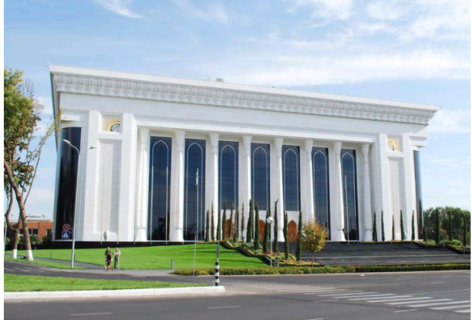
These principles have laid the foundation for the path of independence and
development of Uzbekistan, the basis of the transitional program. Their implementation ensures consistent implementation of socio-political stability in the
country, and most importantly, market relations. The Uzbek model of development is
recognized by the international community as it relies on the national state traditions,
values and mentality of our people, as well as based on the best world experience in
society reform.
All this helped us step by step to our foreign policy. Because when there is a
peaceful state in the state, it will be a global ouster abroad. On the basis of cooperation with Uzbekistan on the world arena, the Constitution, the various documents, the Concept of Foreign Policy adopted in 2012 and the President of the Republic of Uzbekistan Sh.Mirziyoev in connection with the "Year 2017 - People's Friendship and Human Interest Chapter" Strategies for the five priorities of development of the Republic of Uzbekistan ". Fifth direction is "Security, inter-ethnic harmony and religious tolerance" and "Priority directions in the field of deeply thought-out, practical and effective foreign policy", which defines the role of the country in the protection of sovereignty, as well as enhancing inter-civilizational, inter-ethnic, inter-confessional peace and reconciliation. m. It is not accidental.
From ancient times representatives of various nationalities live in friendly Uzbekistan.
All citizens have the right to have all political, economic, social benefits, regardless of nationality, national-cultural centers of nationality, respect for the languages, traditions and customs of all nations, ethnicities (there are more than 130 centers in Uzbekistan) should be equal.
Interreligious relations also define many inter-religious relations. Whenever domestic and foreign policy worthy of the "Uzbek model" is carried out in our
country, when people are active regardless of their language, religion, gender,
ethnicity, they can make a worthy contribution to ensuring stability and security in
our country, and then Uzbekistan will have its own unique image in the world
community, integration becomes stronger.

MAIN CONCLUSION
Since gaining the independence, Uzbekistan took a course to build the democratic state with market economy. The republic obtained the opportunity to independently conduct the foreign economic activity. Today, Uzbekistan is a member of the Organization for Economic Cooperation, the European Bank for Reconstruction and Development, the International Monetary Fund, the International Labor Organization, Shanghai Cooperation Organization and other reputable organizations.

LECTURE 11. HISTORICAL MONUMENTS, LANDMARKS, PROMINENT
FIGURES AND MUSEUMS OF THE REGION

Few countries on earth are blessed with the historic, cultural and architectural
treasures of Uzbekistan. Home to three of the region’s most exceptional cities in Samarkand, Bukhara and Khiva, the quantity and quality of the Silk Road era
mosques, mausoleums and madrasahs, bazaars, citadels and tombs are not only
phenomenal but also astonishing. With so many different things to see and do, there
are a lot of incredible landmarks in Uzbekistan.
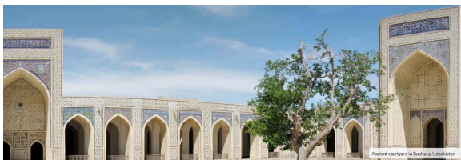
1Registan Square, Samarkand
Few places epitomise Uzbekistan more than Registan Square and it is
unquestionably the country’s most recognisable landmark. Sitting at the ancient
epicentre of the Silk Road city of Samarkand, this beautifully proportioned square is
flanked by three historic madrasahs, the oldest of which dates to the early 15th
century. For centuries Registan Square was the centre of Samarkand’s public life – it
was here that announcements were made, executions took place, markets were held
and festivals celebrated but a decline in trade saw the buildings deteriorate until 20th
century renovations. UNESCO protected, today the structures are dazzling – the
madrasahs intricately decorated with multi-coloured mosaics and the towering domes
resplendent with vibrant azure tiles.
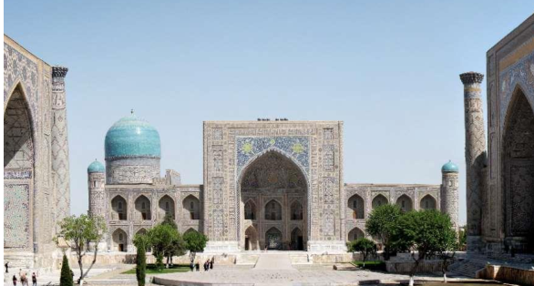
2. Po-i-Kalyan and the Kalyan Minaret, Bukhara

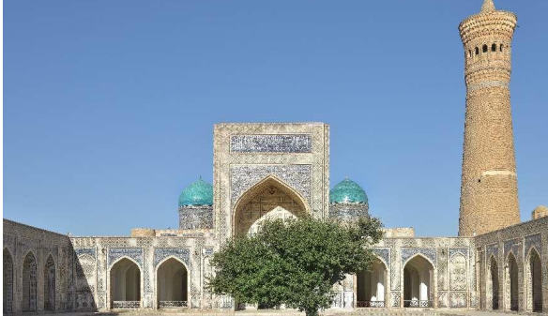
The foremost Islamic religious complex in Bukhara, the Po-i-Kalyan lies at the
heart of what is Central Asia’s holiest city. Best known for the towering Kalyan
Minaret, which was spared destruction by the invading forces of Genghis Khan, the
buildings here have changed little over the centuries. The compound also houses a
500 year old mosque and grand madrasah however the Kalyan Minaret is the highlight. Dating to 1127 AD, the minaret is nearly 50 metres in height and was most
probably the tallest structure in the region at the time of its construction.
3. Kalta Minor Minaret, Khiva

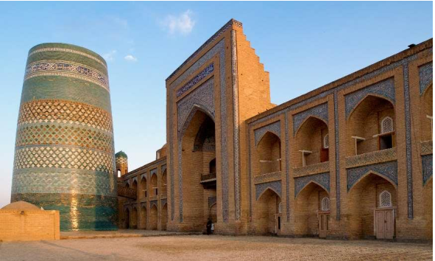
The squat, highly decorative Kalta Minor Minaret is one of Khiva’s most
distinctive sites. Its massive circumference but stunted height has fuelled many
rumours since it was constructed with a popular legend being that the minaret’s
foundations were originally intended to support a structure so tall that those at the top
would be able to see the city of Bukhara over 400kms away. Whether there is any
truth to this is unclear, however, what is certain is that the minaret was intended to be
much taller than its final height but following the death of its sponsor soon after
building started in 1851, construction was halted and the structure left unfinished.
4. Khast-Imam Square, Tashkent
A series of major earthquakes, the most devastating of which occurred in 1966,
deprived Tashkent of much of its ancient heritage. Under Soviet rule many of the
traditional buildings lost were replaced by ones similar to those found throughout the
rest of the USSR and recent development has further changed the city with more
open areas, wide avenues and contemporary architecture. Khast-Imam Square, the
centre of the old city, largely survived both natural disasters and redevelopment and
remains the location of Tashkent’s most important religious and historic monuments.
Places of interest include Tilla Sheikh Mosque, which houses a rare 7th century
Koran, and the Mausoleum of Abu Bakr Kaffal Shashi.
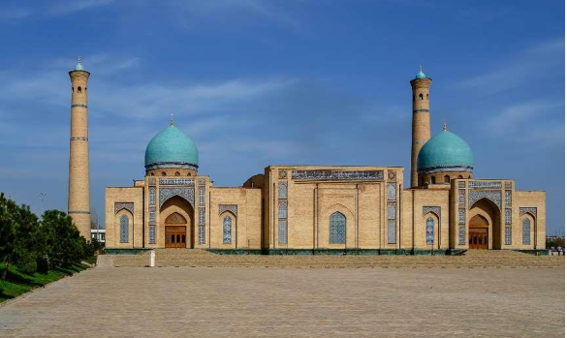

5. Tomb of Daniel, Samarkand

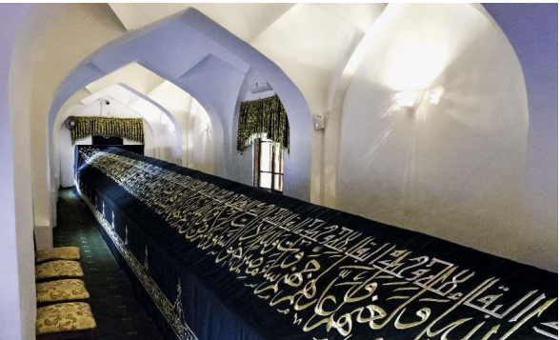
A number of different locations in Central Asia and the Middle East claim to
be the final resting place of the biblical prophet Daniel but one of the most
compelling is set a short distance from the city of Samarkand. Occupying a
commanding position atop a hill that overlooks the Siab River, the prophet’s actual
physical tomb is unusually long with it said to represent his importance and holiness.
Legends abound as to how the remains arrived here, some believe early Christians,
others say Timur returned with them from the Near East, and there is also debate as to
the exact contents of the large coffin. There is also a natural spring which is said to
have healing properties.
6. Chor Minor, Bukhara

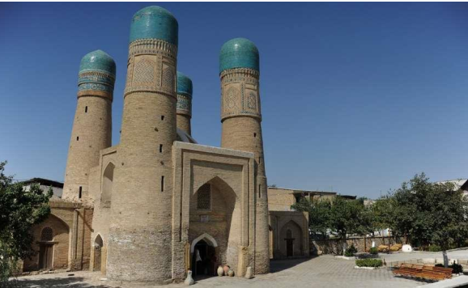
Instantly recognisable, the pretty Chor Minor is one of Bukhara’s more unusual
landmarks. Although small in stature, the building is beautiful proportioned and was
once an entry gatehouse for a two hundred year old madrasah that is no longer
standing. The name translates as ‘Four Minarets’, a literal description of the number
of towers that stand at each corner of the structure. Although not strictly minarets, the
towers feature religious decorations and are topped by turquoise-blue domes.
7. Kunya-ark Citadel, Khiva
Originally dating to the early 12th century, the Kunya-ark Citadel was the main
fortress and residence of the rulers of Khiva. Expanded in the late 17th century, it is
one of the best preserved military structures in Uzbekistan and has changed little over
the years. Adjoining the historical inner city of Khiva, Kunya-Ark is close to the
West Gate and has huge exterior walls that enclose a complex housing everything
from palaces and mosques to an arsenal, mint, workshops, jail and warehouses.
Highlights include the 19th century Summer Mosque, throne room, harem and royal
mint.
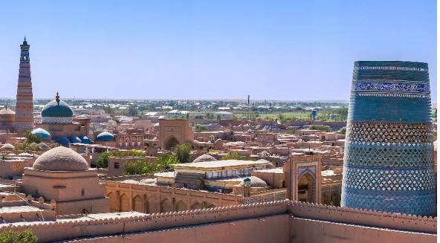
8. Bibi-Khanym Mosque, Samarkand

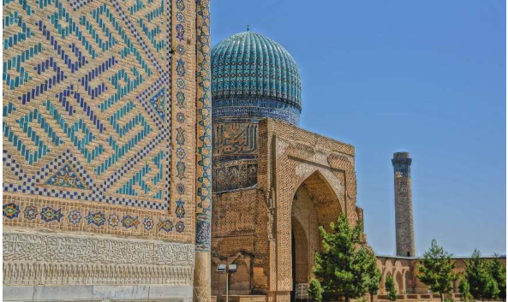
With its turquoise-coloured domes and elaborate geometric tiled designs,
BibiKhanym is one of the country’s most impressive mosques and a centrepiece to
Timur’s vast empire. At the time of its completion in 1404 the mosque was said to
have been one of the largest in the Islamic world and its minarets, monumental dome
and grand entrance gateway required innovative engineering solutions that pushed the
building techniques of the time to their limit. Over the following centuries the
complex fell into disrepair, eventually succumbing to an earthquake at the end of the
19th century but has recently undergone a period of restoration.
9. Ark Fortress, Bukhara
The Ark Fortress, residence of the Bukhara khans, is the city’s oldest structure
and believed to have been inhabited since the 4th century BC. Essentially a walled
royal town within Bukhara’s old city, the Ark Fortress was once the epicentre of the
Bukhara Khanate and contained homes, mosques, stables and markets, a treasury, the
Emir’s apartments, an armoury and a prison. By the early 20th century, the Red Army
had reached Bukhara and bombing caused substantial damage to the interior of the
fortress. However, many of the royal chambers remain as does the Friday Mosque,
prison, the emir’s personal mosque and a collection of museums.
10. Chorsu Bazaar, Tashkent
Standing in the centre of Tashkent’s old town, the huge blue-domed structure
of Chorsu Bazaar dominates the surrounding city. This area has been a centre for
trade and produce for centuries but the current marketplace is a modern construction.
However, the cavernous interior is impressive and everything and anything can be
found here from spices, fruit and vegetables to sweets, clothing and livestock.
Outside, open-air food stalls selling shashlik kebabs, bread and plov are busy at all
times of day. The remaining low-rise mud-brick homes of the old town are a short
walk to the north and there is also a 400 year old madrasah and mosque nearby.
11. Ulugh Beg Observatory, Samarkand
Located north of Samarkand, the Ulugh Beg Observatory provides compelling
evidence of the scientific advancement of the medieval Islamic world. Although little
remains today, in its heyday there was a three-storey observatory, however, its large
curved track is all that can now be seen. Instigated by astronomer, mathematician and
ruler of Samarkand Ulugh Beg, the complex was completed in the 1420s and built to
his exact requirements. The results of the work carried out at the Ulugh Beg
Observatory influenced astronomers as far afield as Europe, China and India. There is
also a small museum to visit.

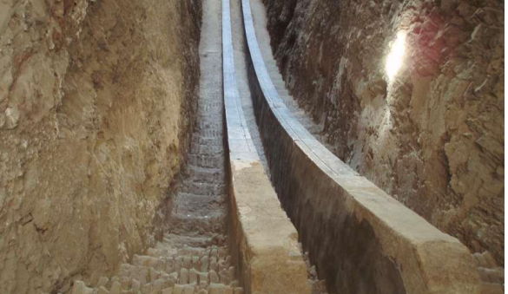

12. Magok-i-Attari Mosque, Bukhara

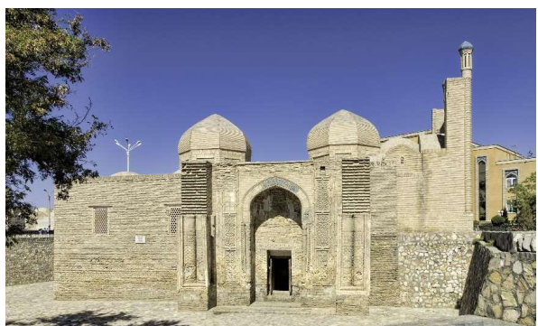
Thought to be one of the oldest surviving mosques in Central Asia, Magok-iAttari is set in the heart of ancient Bukhara and forms part of the UNESCO protected
structures. Long thought to occupy a site of significant religious importance,
excavations in the 1930s also uncovered a pre-Islamic Zoroastrian temple believed to
date to the 5th century. The first mosque was erected some time in the 9th or 10th
centuries, pre-dating the Mongol invasion, and saw further architectural embellishments during the 1500s. Interestingly, the mosque and adjoining square are
lower than the surrounding lanes standing at, what is believed to be, the town’s
original street level.
13. Shakhi-Zinda Necropolis, Samarkand
The most important place of pilgrimage in Uzbekistan, the Shakhi-Zinda
Necropolis is an avenue of interconnected, exquisitely decorated mausoleums and
graves close to the Bibi-Khanym Mosque. In all the complex is formed of religious
buildings constructed over a period of eight hundred years – the earliest of which
belongs to Qusam ibn-Abbas who is traditionally believed to have brought Islam to
Samarkand during the 7th century. The finest of the buildings are those of the
Timurid era and showcase elaborate tilework, intricate mosaics and delicate terracotta
designs.
14. Ismail Samani Mausoleum, Bukhara
Bukhara’s oldest surviving Muslim monument, the Ismail Samani Mausoleum
is the final resting place of the founder of the Samanid Empire – a realm that, at its
zenith, controlled a huge expanse of Central Asia stretching from Kazakhstan in the
north to Iran and Pakistan in the south. Construction of the mausoleum was finished
by the middle of the 10th century and the building has changed little since that time
making it a significant monument both historically and architecturally. Decorated
with a sophisticated and attractive terracotta brick design, the building’s shape is
reminiscent of a Zoroastrian fire temple which indicates a link to ancient pre-Islamic
influences.
15. Ak Saray Palace, Shakrisabz
The monumental edifice of Timur’s summer palace dominates the ancient
remains of Shakrisabz. Directly ordered by Timur, Ak Saray Palace was to be the
grandest building in his empire and a symbol of his power and wealth. A UNESCO
World Heritage Site, the complex was completed at the beginning of the 1400s and,
despite damage over the centuries, has been sensitively restored. Ak Saray is
renowned for the quality of its workmanship and features a wide variety of designs
and colours. The detailed mosaic and majolica work is particularly refined and
features depictions of foliage and calligraphic inscriptions of both Koranic and
secular content.
16. Trading domes of Bukhara
Bukhara’s trading domes have welcomed explorers, travellers and traders for
centuries. Dating back to the 1500s when the city, and wider region, was flourishing
due to the money and produce that arrived via the Silk Road, at its zenith there were
five domed bazaars in Bukhara each of which specialised in specific merchandise.
Today only a few of these covered markets are left standing, however, they remain in
everyday use selling everything from herbs, spices, jewellery and carpets to
household items, clothing and local souvenirs.
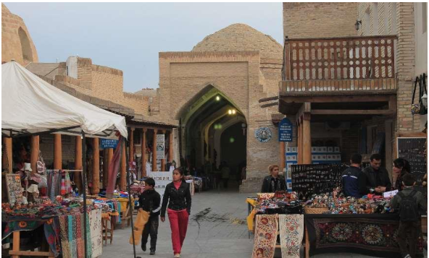
17. Madrasah of Muhammad Amin-khan, Khiva
One of Khiva’s best preserved religious buildings, the Madrasah of
Muhammad Amin-khan is a UNESCO World Heritage Site and located within the
ancient walled city beside the Kalta Minor Minaret. Not as old as many of the other
structures in the vicinity, the madrasah was completed in 1854 and commissioned,
and named after, the ruler of Khiva at that time. Once one of the region’s most
important educational institutions, the Madrasah of Muhammad Amin-khan has twostories, is richly decorated and, under Soviet rule, was for a short period a prison.
18. Mausoleum of Imam al-Bukhari, Samarkand
Located outside of Samarkand, the Mausoleum of Imam al-Bukhari is the final
resting place of one of Islam’s most respected theologians and scientists. Born in
Bukhara in 810 AD, al-Bukhari travelled extensively throughout his life, studied
under influential scholars and, ultimately, wrote a number of significant and
authoritative works. After his death, the mausoleum became a revered pilgrimage site
and a few hundred years later a mosque was built nearby. The whole complex was
renovated at the turn of the last century by the Uzbek government.
19. Islam Khodja Complex, Khiva
A little over a hundred years old, the Islam Khodja complex is one of the more
recent additions to Khiva’s historic centre. Formed of a large madrassah and massive
minaret, the latter is the tallest structure in the city and is nearly 60 metres in height.
The minaret is slender, tapering to a gilded point and is heavily decorated with
concentric rings of blue tiling leading to an elaborate top from which the call to
prayer is recited by the muezzin. It is a steep climb to the summit of the Islam Khodja
minaret but the views of the city are spectacular.

20. Chashma-Ayub, Bukhara One of the more distinctive buildings in Uzbekistan, the Chashma-Ayub mausoleum has a unique conical-shaped dome. Known as ‘Job’s well’, local legend
has it that the holy spring which bubbles up at the site was created when the prophet
Job struck the ground with his staff. The mausoleum was built in stages over a period
of time between the 12th and 16th centuries and inside it is still possible to drink
from the spring which is said to have healing properties.

21. Siyob Bazaar, Samarkand

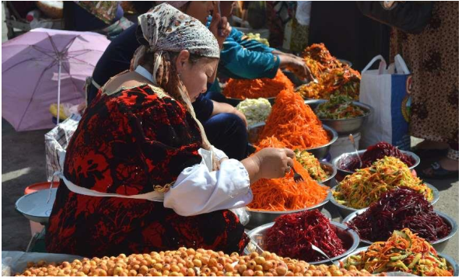
A short walk to the north of Registan Square and next to the monumental
remains of the Bibi-Khanym Mosque, Siyob Bazaar is Samarkand’s most important
and largest market. Part covered and part open-air, the bazaar is largely modern in
appearance but, in many ways, provides a direct link to the city’s ancient trading
heritage. Covering a vast area, this is a true marketplace of the eastern tradition
selling everything from fruit, vegetables, herbs and spices to dried fruits, sweets,
local breads and nuts.

LECTURE 12. EDUCATION SYSTEM OF THE REPUBLIC OF
UZBEKISTAN
Plan
- Structure of the Educational System
- Pre-higher Education System
- Higher Education System
- Integration and internalization processes in the national education
- The national test level system of language assessment
- Conclusion
Structure of Educational System
According to official sources, about 60 percent of Uzbekistan's population is
covered under the system of education. The earlier educational system required 11
years of compulsory schooling for both men and women. Later the policy decision
was made to change from 11 to 9 years of compulsory education. After nine years of
compulsory schooling, students can prepare for higher education in tenth or eleventh
grade or turn to vocational training. After graduating from any type of secondary
education, an individual can enter a higher education institution to obtain a bachelor's
degree and continue study toward a master's or doctoral degree.
Budget constraints and other transition problems following the collapse of the
Soviet Union, have made it difficult to maintain and update educational buildings,
equipment, texts, supplies, teaching methods, and curricula. Foreign aid for education
is desperately needed, but has not been sufficient to compensate for the loss of central
funding.
When viewed in general, the Uzbekistan educational system includes:
• Preschool training (preprimary-from three to seven years old)
• General secondary education (from 7 to 18 years old)
• Secondary vocational education (from 16 to 18 years old)
• Higher education (undergraduate and graduate-from 18 years old).
Pre-higher Education System
Girls and boys are legally considered equal and study in the same classes and schools. Schools are open to all ethnic groups, and minorities in schools are rarely an issue.
The academic year begins on 2 September (the first of September is the Independence Day) or the first working day of September. The academic year ends in
June for secondary schools and in July for higher education. Russian was a common
language for over 100 nationalities living in the Soviet Union and played the same
role as English for the United States. It was also the Lingua Franca of the socialist
world that included Bulgaria, Poland, Mongolia, and other European and Asian
countries. Without Russian as a common language, Uzbeks (and other ethnic groups)
would have to learn Ukrainian, Belorussian, Moldovian, Armenian, and many other
languages to communicate with the multinational population of the Soviet Union.
Therefore, until 1991, Uzbeks preferred schools with instruction in Russian for their
children. To not do so would have put them at a great disadvantage socially. After
Uzbekistan gained its independence, Uzbek (not Russian) became the official
language of instruction. In 1998-1999, some 76.8 percent of pupils at day schools
were educated in Uzbek.
Higher Education System
Examinations in the educational system of Uzbekistan are primarily oral.
Universities, institutes, and some colleges still have entrance exams. Course exams
occur only at the end of the course (semester). State exams are taken at higher
education institutions at the completion of all coursework. The grading system of
Uzbekistan is numerical. The highest grade is 5 (excellent = A), then follows 4 (good
= B), 3 (satisfactory = C), and 2 (unsatisfactory = F). One is never used. Final grades
are determined by test scores, papers, attendance, and class participation.
Because compulsory education is freely provided to all children of Uzbekistan,
private schools have a difficult time justifying their existence. In fact, they were
banned in 1993. Also, since Uzbekistan Law declares the separation of education
from religion, there are no religious schools. However, in 1999, the establishment of
the Tashkent Islamic University was allowed. Computer technology, thanks to
international assistance, is being introduced to educational institutions and training
centers. In 1994, the Central Asian Telecommunications Training Center (CATTC)
was established in Uzbekistan under the Tacis Program of the European Commission.
Training at the CATTC is provided using modern teaching aids, active methods, and
individual and group methods by specialists and experts in different fields. The
Computer Center at the University of Samarkand provides computer service to
departments and research units and collaborates with other institutions and the private
sector to run short training courses. At the secondary school level, computers are still
rare.
As a result of decline in funding, the printing of books, textbooks, and other
publications face numerous difficulties. This problem is common for all NIS
countries. Nevertheless, despite obvious difficulties, according to UNESCO,
Uzbekistan schools supplied about 60 percent of textbooks as a whole and for some
selected subjects up to 100 percent. Publishing houses produced about 149 million
copies of over 1700 various titles. From 1992 to 1997, some 174 textbooks with over
53,000 copies were published, including 138 original, 19 translated, 8 parallel in 2
languages, and 9 experimental textbooks. About 170 various tutorials and educational
literature in 7 languages are published. Audiovisual materials are usually manually
prepared by teachers. With the high price of copying and low salaries, teachers and
professors must be creative.
In the Soviet-type higher education institution, most students studied for a full
working week (five to six days a week, six to eight hours of classes a day). Evening
and correspondence courses were also popular. The first and the second year of the
curriculum usually included the study of social science with similar course requirements for all students. Specialization began in the third year and continued in
the fourth year. Within this period a student had between 4,500 and 5,000 face-toface hours of instruction in 20 to 30 subjects, depending on the field of concentration.
Curriculum included general subjects like philosophy and economy, specialized
subjects determined by the chosen profession, and very specific courses depending on
the deeper specialization. Curriculum was very rigid and equal for all students. There
were no choices. In the modern system higher education institutions, curriculum is
certainly less rigid. However, the authorization of the curriculum is still the
responsibility of a ministry, not a particular institution.
The expansion of curricula, including the addition of courses in French, Arabic,
and English, has placed new stress on a limited supply of teachers and materials. In
the mid-1990s, a major curriculum reform was begun. Western experts advised:
• a more commercial approach to the mathematics curriculum
• more emphasis in economics courses on the relationship of capital to
labor
• more emphasis in social science courses on individual responsibility for
the environment
• the addition of entirely new subjects, such as business management.
Because such changes involve new materials and a new pedagogical approach
by staff, the reform period is estimated at 10 to 15 years. The current transformation
of the educational system is performed along educational models in developed
countries. According to Gulyamov, "During the process of developing the National
Program the experience of reforming education in more than 30 leading countries in
the world has been studied" (Gulyamov 1999).
Integration and internalization processes in the national education
In 1997, President Karimov founded "Umid," a program providing students
with educational fellowships for obtaining education abroad. By the year 2000, over
700 students have been awarded the "Umid" Presidential Scholarship to pursue
graduate and undergraduate degrees in the United States, the United Kingdom,
Germany, France, Italy, and Japan. Certainly, returning graduates are expected to
bring back "the influence," and those who have finished their studies are employed by
the State. The Uzbekistan educators established contacts with the United Nations
Organization and separate countries like France, Germany, the Republic of Korea,
Turkey, and the United States. Many organizations like Peace Corp (USA), ACCELS
(USA), British Council, Merci Project (Great Britain), Goethe Institute (Germany),
NAFE (USA), and Save the Children Fund (Great Britain) participate in the
educational efforts undertaken by Uzbekistan. For example, the Ministry of
Education of Turkey assisted in forming 22 Lycea for over 4.8 thousand students.
Another example is the American Council on Cooperation in Education (ANCALS)
which within 4 years helped over 222 Uzbekistan students get education in the United
States. Finally, within only 2 years, 25 Uzbekistan schools got the certificates of
UNESCO Associated Schools Project (ASP).
An American Educational Advising Center (EAC) funded by the United States
Information Agency (USIA) and administered by the American Council for
Collaboration in Education and Language Study (ACCELS) was established in
Tashkent to assist individuals interested in studying, training, and/or pursuing
research in the United States. Tashkent EAC also monitors three similar regional
educational advising centers located in the other cities. EAC provides ongoing
training for the advisors.
Finally, the European Training Foundation (ETF) established an observatory to
monitor the vocational education and training in Uzbekistan. It also disseminates the
language training programs and helps the European Commission with the implementation of the Tempus program. Since 1994 the latter has financed over 12
projects, including the restructuring of the Geography Faculty at Samarkand State
University and the development of a new history curriculum at Tashkent State
University.
The main trends in the development of modern education include such as
globalization, fundamentalization, humanization, technologization, standardization,
and computerization.
The globalization of education is primarily determined by the fact that
education and society are inseparable from each other. And this still has to be proved
from the standpoint of the priority importance of the development of education for
human civilization, for an individual. The sphere of education is designed to adjust its
priorities and values, taking into account not only current, but also promising, longterm needs of both a person and society, it works for the future, predetermining the personal qualities of each person, his knowledge, skills and abilities, ideological and behavioral priorities.
A single world market, a single information space, the integration of local
civilizations into a single world community ensures the reproduction of social ties
and relations in historical space and time. A single history of mankind, which
absorbed the experience of all peoples, has led to the emergence of one of the most
important problems of mankind - survival. Globalization is becoming a common
destiny for peoples and cultures, which, in order to preserve themselves, must come
to an understanding of the increased responsibility of man and mankind for life and
its quality.
Education must be fundamental, that is, deep and thorough. The recognition of
fundamentalization is caused by the growth in the volume of information, its renewal
every 2-3 years. The primary objectives in this area are: the introduction of a cycle of
general humanitarian disciplines in the natural science and technical education in
order to overcome the disunity of the natural science and humanitarian components
of the integral worldview culture of the individual; creation of integral interdisciplinary courses that contain the most universal and generalized knowledge,
which is the basis for applied research and development, the basis for the formation
of a general and professional culture of the individual, quick adaptation to new
professions and specialties; overcoming the contradiction between fundamental
education and vocational training with the absolute priority of fundamental
knowledge.
The humanization of education concerns the issues of training, education and
development of the personality of students, as well as issues of organization,
functioning and management of education. It is assumed that the humanization of
education should be implemented throughout the education system, permeating the
humanitarian and natural science components of education, the field of technical,
engineering, economic and other sciences. Humanization is a particular manifestation
of the general objective associated with the revival of culturally related education. To
humanize education means to reveal the personal meaning in the study of academic
disciplines, both humanitarian and natural sciences, to realize its importance from the
standpoint of each individual, that is, to make it personally oriented and personally
significant.
The humanization of education is one of the leading modern trends in the
development of education. In our country, this problem was posed more than ten
years ago, but it has not received a complete theoretical and practical solution yet,
although the further level of education and prosperity of the society and individuals
largely depends on this trend.
An important direction in the development of education is the technologization
of the educational process, which involves the introduction of modern tools,
information technologies into education, and the ongoing widespread
computerization. Computer science, the science of the joint activity of a teacher and a
computer has been implemented in the educational process.
It should be noted that the major changes are taking place in the content of
education due to its standardization, the function of which is twofold. On the one
hand, standardization means giving some uniformity, and on the other hand, making
the content of education that would satisfy the corresponding standard. The
educational standards define the requirements for a person's education. As N. I.
Pirogov stated that if education is modern, then the members of the society are also
modern; if the opposite, then the society will also be backward.
The national test level system of language assessment
In Uzbekistan, in accordance with the National test level system of Language
Assessment1 the use of the CEFR is implemented as follows: Table 1.1.
The national test level system of language assessment

Level | Level of Uzbek educational system
Proficient  User | C 1 | Philological higher education, Master’s Degree,  Doctorate Degree
Independent  User | B 2 | Higher education
B 1+ | Language academic lyceum
B 1 | Academic lyceum and professional college
Basic User | A 2+ | Special language secondary school
A 2 | Secondary school
A 1+ | Special language elementary school
A 1 | Elementary school
1Положение о порядке определения уровня знания иностранного языка и выдачи квалификационного
сертификата (Приложение N 1 к Постановлению Кабинета Министров РУз от 31.12.2013 г. N 352).
So, in the State Educational Standard to FLT2 the undergraduates of the nonlinguistic institutions must achieve B2 level of language proficiency. At the same time, the requirements for the level of competences are described in the State Education Standards in general terms and are not reflected in the qualification requirements for foreign language proficiency. In our opinion, the requirements need some additions, namely: graduates should be able to communicate fully with business partners on professional and general cultural topics, negotiate, make reports, carry out international projects, work with foreign documentation and business correspondence, critically analyze the foreign literature, research business technologies and proposals coming to them, carry out oral and written translation from a foreign language into their native and from native into a foreign one. To achieve the ultimate goal of language learning and acquisition is necessary to characterize the content of various types of competences formed in the language classes at universities.

Conclusion
Education has and will continue to play a significant role in development. First,
it increases an individual's internal potential, self-respect, and self-esteem. Second, it
makes an individual a better prospect for employment. Third and most importantly,
an educated individual gives more back to the society. Unfortunately, the results of
education and training are less directly connected to revenue for immediate business
growth, which is why the government tends to cut educational budgets.

LECTURE 13. TRADITIONS AND HOLIDAYS OF THE PEOPLE OF
UZBEKISTAN
Plan
- The national holidays in Uzbekistan
- Traditional and cultural holidays and festivals
- Family holidays
- International holidays
- National traditions and customs
- Conclusion

PUBLIC HOLIDAYS IN UZBEKISTAN
In Uzbekistan, there are a lot of holidays, which are solemnly celebrated and
declared to be weekends-non-working days.

January, 1st - New Year
Uzbekistan celebrates New Year on the first of January. This holiday was
introduced to Uzbek people together with the adoption of Gregorian Calendar in the
end of 19th century by russians. Therefore, the celebration of a New Year and the
symbols of the holiday is almost same as in Russia. Main symbol is, of course a
decorated Christmas tree. However, locals do not associate it with the Christmas.
Grandfather Frost and Snow Maiden are also main characters of the New Year in
Uzbekistan. People at this time celebrate and widely mark this holiday with native
and close behind the covered elegant table. Also gifts and surprises are traditionally
presented each other. They will visit friends and relatives or enjoy themselves
dancing until midnight from 31st December till 1st January, when hours solemnly
beat 12 hours. Then they welcome the New Year wishing each other happy new year.
Some people gather in Restaurants or night clubs, where special New Year Party
shows are organized, while others meet with family members at homes.
January, 14th - Day of Defenders of the Native Land
This holiday in independent Uzbekistan is celebrated in honor of creation of
own Army forces. On 14th January, 1992, the parliament made a decision on
transition of all parts and connections, military educational institutions and other
military formations of the soviet army deployed in territory of the country under
jurisdiction of the Republic of Uzbekistan. Holiday is celebrated in mainly military
institutionas and widely publicized in mass media.
March, 8th - International Women’s' Day
Nowadays this is a major day of global celebration of women. This holiday
was introduced to Uzbek people as a honor to working women during the soviet era.
however, it is lost its ts political flavour, and became simply an occasion for men to
express their love for women in a way somewhat similar to a mixture of Mother's
Day and St Valentine's Day that are celebrated in the West. On this day it is
customary for men to give the women in their lives – mothers, wives, girlfriends,
daughters, colleagues, etc. – flowers and small gifts.
March, 21st – Navruz
Literally means New Day in Persian language. Although Navruz is not an
islamic holiday, it was widely celebrated among locals (mainly muslims) as a
beginning of the New Year before the Georgian calendar was intuduced. Celebrating
navruz was prohibited in soviet times, but after the independence, the government
declared it as a national holiday and symbol of spring. Symbols: Blossoming trees
and flowers, sprin, sumalak (national dish) In Navruz Many Uzbek family prepare for
national dishes such as: sumalak, halim, samosa from spring greens, pilov and others.
Preparation of sumalak, which is usually boiled in large pots and needs continuous
mixing, takes approximatety 24 hours. Thus, people gather around the pots and spend
the day and night singing and dancing national folclore. People go out on navruz with
family members or friends and attend Navruz celebrations, national dance and
sporting shows, which are orginized in city and town centers and parks.
May, 9th - Day of Memory and Honor
Firstly celebrated as the Victory Day that marks the capitulation of Nazi Germany to the Soviet Union in the Second World War. It was first inaugurated in the fifteen republics of the Soviet Union. It has been celebrated since 1946 and the holiday became a non-labour day only in 1965 and only in some of the countries. After the independence, Uzbekistan built Memorial of Memory in the center of Tashkent in 1999 and declared 9th of May as a Day of Memory and Honor. Now, this holiday is celebrated in honour and memory of compatriots who spend their lives protecting the country, its freedom and independence in the past. Poeople visit memorials and place flowers. Visit elder people who have spend their lives heroically and remember those who have passed. Mainly at memorials of Memory and Honour that are found in almost all city centers
September, 1st - Independence Day
One of the greatest and widely celebrated holidays of Uzbekistan - Independence Day. The country obtained its independence from Soviet Union on September 1st, 1991 and since then it is celebrating this day as a National Holiday.
Holiday celebrations, festivals and concierts are organized throughout the country
and people go out for public places and parks in the city. Mass media widely
publicizes the events hold in various places of the country and broadcasts the
concierts. Main celebration conciert, where the president of Uzbekistan attends, is
hold on August 31st in Tashkent's Navoi Park.

October, 1st - Teachers' Day
Students congratulate their teachers and give flowers and small gifts. media
broadcasts many programs and shows dedicated to the education and role of teachers
in the development of new generation.

December, 8th - Constitution Day
This holiday marks the adoption of new constitution of the independent country on December 8th, 1992. Government organizes celebration and concerts in many places and awards some people in honor of their work and patriotism.

Eid al-Adha (Ramazon hayit) and Eid al-Fitr (Kurban Hayit)
As in all countries where live muslims, Eid al-Adha and Eid al-Fitr are widely
celebrated in Uzbekistan too. People have been celebrating these holidays for many
centuries but they were prohibited during the soviet times. But after the independence
government declared them as a naitonal holiday. Men go to mosques early morning
to pray holiday prayers and then visit relatives. Women set up a holiday table. Elders
give candies and sweets to children.
Uzbek national wedding
The major holiday in life of any person is wedding. Traditionally neighbors,
colleagues, relatives from near and far cities and settlements, friends and acquaintances from mahalla (local quarter) are invited for the ceremony, so in the end
it comes as several hundreds of people. In this connection for last decades in the
cities they have built capacious wedding restaurants which are called toyhona (“toy”
is a holiday, “hona” is a room).
Modern Uzbek weddings take place mainly according to ancient traditions and
ceremonies: since early morning in the house of the groom national tools - karnay
and surnay sound, mother sees off the son, calling to him three times and at last
treating with a sweet (to make family life sweet), and he gives her a handkerchief
with money; further the groom with friends goes to the house of the bride
accompanied by musicians, friends by all means should dance on road, and time to
time someone from them jumps up and tries to bring down a wedding cap from the
groom’s head (even if he doesn’t wear it).
Uzbekistan Traditions and Customs
The Uzbek culture has much in common with the culture of other Muslim countries, but nevertheless it has its own features. Having booked a tour to
Uzbekistan in our company you will have a fascinating opportunity to feel on your
personal experience all original beauty and a rich cultural heritage of the Uzbek
people.
A great number of rites and customs accompany the Uzbek family life. Weddings are considered to be the most important event in one's life. Preparations for this special occasion begin from the birth.
Uzbeks love to gather in big groups and entertain the whole village (kishlak) or
mahallya (community in cities) on family occasions. Mass people's festivities are
widely celebrated. They are followed by various ceremonies, festive bazaars at which
musicians, dancers, wrestlers perform. Uzbeks are very friendly and hospitable
people. It is said: "If one does not have delicious food for a guest, one should have
sweet words for him". Uzbeks are supportive of each other. The ancient custom of
Khashar is a unique form of mutual assistance. If a fellow-villager finds himself in
difficulty, all the neighbours gather to help him. Mutual assistance reveals itself also
while preparing for wedding and circumcision parties, house building, and funeral
ceremonies. Uzbeks traditionally have respect for older people.
Beshik-toy
Beshik Toyi – a ritual solemnity related to the first put of the baby into the
cradle. This is one of the most ancient and widespread ceremonies in Uzbekistan.
Usually this event is held on the 7th, 9th, 11th day after the birth of the baby. In
various areas of Uzbekistan, this ritual takes place in a different way scale of the
event depends on the family's income: rich families usually celebrate this event
widely inviting neighbors and most of the relatives. Families with low income
celebrate it moderately within the family. Beshik ("cradle") and other necessary stuff
such as baby table, clothes, toy and etc. for the baby are provided by the relatives of
the baby from a mother side. Baby's parents, grandparents prepare gifts. Richly
decorated beshik and gifts are loaded into the vehicle together with the guests. With
sounds of local musicians the vehicle goes to the house where baby is born. By
tradition, delivered beshik is taken on the right shoulder by baby's grandfather, and
then passed to the right shoulder of his son, who then delivers it to baby's mother.
Guests are invited into the living room to the rich table. In the next room, in the
presence of old women baby’s clothes are changed and put into the cradle. At the end
of the ceremony, guests come to see the baby and to deliver presents. When
ceremony is over, guests go home with full of good emotions, presents, wishing the
best to the house and the hosts!

Sunnat toy - Khatna Qilish – Circumcision
Khatna Qilish is another ancient Uzbek ceremony adopted after accepting
Islam (Sunnat Tuyi). This ceremony is held for boys at ages 3, 5, 7, 9 but nowadays
this aging is not strict and one can do this ceremony when needed. This ceremony is
also called “Sunnat”. Since the birth of a baby boy, parents begin preparation for the
Sunnat Tuyi, gradually acquiring all necessary things. Few months before the
ceremony which is often referred to as the "Celebration" ("Tui"), active preparations
are started. Relatives and neighbors help sew quilts, prepare gifts. All this often ordered to the women with large family in terms of children. Prior to celebration, the
Quran is recited in the presence of the elders of Mahalla (Neighborhood), imam of
the mosque and relatives. Table is set and after the Quran is read elders bless the boy.
During the celebration different gifts and presents are given to the child. In the past, it
was customary to give the foal, on which the boy was seated. It as was a sign of a
man - a warrior. On the same day, among the women held "Tahurar" - lying blankets
and pillows on the chest, this ceremony is usually done by a respected woman.
Lavish food including world famous “Palov” ends the ceremonial.
Morning Osh Palov
Ceremony of the morning palov usually held during the wedding and memorial
services, other holidays like birth of child or anniversaries. Normally, host of the
palov, after discussion with close relative and community, fix the date of palov long
beforehand and send invitations. The day before the actual palov, in the house of the
host family, preparations starts for the palov, including clearing and preparing of all
necessary ingredients for the palov, and other food on the table. Normally all close
relative and friends of the family taking part in this process. After preparations ended,
all guests are invited for the dinner. Usually artists are also invited for “Sabzi
Tograr”. Also, during the “Sabzi tograr” elders are distributing the tasks among
youngsters for tomorrow’s palov. Morning feasting should be ready by the time when
morning pray ends and first guests are arrived. Normally, in the summer time, it is
about 4-5 am and in winter about 6-7 am. During the palov, Uzbek musical
instruments like “Karnay” and “Surnay” “Doira” and “Nogora” played to please the
guests and announce the celebration. Guests get comfortable around the tables and
after blessing the hosts and good wishes, tea and famous Uzbek hot breads served.
Palov is served in “lagans” (big plate) – one plate for two guests. After meal is
finished, lagans are taken off and guests again make wishes and blessing of the host
and leave. After, tables refreshed quickly for the new guests. Morning palov usually
lasts no more than one and a half to two hours. During the feast artists are performing
for the guests with classic songs. In morning palov, for honorable guests gifts are
given – usually these are “Chapan” (traditional men's robes) which is another
tradition of hospitable Uzbek people. Memorial palov is a bit different from the
holiday palov. In this case, guests are reading the verses from Quran and remember
with good words of deceased person, presenting condolences to the family of the
deceased person. After palov, again they read the verses from Quran and leave. There
are no artist invited for such ceremonies and tables are more modest. It is interesting
to note that in both holiday and funeral palov, only men participating.
Mahalla – The Neighborhood
To the traditional forms of social relations in Uzbekistan belongs first of all
“Mahalla” – the neighborhood community. Uzbek “Mahalla” has rich and ancient
history and is the center of family and religious ceremonies and festivals. Here in
“Mahalla” carefully preserved and passed on from one to next generation their
holding rituals. Usually, there is a local mosque in each “Mahalla”. It is still alive old
tradition of mutual aid – “Hashar”. With this aid “Khashar” community helps build
the houses for the inhabitants of local “Mahalla”, improving their district, street, city
and etc. In sovereign Uzbekistan “Mahalla” has become the keeper of cultural and
moral traditions of the Uzbek people, recognized as self-government mechanism.
Today “Mahalla” is a territorial association of families with a goal to co-operation
and mutual help in whole territory of Uzbekistan both old districts with old and
traditional houses and new parts of cities with high-rise buildings. In “Mahalla” live
in peace and harmony people of different nationalities. Network of more than 10,000
“Mahallas” covers the entire territory of the country and are an important element in
the strengthening of civil society. The entire population of Uzbekistan will recognize
them as an effective form of social life. Uzbek reality is: "Who comes to us for the first time, becomes a friend. Who comes secondly – turns to be a relative!
Conclusion
Uzbekistan holidays and festivals are different. Some of them are common to
different nations and others are observed only by particular nationalities. All holidays
are interesting, individual; each holiday has its own unique features, characteristics,
history and traditions.

LECTURE 14. SPORTS AND MASS MEDIA IN THE REPUBLIC OF
UZBEKISTAN
Plan
- Kurash – national sport activity
- Implementation of measures to promote sport activity
- Mass media development
- Conclusion

National sport activity
Over the centuries, Uzbekistan has had a tradition of fostering equestrians and
wrestlers (palvins). Some of the sports that originate in the country are the kurash,
which is a type of upright wrestling. Other types of wrestling are belbogli kurash,
turon, and boyqurgan all having the same origins. Other popular sports in Uzbekistan
are football, basketball, boxing, wrestling, and judo.

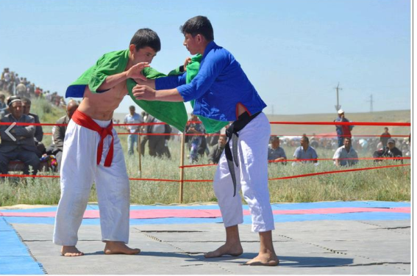
Kurash – National Fight in Uzbekistan
Kurash (translated as “attaining a goal by fair means”) is a kind of national
waist belt fight, traditional among the Turkic peoples officially included in the
world’s network of non-Olympic sports and supported by UNESCO. This kind of
single combats originated in the territory of Uzbekistan presumably about 3,500 years
ago. In the ancient legendary epos Alpomysh, kurash is mentioned as the most
popular and favorite kinds of single combat. Whereas historian and philosopher
Herodotus in his work “History”, described kurash in detail among other customs and
traditions of ancient Uzbekistan.
Avicena considered this kind of single combats salubrious not only for body
but also for spirit, while Tamerlane introduced kurash to his fitness and selfprotection program, developed for the soldiers of his unconquerable troops.
Furthermore certain battles were preceded by straight fights: where fighters of the
feuding parties met. There were cases when upon such straight fights the
commanders ceased hostilities and canceled the battle. Kurash was not only a kind of
single combats but also public entertainment during various events and festivities.
Years went by, but kurash did not lose its national popularity, being one of the most
favorite and respected traditions among the Uzbekistan’s peoples.

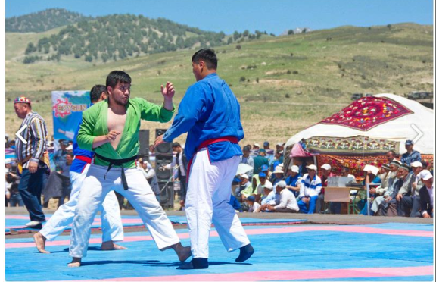
Over a number of centuries the kurash rules, as well as technique, traditions
and philosophy were passed from generation to generation. But no attempts to
systematize as well as generalize the whole information on kurash were made;
indeed, each family anyway has all necessary knowledge about it. And what is more,
kurash never spread beyond Central Asia. It was not until 1980 when Komil
Yusupov, kurash, judo and sambo master, began studies which ten years later resulted
in making universal rules. The millennial traditions which were thoroughly studied
served as a basis to determine weights, terminology, jests, fight duration, uniforms
for fighters and referees. Everything that was essential to turn an ancient folk
entertainment into a modern kind of sport was worked out.
Kurash uniform includes wide white trousers and a loose shirt. An
imprescriptible part of the uniform is a fabric belt used for comfortable hold of the
rival. The girdle made of soft fabric measures 180–220 cm long and 50–70 cm wide.
The main kurash rules are rather simple. The competitions are held on a special mat
with thickness at least 5 cm, with a marked working zone (located in the center),
protective zone and with a “passive zone” separating them. Two participants meet in
the working zone. The only position permitted for the combat is a standing stance.
The aim set before the contestants is to throw the rival on the back; this result in
kurash is considered a victory by fall. To achieve the goal the fighters are allowed
nothing but dashes and undercuts to be assessed by the judges. Kurash is a safe and
simple combat sport since any painful, beating and submission holds, grips below the
belt are prohibited there. In spite of these prohibitions the straight fights are very
dynamic and theoric.
Kurash has embodied a centuries-long philosophy and such values as respect to
the rival and humanism, honesty and ability go all the way. This kind of single
combat is one of the youngest international sports; it starts gaining popularity all over
the world. Kurash world championships as well as those of Russian and European
take place on a regular basis. The International Kurash Association with the
participation of representatives from 28 countries from Asia, Africa and Europe was
founded in 1998 and which has been functioning up to date.
Football
Football is the most popular sport in Uzbekistan. Uzbekistan's premier football
league is the Uzbek League, which features 14 teams since 2010, before 16. The
current champions are Lokomotiv Tashkent, and the team with the most
championships is FC Pakhtakor Tashkent with eight. The current Player of the Year
(2017) is Marat Bikmaev.
The most successful football clubs in Uzbekistan are FC Bunyodkor, FC
Pakhtakor and FC Nasaf. In 2011 FC Nasaf won AFC Cup and became the first
Uzbekistan team to win the international club cup. Uzbek clubs participate in the
annual CIS Cup.
Uzbekistan U-16 won AFC U-16 Championship in 2012. In 2018 Uzbekistan
U-23 became the champions in AFC U-23 Championship hosted by China.
Uzbekistan national team's best achievement at the Asian Cup was a fourth-place
finish at the 2011 AFC Asian Cup.
Ravshan Irmatov was named The Best Referee in Asia in four consecutives
years (2008, 2009, 2010, 2011 and 2014). At Globe Soccer Awards in 2015 he was
rewarded as Best Referee of The Year.
The Bunyodkor Stadium has a capacity of 34,000, and is mostly used for
football matches.

Ice Hockey
Uzbekistan used to be part of the Soviet Union national ice hockey team.
Humo Tashkent, a professional ice hockey team was established in 2019 with
the aim of joining Kontinental Hockey League (KHL), a top level Eurasian league in
future. Humo will join the second-tier Supreme Hockey League (VHL) for the 2019-
20 season. Humo play their games at the Humo Ice Dome costing over €175 million;
both the team and arena derive their name from the mythical Huma bird, a symbol of
happiness and freedom.]
Humo Tashkent was a member of the reformed Uzbekistan Ice Hockey League
which began play in February 2019. The UIHL consisted of three other teams
Binokor Tashkent, HK Tashkent, & Semurg Tashkent, with all of the teams playing
out of the Humo Ice Dome.[4] Semurg became the champions in the playoffs.[5]
Uzbekistan Hockey Federation (UHF) began preparation for joining IIHF as a
member and forming national ice hockey team in participating IIHF competitions.[6]
Sport promotion and achievements
Uzbekistan pays great attention to the development and promotion of sports
and physical culture. Over the years of independence, the country has established an
effective system of training of professional athletes, coaches and referees. The
implementation of these objectives in every way contributes to promotion of healthy
life-style, education of harmoniously developed young people, further development
of physical culture and sports in the country.
An important legal basis for ongoing reforms in this area is the Law of the
Republic of Uzbekistan "On Physical Culture and Sports" and other laws and
regulations directed to involvement of people, especially young people, women and
children, to physical culture and sports.
Young boys and girls, professionals of individual and game disciplines, are
showing exclusive preparation and phenomenal skills at representative forums,
eloquently confirm that they represent a country with a rich sports traditions. The
results of the measures can be seen in the growing number of our fellow citizens who
are involved in sports and won prizes at various international tournaments.
Today, the names of such outstanding and talented athletes as judoka Rishod
Sobirov, canoeist Vadim Menkov, wrestler Artur Taymazov, tennis players Denis
Istomin and Nigina Abduraimova, swimmer Sergei Pankov, gymnast Ulyana Trofimova and Oksana Chusovitina, athlete Svetlana Radziwill, soccer player Odil
Ahmedov, boxer Elshod Rasulov, taekwondoist Dmitry Shokin, and of course, FIFA
referee Ravshan Irmatov, and many others glorified Uzbekistan far beyond its
borders.
The main work on the development of sport in the country is carried out by the
Ministry of Culture and Sports. The Uzbek National Olympic Committee (NOC)
conducts activity on further development of the Olympic Movement and participation
of the local athletes in international competitions. In 1993, NOC became a member of
the International Olympic Committee.
The Uzbek State Institute of Physical Culture provides training of physical
education teachers and coaches. It annually teaches about 2 thousand students.
With the purpose of training of high-class athletes the work on improving the
material-technical base necessary for the formation of future champions is continued.
In particular, the Republican Specialized Children and Youth Sports School of
Olympic Reserve on rhythmic gymnastics was established on the basis of Universal
Sports Palace. Central Asian Judo Center, National Center of boxing and Sports
complex of Taekwondo Association have been built. The established sports
infrastructure of Uzbekistan has become a venue for major international competitions, including world and Asian boxing, taekwondo, wrestling, fencing and other types of sports.
The country has a strong focus on the selection of talented young athletes from
among the pupils of sports clubs, teams and organization of training to improve sport
skills, creation of necessary conditions for strengthening the sports reserve on the
basis of further development of the high school of sports and colleges of Olympic
reserve.
In this regard, Uzbekistan’s policy to expand the large-scale involvement of
children in sports is especially important. It is rightly considered as the basis of a
healthy and harmoniously developed generation. The country has created a unique
three-stage system of conducting of sports competitions among pupils and students -
"Umid Nihollari", "Barkamol Avlod" and "Universiada", which make an invaluable
contribution to the training of gifted and talented athletes defending the honor of their
country at international sports tournament and Olympic Games.
Establishment of the Fund for development of children's sports, in accordance
with the Presidential Decree in 2002, became an important step in the development of
children's sport. It’s main task is to assist in the implementation of state policy in the
field of physical education and sport among children, awakening interest in sports
among the younger generation, protection of young people from various harmful
influences, upbringing them in the spirit of patriotism.
Since the establishment of the Fund, more than 1700 children's sports
buildings in the capital and regions have been constructed and commissioned. All of
them are provided with sports facilities that meet modern requirements. 95300 sports
sections carry on their activities there. In 2014, the country has held 9500 sports
events, about 7000 of them - in rural areas. 1.8 millions juniors attended them.
The development of children's sport in Uzbekistan gives appropriate results. In
particular, in 2010, the national football team U-16 won the silver medal of the Asian
Championship, and a year later they entered the top eight teams in the world
championship U-17, which took place in Mexico. In 2012, Uzbekistan’s football
team U-16 has achieved brilliant success when they gained a victory at the Asian
championship.
Moreover, Shahida Zahidova, Sevara Babakulova and Gulsanam Yuldasheva
won silver medals in synchronized swimming at the Asian Championship in
Indonesia.
Nine-years old chess player Nodirbek Abdusattarov won the world
championship on rapid chess in the city of Maribor (Slovenia), which involved about
2600 players from 126 countries.
In 2013, Nafisa Muminova became the first female chess player from
Uzbekistan, who received the title of International FIDE Grandmaster. Her striking
success went down in history of national sport.
Dilshod Choriev and Ramziddin Saidov have won gold medals at the Judo
Asian Championship.
Three Uzbekistan’s athletes have won gold medals in the World Championship
on universal fight which took place in Russia. Davron Salimov became the winner of
the World Championship on hand-to-hand fighting. Men’s and women’s teams of
Uzbekistan on water polo became the strongest among all the participants of the
international tournament which was held in Thailand. Nine-years old Javohir
Sindarov became world chess champion in Brazil. And the eight-years old Zarguna
Ahrorkulova won the World Championships on karate-do in Minsk. "Gold" list can
be continued.
The young athletes have achieved great victories thanks to a significant
contribution of their coaches. In Uzbekistan, the work focusing on the training of
trainers, particularly among women, is carried out. An effective system of promoting
of their work is established. The number of coaches in 2015 comparing with 2003
increased by nearly 1.8 times, including female trainers - almost 6 times. Along with
this the composition of professional coaching and teaching staff has been changed
qualitatively - about half of them have specialized higher education.
The ongoing work in Uzbekistan on the development of sports is gaining recognition in the world. Visiting our country in 2013-2014, leaders andrepresentatives of the Olympic Council of Asia, the Asian Paralympics Committee,
International Federations of weightlifting, boxing, fencing, athletics and gymnastics,
the International Union of wrestling, Asian Taekwondo Union, the World AntiDoping Agency highly assessed the undertaken measures for development of the
Olympic movement in Uzbekistan.
President of the International Olympic Committee (IOC) Thomas Bach and President of the Association of National Olympic Committees and the Olympic
Council of Asia (OCA) Sheikh Ahmad Al-Fahad Al-Sabah paid a visit to Uzbekistan.
Eminent guests highly praised the quality of sports buildings and scale of
projects in our country. According to them, all the more significant achievements of
Uzbek athletes at the Olympic and Asian Games, world and continental
championships are the result of the creative work.
For outstanding achievements in the development of sports and Olympic
movement, the President of Uzbekistan was awarded the Medal of the International
Olympic Committee. Also, for the profound contribution to the development of
football in the country and in Asia, Islam Karimov was awarded by the Olympic
Council of Asia.
Thus, thanks to scale transformations undertaken in the country, sport has
become one of the most prestigious areas of activity, especially among young people.
Names of talented representatives of Uzbekistan, who won prestigious international
awards, are inscribed in the annals of the national and world sport.
Mass media development
Mass media in Uzbekistan is concerned with the situation of Uzbek media.
Although a government decree officially eliminated state censorship in 2002, it has
continued to severely restrict independent journalism.
After President Shavkat Mirziyoyev came to power, the media, which under
the previous regime was laid up in official narratives and strict censorship, is now
given the opportunity to provide more critical coverage and to develop in a freer and
more pluralistic environment.
Total newspaper readership is estimated at only 50,000; the newspaper market
is dominated by the state-owned papers Pravda Vostoka, Halq Sozi, and Narodnoye
Slovo. The largest privately owned papers are Novosti Uzbekistana, Noviy Vek,
Noviy Den, and Mohiyat. The state controls newspaper distribution and materials
supply. In the early 2000s, newspaper articles occasionally have criticized
government policy and social conditions, but bribery of journalists is common.
The only national news agency, the Uzbekistan National News Agency, is state-controlled. Agence France-Presse, Anadolu Ajansı (of Turkey), the Associated
Press, Interfax (of Russia), and Reuters are foreign agencies with offices in
Uzbekistan.
In Uzbekistan, Public Fund for Support and Development of National Mass
Media started its activity. The new fund aims to promote the development of selfgovernance mechanisms for the national media community.
“We are pleased to inform you that the National Fund for Support and
Development of National Mass Media has been registered by the Justice Ministry of
Uzbekistan as a non-governmental non-profit organization. It has officially started its
activity,” the Fund’s telegram channel said.
The main purpose of our Public Fund is to help media outlets develop and
maintain equal rights in the media market, to promote the rights of journalists and
bloggers.
The Public Fund also aims to assist in the development of self-governance
mechanisms for the national media community. Strengthening the material-technical base of the media, supporting the activities of journalists and bloggers, providing them with legal, organizational,
technical and other assistance are priorities of the Public Fund.
“In the future, we will provide more details about the Public Fund and its
projects. We hope you will continue to follow us,” the Fund added.
The UNESCO Tashkent Office within the framework of the project
“Enhancing the Capacity of Uzbek Media to Serve the Public Interest – Phase II*”,
funded generously by the UK Government, published a Handbook for journalists and
journalism teachers "Media and Information Literacy in Journalism" in four
languages (Uzbek, English, Russian and Karakalpak).
This Handbook aims at being an important and practical tool for journalists in
fulfilling their professional activities and mainly in media information literacy (MIL).
The first three parts of the Handbook include theoretical material and are
accompanied with exercises and case studies; the last part consists entirely of
practical tools and exercises that aim to ensure that the material was understood. The
Handbook deals with "fake news" and disinformation, provides a conceptual
framework for media and information literacy, shows its importance, and explores
principles and role of the MIL in journalism education. Also, the Handbook covers
topics such as ethics on the Internet, human rights and work with sources, journalistic
skills in collecting and processing information, ways to verify and provide reliable
information, and the identification of fakes that may adversely affect the public.

LECTURE 15. THE ROLE OF UZBEKISTAN IN THE WORLD
COMMUNITY AND INTERNATIONAL RELATIONS
Plan
- Concept of foreign policy
- International collaboration and diplomatic relations
- Uzbekistan's integration to the world community
- Priority directions of Uzbekistan's foreign policy
Concept of foreign policy
Significant changes have taken place with the establishment of foreign policy.
Our government has legally endorsed its foreign policy priorities by studying and
analyzing various options for the social progress of the world. Particularly, Article 17 of Foreign Policy, Section 4 of the Constitution of the Republic of Uzbekistan, states:
The Republic of Uzbekistan is a full-fledged subject of international relations.
Its foreign policy is based on sovereign equality, non-use or threat of force, inviolability of borders, and peaceful resolution of disputes, non-interference in other
internal affairs, and other universally recognized rules and norms of international law.
Central Asia's regional security will always be a priority for Uzbekistan's
foreign policy. Uzbekistan carries out specific measures to help Central Asia to shape
a positive international image and achieve a worthwhile geopolitical position in the
world community. The idea of President Islam Karimov "Turkistan - our common
home" is a vivid example of this. Uzbekistan has been striving to thoroughly
investigate the threats posing a threat to the Central Asian region and gradually
resolve these problems.
The Concept of Foreign Policy Activity of the Republic of Uzbekistan, elaborated on the initiative of President Islam Karimov in September 2012, has greatly contributed to the international community. The head of our state emphasized the importance of the document at the solemn ceremony dedicated to the 20th anniversary of the Constitution of the Republic of Uzbekistan and the festive greeting to the defenders of the Motherland on the occasion of the 21st anniversary of the establishment of the Armed Forces.
Indeed, in the conditions of complex situation in our region, the external world,
aimed at preserving the peace and prosperity of our country, creating conditions for
mutual understanding and cohesion with the neighboring states and peoples around
us, at a time when various conflicts are getting stronger and closer, policy is in line
with the true hopes and aspirations of our people. These are the views and approaches
of the "concept of foreign policy of the Republic of Uzbekistan".
The necessity of the development and adoption of this Concept at the present
stage was borne out by the deepening of the transformation of Uzbekistan into a new
stage in the path of independent development and the profound changes taking place
in international political and economic relations. Throughout the years of independence, Uzbekistan has developed a comprehensive foreign policy course
based on national interests and has been widely recognized in the world community
and strengthened our country's reputation. At the same time, Uzbekistan's new foreign policy priorities, further strengthening of the role and role of our country in the system of modern international relations, as well as deep and intensive changes in
world politics and economy have brought about the necessity of improving the
conceptual foundations of our foreign policy.
Taking into account the abovementioned, in January 2012, President of the
Republic of Uzbekistan set an important task to develop a doctrinal document for the
balanced and active, stable foreign policy strategy in the context of the rapid and
rapidly changing international political processes of the 21st century.
A special Interdepartmental Panel was set up to provide a comprehensive,
comprehensive approach to the development of such a document at the state level.
The Interdepartmental Council and a number of working groups established within its
framework have conducted on-going consultations, workshops on drafting the draft
document, its content, relevant sections and text. Together with a deep study of the
range of issues related to foreign policy, a great deal of work has been done:
Firstly, the Concept was prepared taking into account the 20-year development
of Uzbekistan's independence and the rich historical experience of Uzbek statehood.
Secondly, the experience of developed countries on the development and
adoption of conceptual documents in foreign policy has been carefully analyzed and
studied.
Thirdly, the current situation in our region and in the international arena, the
peculiarities of the complex geopolitical situation around the country, as well as the
issues of ensuring security and sustainable development of Central Asia are taken
into account in the interests of comprehensive Uzbekistan.
Fourthly, the laws of our country, which regulate foreign policy and economic
activity, and other legal acts, have been perfectly inventoried by international treaties.
The concept of foreign political activity meets the requirements for further
national security, sustainable development, maintaining high economic growth rates,
creating the most favorable external environment for the continuation of the tasks of
building a free democratic nation based on a socially-oriented market economy and
civil society.
The concept of foreign policy of the Republic of Uzbekistan is an integral
system of ideas that defines the fundamental principles and strategic priorities of the
foreign policy of our state, its goals and objectives in the international arena,
mechanisms of promoting the national interests of Uzbekistan in the medium and
long term.
The content and rules of the Concept are based on the Constitution and laws of
the Republic of Uzbekistan, as well as the Concept of Further Deepening Democratic
Reforms and Forming Civil Society in the Country. It also complies with universally
recognized norms and principles of international law, including the Charter of the
United Nations, the Universal Declaration of Human Rights, the Declaration on
International Law, the Helsinki Final Act of the Council for Security and Cooperation in Europe and other relevant documents.
This document is based on the long-term strategic interests of our state in the
fundamental tasks of the President of the Republic of Uzbekistan, speeches and
speeches of President Islam Karimov, and realistic conditions in our region and the
world, political and economic security processes.
The Concept consists of "General provisions" and four chapters:
I. "Assessment of the Changes in Current System of Public Relations in the
Context of Uzbekistan's Interest";
II. "The Basic Goals, Principles and Duties of the Foreign Policy of the
Republic of Turkey";
III. "Priority directions of foreign policy of the Republic of Uzbekistan";
IV. "Mechanisms of Formation and Implementation of Foreign Policy of the
Republic of Uzbekistan".
The first section gives a detailed description of the current state of public
relations. It is recognized that changing the political and economic power in the
international arena can lead to unpredictable consequences for regional and global
security. It is underlined that there is a growing threat to the security of traditional
and unusual threats to the security of the country, the tension and strains of tensions
near the borders of Uzbekistan, and the threat of an increase in the number of
situations leading to new armed conflicts and conflicts in key parts of the world.
The ongoing "geopolitical games", which are continuing in the world, focus on
increasing intensifying "geopolitical rivalry" in the world of tensions and strategic
abatement. It has been pointed out that some of the international actors are pursuing a
short-term and pervasive system of unilateral actions, which are violating the
fundamental principles of international law.
The chapter emphasizes that the globalization process is consistent and
irreversible, while on the one hand it opens opportunities for the development of
countries, and on the other hand, there are various risks in the fields of economics,
energy, ecology, food, information exchange, humanitarian security. and that it has
been proven to be harmful. The effects of these processes are: Increasing the
interdependence of countries in the world; crisis situations in the world economy;
Significant changes in the system of international financial relations; the Economic
Development Center's transition to Asia; the sharpening of the struggle for strategic
resources; the gap between the development of countries and regions of the world is
growing.
The Concept also gives special attention to the Central Asian region and states
that "vital interests of Uzbekistan are related to this region". Specifically, Central
Asia is becoming a major destination of the world and a region where strategic
interests of the largest countries are facing due to their significant geopolitical
location and rich reserves of mineral resources. Large countries are showing that
Central Asian countries are eager to influence their own model of development and
political path, and the "rivalry" of external forces in the region is growing.
Particular attention was paid to the problem of rational use of water resources
in Transboundary Rivers in the region. The complex environmental problems that
threaten the health of the millions of people living in the region, the gene pool of the
population, in particular, the catastrophic consequences of the Aral Sea construction,
industrial pollution of transboundary water resources and environmental pollution,
are increasingly dangerous for the well-being and prosperity of Central Asia
highlighted.
In addition, the document highlights the fact that Central Asian countries have
a negative impact on the prospects for sustainable economic growth, with the lack of
alternative routes and restrictions on transport and communications routes that allow
them to access the seaports in the region. Delimitation and demarcation of border
crossings between neighboring countries has resulted in the complication of the
situation in Central Asia, and some political and economic problems between
neighboring states have been hampered by the difficulties of solving topical issues
among their economic entities.
It should be noted that the Concept notes that Uzbekistan has a clear, good
neighborhood, friendship and good-neighborly policy. Uzbekistan is committed to
resolving all urgent issues in the region in accordance with the principles of
international law, through negotiations, based on the principles of mutual interest,
non-interference in one another's internal affairs. Central Asian problems need to be
solved by the countries in the region without the intervention of external forces.
This document focuses on the difficult and complicated situation in Afghanistan. In his speech at the solemn ceremony dedicated to the 20th anniversary of the Constitution of the Republic of Uzbekistan, the President emphasized that the withdrawal of the so-called "ESCAP" coalition troops from Afghanistan and beyond in 2014, the situation in this country and the surrounding region is aggravated by the threat of terrorism, extremism and drug trafficking. , even if the situation in the
country may go beyond the borders, it is not a serious concern in neighboring
countries.
International collaboration and diplomatic relations
Developments in this direction are not excluded by many prominent experts
that the contradiction of today's conflict has become a conflict between nations and
ethnicities, a new civil war in Afghanistan, and various dangers in the region.
It is safe to say that the best way to avoid such a negative event in the current
situation is to form a dialogue team with United Nations, Afghanistan's neighbors, as
well as the United States, NATO and Russia.
The main purpose of this group's action is to reach a compromise between the
fighting forces and to form a coalition of the Afghan government. The main ethnic,
religious, and religious groups in Afghanistan would be replaced by that government.
It should be noted that there is no alternative to this solution. This is clearly the
position of Uzbekistan in relation to neighboring Afghanistan. Uzbekistan stands for
long-term stability and long-term peace in Afghanistan.
Uzbekistan has formed its relations with neighboring Afghanistan on a bilateral basis, taking into account the national interests of the two nations, respecting the Afghan people's choice of the future of their country, and will continue to follow this principle.
The second part of the concept outlines the basic principles of Uzbekistan's
foreign policy. Specifically, the following is specified:
- Commitment to the preservation of peace and security in the world and
adherence to generally recognized international norms and principles;
- Openness to cooperation, irrespective of ideological views;
- equality and mutual benefit, sovereignty, territorial integrity, inviolability of
borders, non-interference in internal affairs, peaceful resolution of disputes, non-use
of force or threat of force.
Uzbekistan advocates a pragmatic, rational, and consistent policy, and adheres
to the principles of foreign policy goals and objectives that correspond to the long-term interests of the state, its resources and capabilities. In the concept, the following rule of principle is also written:
- The Republic of Uzbekistan, in order to ensure the highest interests of the
state, the people, its prosperity and security, make alliances with the priorities of the
country's modernization, compliance with existing national legislation and accepted
international commitments, accession to collective bargaining and other interstate
structures, reserves the right;
- Uzbekistan conducts peacekeeping policies and does not participate in
military-political blocs, and reserves the right to leave any interstate structures in
military-political blocs;
- The Republic of Uzbekistan shall take into account political, economic and
other measures to prevent armed conflicts in neighboring countries and to prevent
tensions, and to prevent the deployment of foreign military bases and facilities on its
territory;
In accordance with the Constitution, the Law on Defense, and the Military
Doctrine, the Armed Forces of the Republic of Uzbekistan are established only to
protect the sovereignty and territorial integrity of the country, the peaceful life and
security of the population and not participate in peacekeeping operations abroad.
In this section of the document, the tasks of Uzbekistan in the foreign policy
area are clearly and clearly defined. At the same time, the following are of particular
importance:
- pursue a consistent and active foreign policy strategy aimed at the strict
protection and promotion of national interests;
- Keeping and strengthening peace and stability in Central Asia, transforming
the region into security and sustainable development. Applying preventive diplomacy
methods in timely resolution of problems in Central Asia to prevent problems and
escalation of conflicts, conflicts, tensions and crises;
- Formation of balanced and multifaceted system of strategic partnership
relations with leading countries and international organizations of the world; maintain
geopolitical balance in the region; wide diversification of contacts in foreign political,
economic, trade, transport and other spheres; attracting high technologies;
- Use of bilateral and multilateral cooperation mechanisms to increase the
effectiveness of attracting foreign direct investment and advanced technology into the
prioritized sectors of the national economy;
- Development and implementation of promising transport and communication
projects aimed at eliminating problems related to the geographical location of the
region, remote access to the open sea, practical assistance and acceleration of the
process of formation of multimodal transport and logistics centers in our country;
- Consistent implementation of Uzbekistan's international initiatives aimed at
strengthening peace and stability in the region and in the international arena, taking
measures to further enhance the image and reputation of the country in the world
community;
- comprehensive protection of legitimate rights and interests of citizens and
legal entities of the Republic of Uzbekistan abroad.
The third part of the document outlines another of the most sensitive and
complex aspects of foreign policy - the geographical priority of external relations.
The main priority of the foreign policy of the Republic of Uzbekistan is the Central
Asian region. Another priority is the relationship with CIS countries.
One of the priorities of Uzbekistan's foreign policy is the development of
multifaceted cooperation with industrially developed Western countries, which is a
leading technology source for modernization processes, which takes a leading
position in the global political and economic system. One of the main priorities of our
foreign policy is the Asia-Pacific region, which occupies one of the leading positions
in global politics and economy. It is also underlined that Uzbekistan will continue to develop and strengthen mutually beneficial relations with traditional countries in the Middle East and with
the traditional historical and cultural ties and the future features of the crucial changes
taking place in this part of the world. It is also widely recognized in the document that the expansion and deepening of contacts with Latin America and the leading countries in the Caribbean and
countries in the African continent, both on a bilateral basis and within international
organizations, are in line with the national interests of Uzbekistan.
Uzbekistan's integration to the world community
One of the most important priorities of our foreign policy is the participation of
Uzbekistan in international and regional organizations. In this regard, first of all, the
relationships with the United Nations and its specialized structures are envisioned. It
should be noted that Uzbekistan considers the United Nations as the only universal
organization for the maintenance of global security and stability, the solution of
interstate issues. We are consistently continuing our cooperation with Sustainable
Development, Millennium Development Goals, the United Nations and its
specialized agencies in addressing a range of issues in the Central Asian region, in
particular, in addressing environmental issues.
As well as specialized agencies in the UN System, Uzbekistan will develop
cooperation with UNESCO, UNICEF, UNDP, Food and Agriculture Organization
(FAO), World Tourism Organization and other relevant agencies.
It should be noted that active participation in the activities of international
organizations and associations such as the Shanghai Cooperation Organization, the
Commonwealth of Independent States, the Organization for Security and Cooperation
in Europe, the Organization of Islamic Cooperation and other similar nationalities is
one of the priorities of our foreign policy.
The fourth part of the Concept is based on the implementation of a comprehensive, unified and integrated state policy, envisaging effective use of a
complex of political, diplomatic, contractual, legal, trade-economic and other
mechanisms, methods and styles, forms and tools for the country's foreign policy
approach is required.
The implementation of the foreign policy strategy of the Republic of
Uzbekistan is entrusted to the relevant state bodies and they are coordinated and
coordinated to ensure the protection and advancement of the national interests of the
country in the international arena, consistent implementation of the goals and
objectives. Foreign policy of the country is carried out under the direction of the
President of the Republic of Uzbekistan. The President determines the strategic goals
and objectives of the state on international and regional issues and acts as the head of
state on behalf of the Republic of Turkey on the international arena.
The Concept defines a central role of the Ministry of Foreign Affairs in the
system of government agencies involved in the implementation of the foreign policy
of the country and in particular is responsible for the overall coordination of activities
in this area.
It is worth noting that the document highlights the role of parliament in the
implementation of the state foreign policy strategy of the Legislative Chamber and
the Senate of the Oliy Majlis of the Republic of Uzbekistan. The role of the Parliament in the implementation of foreign policy goals and objectives, the
perfection of the legislative framework of foreign policy and economic activity, and
the development of inter-parliamentary relations with mature foreign countries are
recognized to be unsurprising.
This section of the Concept defines the importance of organizing and continuously developing information and analytical work systematically to implement a foreign policy strategy. Continuously developing on the international arena, continuous monitoring of the development of our country's events, identifying threats that may or may threaten our national security and interests, and timely
development of appropriate proposals and measures on a thorough basis. is becoming
increasingly popular.
Ensuring our national security in a rapidly changing world is not just a
response to the processes and events occurring in our neighborhood, but also the
timely prevention of their negative consequences, the foreseeable potential threats,
the development of appropriate precautions, and the elimination of threats that is to
say.
Another important issue in the Concept is the professionalism of the world in
the political, economic, military and other spheres, understanding the essence and
significance of the objectives and tasks of the international community, which
effectively utilizes the achievements of modern science and technology and
improving the training and delivery system of national cadres with high professional
skills.
Priority directions of Uzbekistan's foreign policy
One of the main determinants of Uzbekistan's foreign policy is the Strategy for
Action in the five priority areas of development of the Republic of Uzbekistan in
2017-2021. It outlines the key aspects of Uzbekistan's foreign policy.
Ensuring security, inter-ethnic accord and religious tolerance, as well as
priorities for deeply thought-out, mutually beneficial and effective foreign policy
Priority areas for security, religious tolerance and interethnic accord:
• protection of the constitutional order, sovereignty, territorial integrity of the
Republic of Uzbekistan;
• Ensuring information security and information security, timely and
appropriate response to information threats;
• Strengthening civic, inter-ethnic and inter-confessional peace and accord;
• Strengthening the defense capability of the state, increasing the combat
capability and capabilities of the Armed Forces of the Republic of Uzbekistan;
• Prevention of ecological problems that may affect the environment,
population health and gene pool;
• Improvement of the emergency prevention and control system.
Priority directions in deeply thought-out, mutually advantageous and practical
foreign policy:
• Strengthening the sovereignty and sovereignty of the state, increasing the role
and role of the country as an equal right for international relations, joining the
developed democracies, forming a climate of security, stability and neighborhood in
the vicinity of Uzbekistan;
• Strengthening the international standing of the Republic of Uzbekistan,
impartial information to the international community about the ongoing reforms in
the country;
• Improving the legal and regulatory basis of foreign policy and foreign
economic activity of the Republic of Uzbekistan and the contractual framework of
international cooperation;
• Solving the issues of delimitation and demarcation of the state border.
Shaukat Mirziyoyev, who received credentials from ambassadors of foreign
countries in Tashkent on 2 May 2017, noted that Uzbekistan has consistently pursued
a well-thought out foreign policy from its first days of independence.
Shavkat Mirziyoyev sincerely congratulated the heads of the diplomatic missions, saying that Uzbekistan attaches great importance to the development of cooperation with these countries. Well-considered policy "Since the early days of independence, the Republic of Uzbekistan is consistently pursuing a well thought-out foreign policy," said Shavkat Mirziyoev. "Its basis is the centuries-old history, culture, traditions and values of our people, their noble dreams and aspirations. Uzbekistan's foreign policy is in full compliance with the fundamental principles set out in the Charter of the United Nations and the Constitution, our international commitments.
"We are committed to continuing our foreign policy in the strategic goals and
priorities set forth in the Concept of Foreign Policy Activity of the Republic of
Uzbekistan, and we are always committed to the peaceful, political, and peaceful
solution of the chosen, peaceful, and contradictory confrontation." said the head of
state. Failure to join any of the military-political blocs, to prevent the deployment of
military bases and facilities in other parts of Uzbekistan, and to prevent the
participation of our military in foreign operations is a strict political position of our
state. Shavkat Mirziyoev, President of the Republic of Uzbekistan, emphasized that
we are pragmatic in the spirit of openness and sympathy for all our foreign policy
partners. Uzbekistan and the European Union highly value the effective relations with
Uzbekistan. The solid legal basis of this is the Partnership and Cooperation
Agreement. Based on this document, effective mechanisms of multilateral relations -
the Cooperation Council and the Committee, the Inter-Parliamentary Cooperation
Committee and other structures.
Holding a regular meeting of the EU-Central Asia ministerial ministers in
autumn this year will help boost mutually beneficial cooperation.
Last year, “The textile agreement”, approved by the European Parliament,
opens new prospects for further strengthening trade and economic cooperation. The
country is actively working on further development of cooperation with the European
Bank for Reconstruction and Development within the framework of the large-scale
investment program of Uzbekistan - the European Union.

