Video Lesson Handout
IELTS ACADEMIC WRITING MODULE
Writing Task 1
You should spend about 20 minutes on this task.
The table below describes visitor numbers for various museums and galleries in the UK over three decades: 1981, 1991 and 2001.
Write a report for a university lecturer describing the information shown below
You should write at least 150 words.
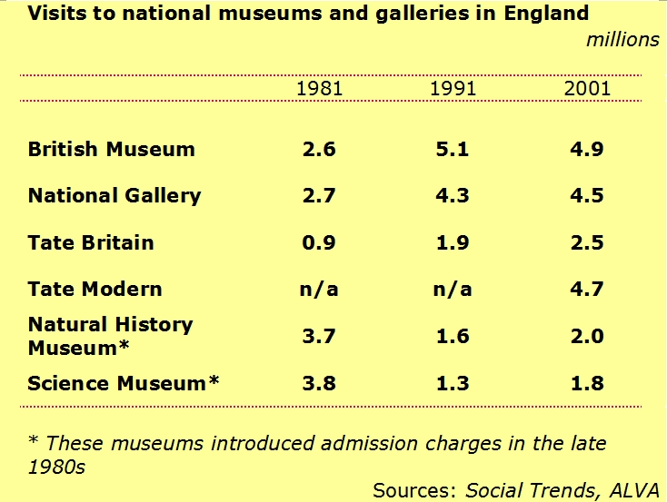

Sample Answer
The table illustrates visitor figures for various UK cultural attractions in 1981, 1991 and 2001.
Three of the museums and galleries saw a general increase in the number of visits over the period. Firstly, figures for the British Museum jumped significantly by 2.3 million (despite a marginal decline in 2001), and, secondly, for the National Gallery, from 2.7 to 4.5. In spite of starting at lower than any other attraction (0.9 million visits in 1981), visits to the Tate Britain increased most dramatically from 1.9 million in 1991, and again to 2.5 in 2001, becoming the fourth most popular cultural attraction. There were no figures for the Tate Modern for the first two decades, however, it enjoyed 4.7 million visitors in 2001.
Although the Natural History Museum and the Science Museum
recorded the highest figures in 1981, visits declined dramatically before 1991, because these attractions started charging entrance fees. Finally, despite a rise in 2001, figures are still to reach previous levels.

