Video Lesson Handout
IELTS ACADEMIC WRITING MODULE
Writing Task 1
You should spend about 20 minutes on this task.
The chart below shows the amount of money per week spent on fast foods in Britain. The graph shows the trends in consumption of fast foods.
Write a report for a university lecturer describing the information shown below
You should write at least 150 words.
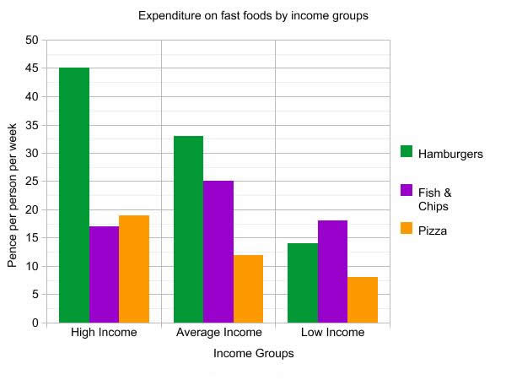
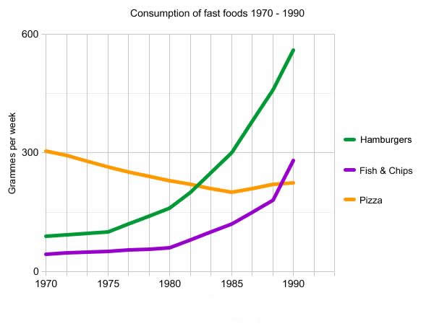

Sample Answer
The diagrams give information on expenditure and consumption of fast foods in the UK.
The chart shows that high income earners consumed by far the most fast foods, spending at least 12 pence more on hamburgers than on the other foods. Average income earners also favoured hamburgers (33 pence per week), followed by fish and chips at 24 pence, then 11 pence on pizza. Low income earners spent the least money, however fish and chips were their most popular fast food, followed by hamburgers and then pizza.
From the graph, we can see that in 1970, pizza was by far the most popular fast food. The consumption of hamburgers and fish and chips rose steadily over the 20 year period, hamburgers exceeding pizza around 1982, and fish and chips consumption rising above pizza around 1997. The consumption of pizza was in decline over much of the period until 1985, but experienced a slight recovery to 1990.

