Video Lesson Handout
IELTS ACADEMIC WRITING MODULE
Writing Task 1
You should spend about 20 minutes on this task.
The bar chart below shows the reasons why adults choose to take up education courses. The pie chart shows how adults believe the costs of their course should be shared.
Write a report for a university lecturer describing the information shown below
You should write at least 150 words.
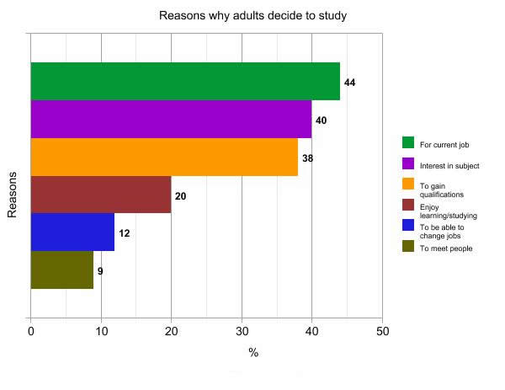
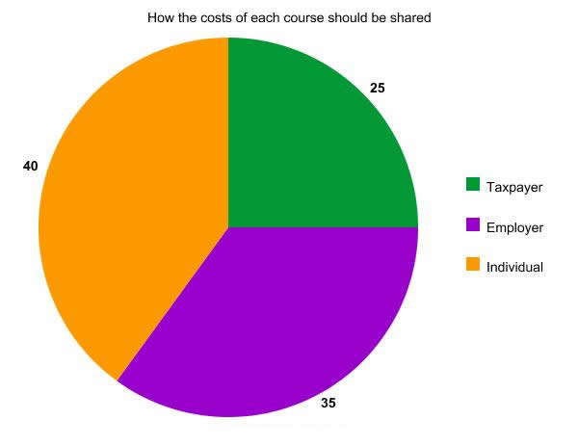

Sample Answer
The following charts show the results of a survey asking why adults study, and how they thought their education should be paid for.
The top three reasons given (‘for current job’, ‘interest in subject’, and ‘to gain qualifications’) saw no significant difference in proportion, and were 44%, 40% and 38% respectively. Enjoyment of learning was significantly lower than these motivations, and had a 20% share of the total. Finally, the lowest two percentages were for adults who wanted to change careers (12%), and for those who saw studying as a way of meeting people (9%).
The pie chart shows that the people surveyed believed the student should foot the highest proportion of the bill for adult education courses (40%). Only slightly less, the employer was expected to pay 35% of the course fees. Finally, and markedly lower than the other two, respondents thought that the government should bear exactly a quarter of the costs.

