Video Lesson Handout
IELTS ACADEMIC WRITING MODULE
Writing Task 1
You should spend about 20 minutes on this task.
The charts show the quantity of milk, in pints, consumed daily by children in the UK in 1997.
Write a report for a university lecturer describing the information shown below
You should write at least 150 words.
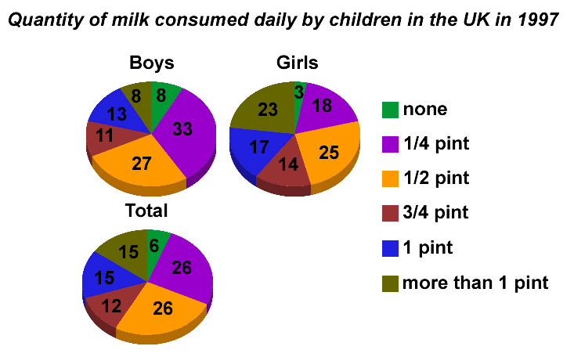

Sample Answer
The bar charts give information about the daily milk consumption (in pints) of children in Britain in 1997.
The two largest proportions for male children were for a quarter of a pint and half a pint (33% and 27% respectively). For girls, however, half a pint (25%) and more than 1 pint (23%) were the most significant proportions. Considerably more boys than girls consumed between three quarters and 1 pint. 8% of boys consumed more than one pint per day (equal to the proportion consuming no milk). This, as can be seen earlier in the paragraph, is in stark contrast with the fraction of the girls who said they drank more than one pint every day. Finally a very insignificant proportion of girls (3%) drank no milk at all.
When we combine the proportions, we can see that the majority of the children drank between a quarter and a half pint daily (both at 26%). The next most significant proportion was for those drinking more than three quarters of a pint. The lowest of the total was for children drinking no milk at all (6% of the total).

