Video Lesson Handout
IELTS ACADEMIC WRITING MODULE
Writing Task 1
You should spend about 20 minutes on this task.
The graphs show the number of licensed cars in the UK from 1982 and 2006, and household access to a car from 1980 to 2005.
Write a report for a university lecturer describing the information shown below
You should write at least 150 words.
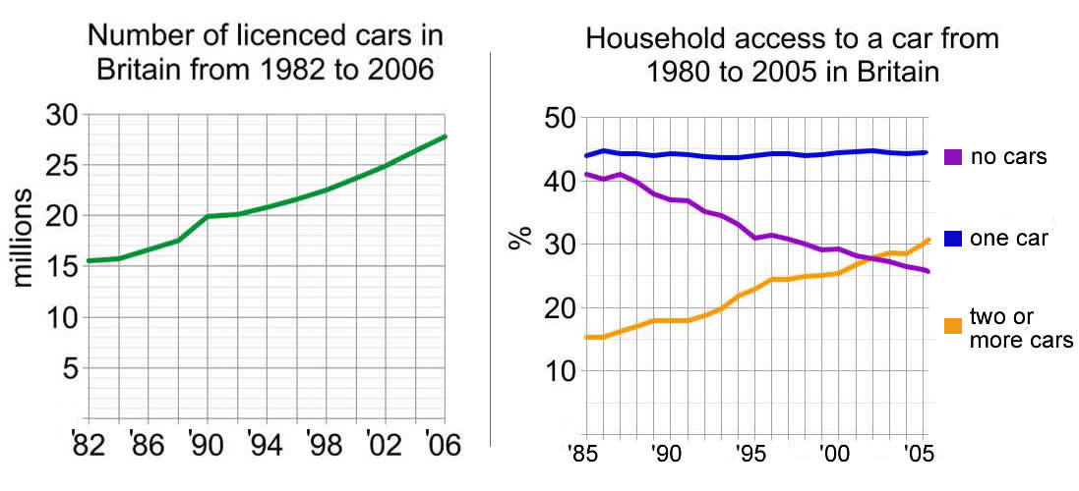

Sample Answer
The graphs show the total number of cars licensed, and the percentage of households with access to cars in Britain, over two and a half decades from 1980.
The number of licensed cars rose steadily from 15.5 million in 1982 to 27.8 million in 2006, an 80% rise. The most significant rise was from 1988 to 1990 after which numbers remained constant for two years, before increasing as before.
This substantial increase is reflected in an increase in the proportion of households having access to two or more cars. In 1985, 41% of households did not have access to a car, falling to 25% by 2005. The proportion of households having access to one car remained stable at around 45%. In contrast, the proportion with access to two cars doubled from 15% to 31%. This proportion exceeded that for households with no car in around 2002, and in 2005 the difference between these proportions was approximately 7% in favour of families with two or more cars.

