Video Lesson Handout
IELTS ACADEMIC WRITING MODULE
Writing Task 1
You should spend about 20 minutes on this task.
The bar chart below shows the percentages of students who failed their end of year examinations at an American college in 1999 and 2003.
Write a report for a university lecturer describing the information shown below
You should write at least 150 words.
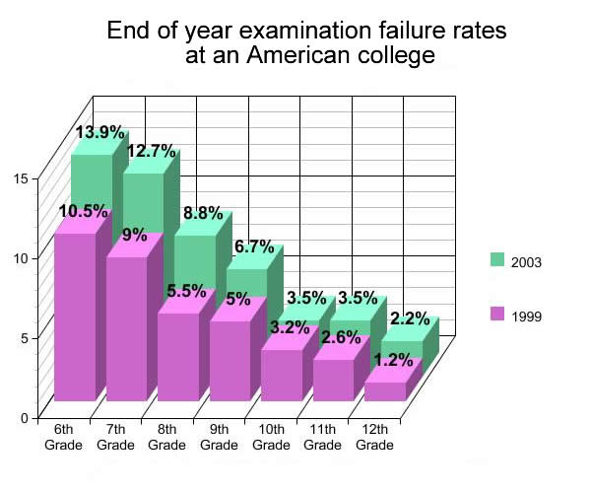

Sample Answer
The bar chart compares percentage failure rates of students in end of year examinations at an American college in 1999 and 2003.
Both years recorded a decrease in exam failures as students got older. In 1999, 10.5% of 6th graders failed their exams compared to 1.2% of 12th graders. The largest fall from was from 7th grade to 8th grade, constituting a 4.5% better success rate for the older students. 2003 experienced a similar disparity with 13.9% of 6th grade pupils failing, decreasing to a mere 2.2% of final year students. This decline suggests that as students get older, they become more serious about their studies.
Comparing the two years recorded, it becomes clear that as time passed, students became more likely to fail. The most significant rise was for the 6th, 7th and 8th graders at an increase of 3.4%, 3.7% and 3.3% respectively. Although students became more successful the older they got, there was still an increase in failure rates in the last three school years from a total of 7% in 1999 to 9.2 % in 2003.

